**One-Year Follow Up of Noninvasive Ventilation in Ordinary Wards: a Single Centre Observational Study**

**RESULTS**

*Acute respiratory failure (ARF) diagnosis*

Subjects included in the category of ARF diagnosis defined as others included: pulmonary embolism (n=4), acute respiratory distress syndrome (ARDS) (n=1), post operative ARF (n=38), pleural effusion (n=14), obstructive sleep apnea syndrome (OSAS) (n=2), thoracic trauma (n=12), neuromuscular disease (n=4), end-stage malignancy (n=13), pancreatitis (n=2), interstitial lung disease (n=11), ARF in acute neurologic subjects (n=3).

*Comorbidities*

Subjects included in the category of comorbidities defined as others included 35 subjects with solid cancer, 11 with sepsis, 5 with cirrhosis, 8 with alcohol abuse, 7 with immunodepression, 9 with OSAS.

*Intensive care unit (ICU) Admission*

81/383 subjects (21%) required intensive care unit (ICU) admission during hospital stay of which 41 subjects after failing noninvasive ventilation (NIV) started outside ICU, while the remaining 40 subjects continued NIV outside ICU after ICU discharge. Among those failing NIV, leading causes of failure were desaturation, tachypnea, and hemodynamic instability, in line with previous studies.

At the logistic regression model among the variables considered, i.e., age, do-not-intubate (DNI) status, ARF diagnosis, gender, comorbidities, do-not-intubate status seems the only factor inversely associated with ICU transfer of subjects treated with NIV (*P* = .004, Table 5S-A).

**TABLES**

|  |  |  |  |  |  |  |
| --- | --- | --- | --- | --- | --- | --- |
| **Clinical and demographic characteristics** | **Total**  n = 383 | **CPE**  n = 128 | **Pneumonia**  n = 99 | **COPD**  n = 52 | **Others**  n = 104 | ***P*** |
| **Age, years, median (IQR)** | 79 (72-85) | 81 (74-86) | 80 (69-86) | 80 (73-86) | 77 (70-84) | .43 |
| **Gender, n (%)** |  | | | | | |
| Male | 218 (57) | 69 (32) | 66 (30) | 26 (12) | 57 (26) | .14 |
| Female | 165 (43) | 59 (36) | 33 (20) | 26 (16) | 47 (28) | .14 |
| **NIV treatment, n (%)** |  | | | | | |
| NPPV | 136 (36) | 24 (18) | 21 (15) | 48 (35) | 43 (32) | <.001 |
| CPAP | 247 (64) | 104 (42) | 78 (32) | 4 (1) | 61 (25) | <.001 |
| **Comorbidities, n (%)** |  | | | | | |
| Cardiomyopathy | 186 (49) | 89 (48) | 39 (21) | 28 (15) | 30 (16) | <.001 |
| Hypertension | 165 (43) | 63 (38) | 36 (22) | 27 (16) | 39 (24) | .08 |
| Diabetes | 85 (22) | 31 (36) | 16 (19) | 14 (17) | 24 (28) | .37 |
| Obesity | 48 (13) | 22 (46) | 8 (17) | 11 (23) | 7 (14) | .02 |
| Chronic renal failure | 65 (17) | 30 (46) | 14 (22) | 8 (12) | 13 (20) | .12 |
| Smoke | 45 (12) | 15 (33) | 9 (20) | 11 (25) | 10 (22) | .13 |
| Hematologic malignancy | 27 (7) | 4 (15) | 12 (45) | 2 (7) | 9 (33) | .044 |
| Long-term home NIV | 9 (2) | 5 (56) | 0 (0) | 1 (11) | 3 (33) | .27 |
| Others | 75 (20) | 14 (19) | 30 (40) | 9 (12) | 22 (29) | .003 |
| **DNI status, n (%)** | 120 (31) | 30 (25) | 38 (32) | 18 (15) | 34 (28) | .10 |

**Table 1S.** Demographic and clinical characteristics of subjects treated with NIV, based on acute respiratory failure diagnosis. Values are expressed as number and percentage or as median and interquartile range.

CPE = cardiogenic pulmonary edema, COPD = chronic obstructive pulmonary disease exacerbation, CPAP = continuous positive airway pressure, DNI = do-not-intubate, IQR = interquartile range, n = number, NIV = noninvasive ventilation, NPPV = noninvasive positive pressure ventilation.

|  |  |  |  |  |  |  |
| --- | --- | --- | --- | --- | --- | --- |
| **Baseline laboratory values** | **Total**  n = 383 | **CPE**  n = 128 | **Pneumonia**  n = 99 | **COPD**  n = 52 | **Others**  n = 104 | ***P*** |
| **pH, median (IQR)** | 7.39 (7.32-7.45) | 7.39 (7.33-7.44) | 7.42 (7.34-7.46) | 7.32 (7.30-7.37) | 7.41 (7.34-7.45) | .031 |
| **PaCO2, mmHg, median (IQR)** | 41.6 (36.0-55.3) | 39.0 (34.4-47.4) | 38.0 (33.6-48.9) | 69.5 (58.1-82.5) | 40.0 (36.0-48.7) | .07 |
| **PaO2, mmHg, median (IQR)** | 60.0 (49.2-73.4) | 60.0 (47.5-73.4) | 57.2 (49.6-68.8) | 61.0 (46.2-72.5) | 62.3 (53.0-84.0) | .17 |
| **HCO3-, mEq/L, median (IQR)** | 25.9 (22.6-31.1) | 24.6 (21.0-28.0) | 25.2 (22.5-30.0) | 36.6 (30.6-40.9) | 26.0 (23.0-30.4) | .08 |
| **Lactate, mMol/L, median (IQR)** | 1.3 (0.9-2.3) | 1.5 (1.0-2.7) | 1.5 (1.1-2.2) | 0.6 (0.9-1.2) | 1.4 (1.0-2.4) | .30 |
| **WBC, x103/µL, median (IQR)** | 11.0 (8.0-16.0) | 11.0 (8.0-14.0) | 13.0 (7.0-17.0) | 11.0 (9.0-15.0) | 11.0 (8.0-17.0) | .004 |
| **Neutrophils, x103/µL,  median (IQR)** | 9.0 (6.0-12.0) | 9.0 (6.0-11.0) | 9.5 (5.5-15.0) | 8.5 (6.0-11.5) | 9.0 (6.0-13.0) | .34 |
| **Creatinine, mg/dL, median (IQR)** | 1.00 (1.00-2.00) | 1.00 (1.00-2.00) | 1.00 (1.00-1.59) | 1.00 (0.71-1.39) | 1.00 (0.99-1.31) | .02 |
| **ALT, U/L, median (IQR)** | 22 (16-37) | 22 (16-32) | 23 (16-43) | 17 (12-25) | 24 (18-40) | .27 |

**Table 2S.** Laboratory values at the baseline, based on acute respiratory failure diagnosis. Values are expressed as median and interquartile range.

ALT = alanine aminotransferase, CPE = cardiogenic pulmonary edema, COPD = chronic obstructive pulmonary disease exacerbation, HCO-3 = bicarbonates, IQR = interquartile range, n = number, PaCO2 = arterial partial pressure of carbon dioxide, PaO2 =arterial partial pressure of oxygen. WBC = white blood cells.

|  |  |  |  |  |
| --- | --- | --- | --- | --- |
| **Baseline laboratory values** | **Total**  n = 383 | **Hypoxemic ARF**  n = 237 | **Hypercapnic ARF**  n = 146 | ***P*** |
| **pH, median (IQR)** | 7.39 (7.32-7.45) | 7.43 (7.37-7.47) | 7.32 (7.27-7.37) | <.001 |
| **PaCO2, mmHg, median (IQR)** | 41.6 (36.0-55.3) | 36.8 (33.0-39.7) | 58.8 (50.1-72.2) | <.001 |
| **PaO2, mmHg, median (IQR)** | 60.0 (49.2-73.4) | 59.0 (50.0-73.5) | 59.5 (45.7-71.6) | .25 |
| **HCO3-, mEq/L, median (IQR)** | 25.9 (22.6-31.1) | 24.3 (21.0-27.0) | 31.8 (29.6-37.4) | .003 |
| **Lactate, mMol/L, median (IQR)** | 1.3 (0.9-2.3) | 1.5 (1.1-2.6) | 1.1 (0.7-1.9) | .08 |
| **WBC, x103/µL, median (IQR)** | 11.0 (8.0-16.0) | 12.0 (8.0-17.0) | 11.0 (8.0-15.0) | .07 |
| **Neutrophils, x103/µL,  median (IQR)** | 9.0 (6.0-12.0) | 10.0 (6.0-13.0) | 8.5 (6.0-12.0) | .15 |
| **Creatinine, mg/dL, median (IQR)** | 1.00 (1.00-2.00) | 1.00 (1.00-2.00) | 1.00 (0.82-1.61) | .16 |
| **ALT, U/L, median (IQR)** | 22 (16-37) | 24 (17-42) | 20 (14-29) | .33 |

**Table 3S.** Laboratory values at baseline, based on acute respiratory failure etiology. Values are expressed as median and interquartile range.

ALT = alanine aminotransferase, ARF = acute respiratory failure, HCO-3 = bicarbonates, IQR = interquartile range, n = number, PaCO2 = arterial partial pressure of carbon dioxide, PaO2 =arterial partial pressure of oxygen. WBC = white blood cells.

|  |  |  |
| --- | --- | --- |
|  | **HR** | **[95% CI]** |
| Age | 1.40 | 1.09-1.79 |
| DNI status§ | 1.88 | 1.15-3.07 |
| Pneumonia° | 1.22 | .61-2.46 |
| Cardiogenic pulmonary edema° | .89 | .44-1.80 |
| Other ARF diagnosis° | 1.21 | .58-2.52 |
| Male gender | 1.26 | .79-1.99 |
| Cardiomyopathy* | 1.33 | .84-2.13 |
| Hypertension* | 1.02 | .66-1.57 |
| COPD* | 1.64 | .99-2.72 |
| Diabetes* | .90 | .53-1.53 |
| Obesity* | 1.32 | .68-2.54 |
| Chronic renal failure* | 1.10 | .62-1.95 |
| Smoke* | 1.03 | .49-2.18 |
| Hematologic malignancy* | 1.46 | .57-3.74 |
| Long-term home NIV* | 1.61 | .47-5.54 |
| Other comorbidity* | 1.00 | .56-1.79 |
| LR= 31.2 *P* = .01 | | |

**Table 4S.** Cox regression model on one-year survival. Age is considered as divided by age groups, <50 years and subsequently by classes of ten years.

§vs full treatment; °vs COPD exacerbation; *vs absence of disease condition.

ARF = acute respiratory failure, CI = confidence interval, COPD = chronic obstructive pulmonary disease exacerbation, DNI = do not intubate, HR = hazard ratio, LR = likelihood-ratio test, NIV = noninvasive ventilation.

**A.**

|  |  |  |
| --- | --- | --- |
|  | **OR** | **[95% CI]** |
| Age | .90 | .65-1.23 |
| DNI status§ | .19 | .065-.59 |
| Pneumonia° | 1.84 | .49-6.89 |
| Cardiogenic pulmonary edema° | 1.03 | .27-3.93 |
| Other ARF diagnosis° | 1.05 | .27-4.10 |
| Male gender | .83 | .41-1.69 |
| Cardiomyopathy* | 1.05 | .47-2.34 |
| Hypertension* | .84 | .40-1.77 |
| COPD* | .79 | .31-2.07 |
| Diabetes* | .50 | .18-1.42 |
| Obesity* | .60 | .16-2.25 |
| Chronic renal failure* | .92 | .32-2.67 |
| Smoke* | 2.28 | .86-6.04 |
| Hematologic malignancy* | 1.63 | .53-5.04 |
| Long-term home NIV* | 1.45 | .15-14.16 |
| Other comorbidity* | .98 | .41-1.55 |
| LR= 24.8 *P* = .07 | | |

**B.**

|  |  |  |
| --- | --- | --- |
|  | **OR** | **[95% CI]** |
| Age | .96 | .66-1.39 |
| DNI status§ | .34 | .12-.95 |
| Pneumonia° | .40 | .12-1.35 |
| Cardiogenic pulmonary edema° | .48 | .17-1.41 |
| Other ARF diagnosis° | .47 | .14-1.51 |
| Male gender | 1.24 | .58-2.65 |
| Cardiomyopathy* | 1.50 | .67-3.33 |
| Hypertension* | .83 | .39-1.78 |
| COPD* | 1.25 | .51-3.05 |
| Diabetes* | 1.64 | .71-3.77 |
| Obesity* | 2.44 | .94-6.31 |
| Chronic renal failure* | .77 | .28-2.10 |
| Smoke* | 1.77 | .66-4.73 |
| Hematologic malignancy* | 3.99 | 1.22-13.07 |
| Other comorbidity* | .59 | .21-1.65 |
| LR= 26.3 *P* = .035 | | |

**Table 5S.** Multivariable logistic regression model with transfers to intensive care unit (5S-A) and re-treatments (5S-B) as dependent variables, respectively.

Age is considered as divided by age groups, < 50 years and subsequently by classes of ten years. Long-term home noninvasive ventilation was not considered in the re-treatment model, as all subjects with this comorbidity were re-treated.

§vs full treatment; °vs COPD exacerbation; *vs absence of disease condition.

ARF = acute respiratory failure, CI = confidence interval, COPD = chronic obstructive pulmonary disease exacerbation, DNI = do not intubate, LR = likelihood-ratio test, NIV = noninvasive ventilation, OR = odds ratio.

**FIGURES**

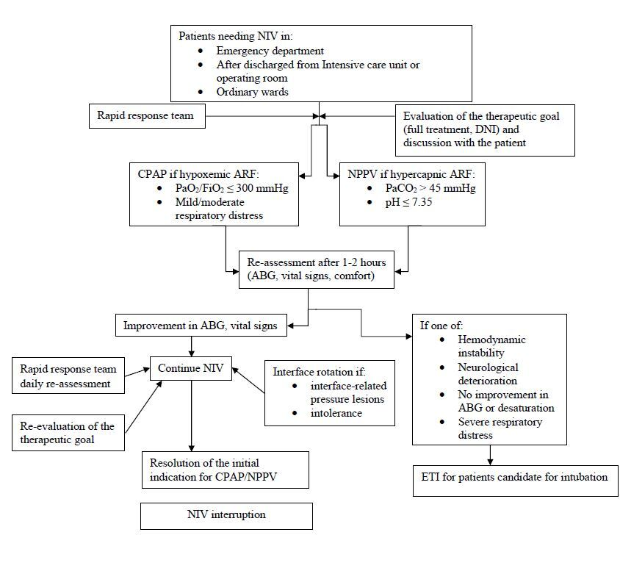**Figure 1S.** Algorithm of treatment and follow-up of subjects in noninvasive ventilation outside the intensive care unit.

ABG = arterial blood gas, ARF = acute respiratory failure, CPAP = continuous positive airway pressure, DNI = do-not-intubate, ETI = endotracheal intubation, NIV = noninvasive ventilation, NPPV = noninvasive positive pressure ventilation, PaCO2 = arterial partial pressure of carbon dioxide, PaO2/FiO2 = arterial partial pressure of oxygen over inspired fraction of oxygen ratio.

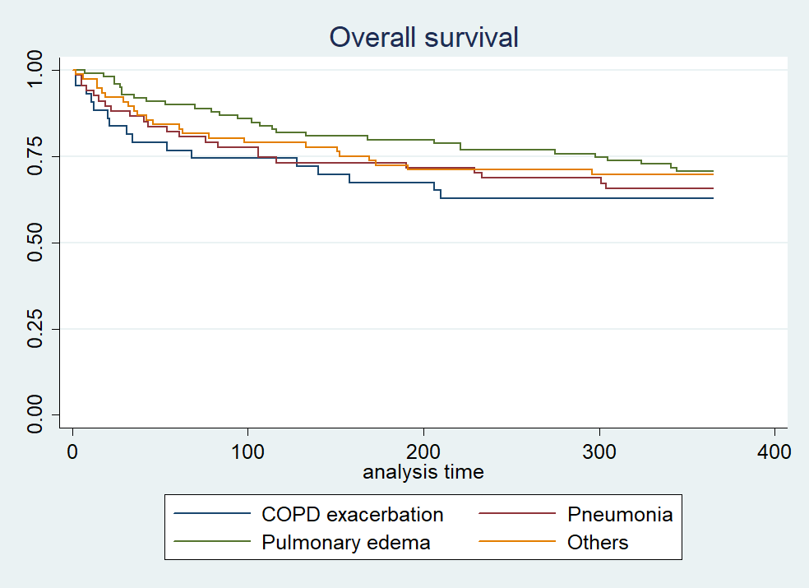

**Figure 2S.** One-year survival after hospital discharge of subjects treated with noninvasive outside the intensive care unit, based on acute respiratory failure diagnosis (*P* = .60).

COPD = chronic obstructive pulmonary disease exacerbation.