**Search strategy**

**Search strategy in PubMed**

((("Pulmonary Disease, Chronic Obstructive"[Mesh]) OR ((((((((COPD[Title/Abstract]) OR (Chronic Obstructive Pulmonary Disease[Title/Abstract])) OR (Chronic Obstructive Airway Disease[Title/Abstract])) OR (Chronic Obstructive Lung Disease[Title/Abstract])) OR (Airflow Obstruction, Chronic[Title/Abstract])) OR (Airflow Obstructions, Chronic[Title/Abstract])) OR (Chronic Airflow Obstructions[Title/Abstract])) OR (Chronic Airflow Obstruction[Title/Abstract]))) AND ((((((((((((Inhaled corticosteroids[Title/Abstract]) OR (ICS[Title/Abstract])) OR (Budesonide[Title/Abstract])) OR (Pulmicort[Title/Abstract])) OR (mometasone[Title/Abstract])) OR (flunisolide[Title/Abstract])) OR (beclomethasone[Title/Abstract])) OR (Foradil[Title/Abstract])) OR (Advair[Title/Abstract])) OR (fluticasone[Title/Abstract])) OR (ciclesonide[Title/Abstract])) OR (triamcinolone[Title/Abstract]))) AND ((((((randomized controlled trial[Publication Type]) OR (controlled clinical trial[Publication Type])) OR (randomized[Title/Abstract])) OR (placebo[Title/Abstract])) OR (randomly[Title/Abstract])) OR (trial[Title/Abstract]))

**Search strategy in Embase**

#1 'chronic obstructive lung disease'/exp OR 'copd':ab,ti OR 'chronic obstructive pulmonary disease':ab,ti OR 'chronic obstructive airway disease':ab,ti OR 'chronic obstructive lung disease':ab,ti OR 'airflow obstruction, chronic':ab,ti OR 'airflow obstructions, chronic':ab,ti OR 'chronic airflow obstructions':ab,ti OR 'chronic airflow obstruction':ab,ti

#2 'inhaled corticosteroids':ab,ti OR 'ics':ab,ti OR 'budesonide':ab,ti OR 'pulmicort':ab,ti OR 'mometasone':ab,ti OR 'flunisolide':ab,ti OR 'beclomethasone':ab,ti OR 'foradil':ab,ti OR 'advair':ab,ti OR 'fluticasone':ab,ti OR 'ciclesonide':ab,ti OR 'triamcinolone':ab,ti

#3 'randomized controlled trial'/exp OR 'controlled trial, randomized':ab,ti OR 'randomised controlled study':ab,ti OR 'randomised controlled trial':ab,ti OR 'randomized controlled study':ab,ti OR 'randomized controlled trial':ab,ti OR 'trial, randomized controlled':ab,ti

#4 #1 AND #2 AND #3

**Search strategy in Cochrane Library**

#1 MeSH descriptor: [Pulmonary Disease, Chronic Obstructive]

#2 (COPD):ti,ab,kw OR (Chronic Obstructive Pulmonary Disease):ti,ab,kw OR (Chronic Obstructive Airway Disease):ti,ab,kw OR (Chronic Obstructive Lung Disease):ti,ab,kw AND (Airflow Obstruction, Chronic):ti,ab,kw

#3 (Airflow Obstructions, Chronic):ti,ab,kw OR (Chronic Airflow Obstructions):ti,ab,kw OR (Chronic Airflow Obstruction):ti,ab,kw

#4 #1 OR #2 OR #3

#5 (inhaled corticosteroids):ti,ab,kw OR (ICS):ti,ab,kw OR (budesonide):ti,ab,kw OR (mometasone):ti,ab,kw OR (beclomethasone):ti,ab,kw

#6 (fluticasone):ti,ab,kw OR (ciclesonide):ti,ab,kw OR (triamcinolone):ti,ab,kw

#7 #5 OR #6

#8 #4 AND #7

**Table S1** Daily dose of ICS

|  |  |  |  |
| --- | --- | --- | --- |
| **ICS** |  | **Daily dose (μg)** |  |
| **Low** | **Medium** | **High** |
| Budesonide | 200-400 | >400-800 | >800 |
| Fluticasone furoate | 50 | 100 | 200 |
| Fluticasone propionate | 100-250 | >250-500 | >500 |
| Mometasone furoate | 200 — 400 | | >400 |
| Triamcinolone | 400-1000 | >1000-2000 | >2000 |

**Table S2** GRADE assessment for the effect of ICS on the risk of fracture and osteoporosis

| **Certainty assessment** | | | | | | | **№ of patients** | | **Effect** | | **Certainty** | **Importance** |
| --- | --- | --- | --- | --- | --- | --- | --- | --- | --- | --- | --- | --- |
| **№ of studies** | **Study design** | **Risk of bias** | **Inconsistency** | **Indirectness** | **Imprecision** | **Other considerations** | **ICS** | **Non-ICS** | **Relative (95% CI)** | **Absolute (95% CI)** |
| **Fracture risk (follow-up: range 12 weeks to 156 weeks; assessed with: RR)** | | | | | | | | | | | | |
| 24 | randomised trials | not serious | not serious | serious | seriousa | none | 765/35827 (2.1%) | 490/24665 (2.0%) | **RR 1.10** (0.98 to 1.23) | **2 more per 1,000** (from 0 fewer to 5 more) | ⨁⨁◯◯ Low | IMPORTANT |
| **Osteoporosis risk (follow-up: range 24 weeks to 156 weeks; assessed with: RR)** | | | | | | | | | | | | |
| 4 | randomised trials | not serious | not serious | serious | seriousb | publication bias strongly suspectedc | 18/1377 (1.3%) | 17/1142 (1.5%) | **RR 0.93** (0.49 to 1.79) | **1 fewer per 1,000** (from 8 fewer to 12 more) | ⨁◯◯◯ Very low | IMPORTANT |

**CI:** confidence interval; **RR:** risk ratio

#### Explanations

a. 95% confidence interval include invalid value

b. The confidence interval is not narrow enough

c. The number of included studies was small

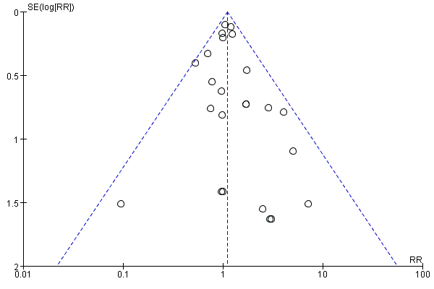

**Figure S1** Funnel plot for the effect of ICS on fracture risk