**Figure S1.** Schematic of extraction of the data set.

**Figure S2.** Observed versus expected plot showing deciles of 30-day readmission predicted probability.

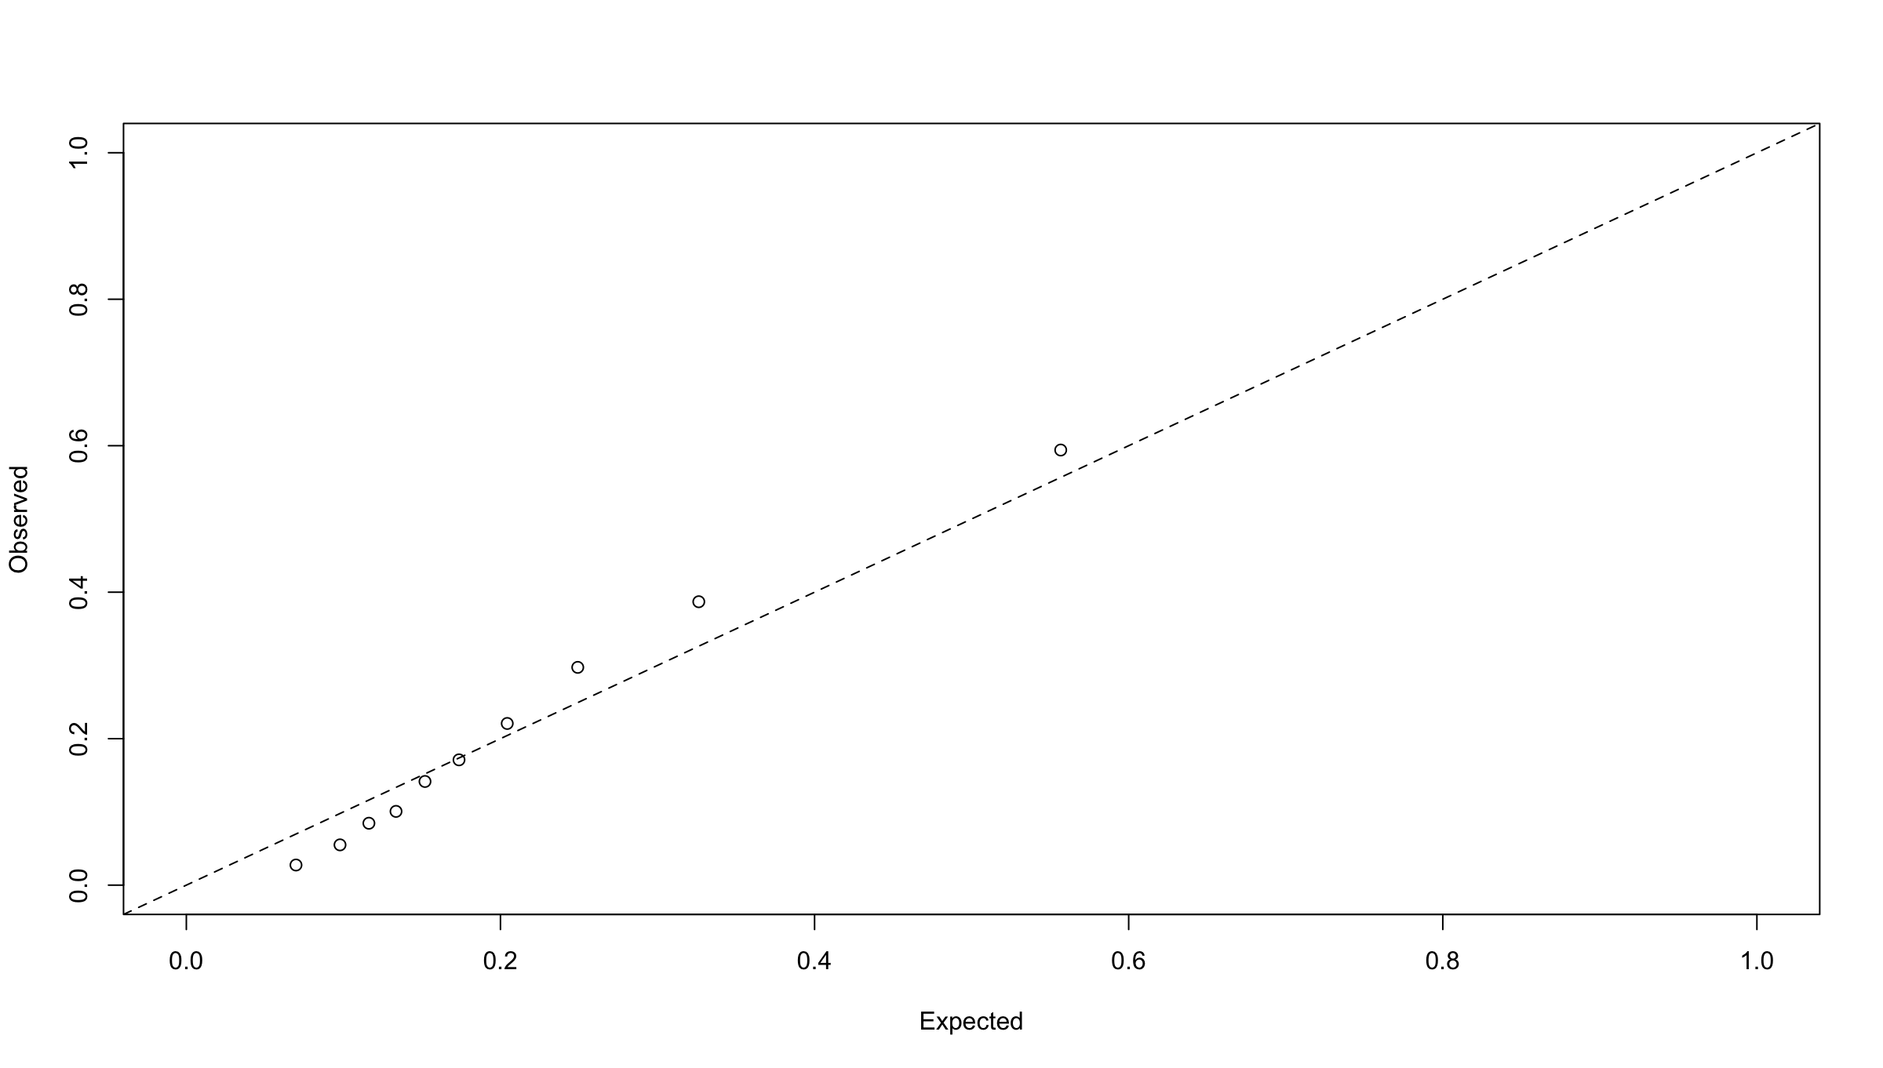

**Figure S3.** Linear splines for length of stay in the prediction model.

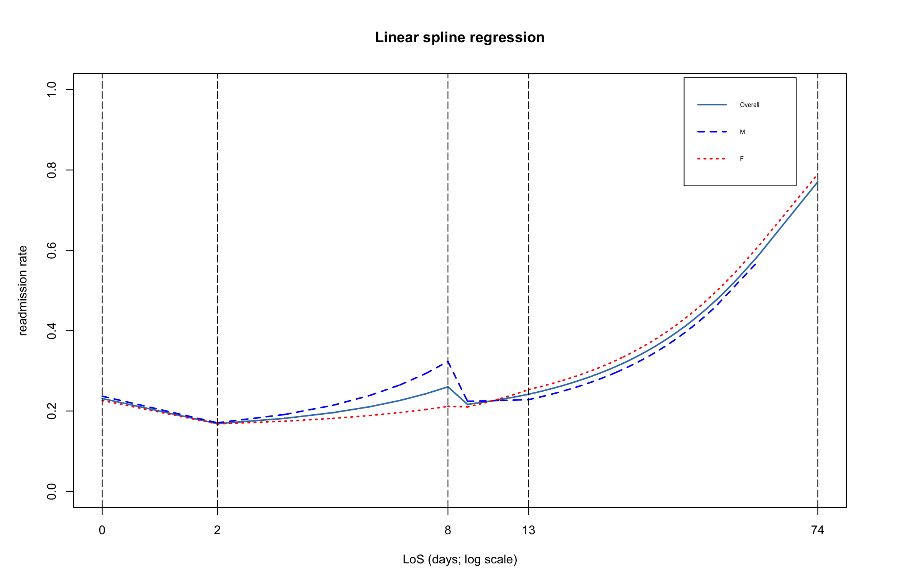

**Table S1:** Estimated effects of disease group variables in the predictive model.

|  |  |  |  |  |  |
| --- | --- | --- | --- | --- | --- |
| **Type of Variable** | **Variable** | | **Odds ratio (95% CI)** | | |
| Admission Diagnosis Group (reference is Others) | Certain infectious and parasitic diseases | | 0.88 (0.63–1.22) | | |
| Diseases of the digestive system | | 1.31 (0.95–1.80) | | |
| Diseases of the genitourinary system | | 0.80 (0.47–1.38) | | |
| Diseases of the musculoskeletal system and connective tissue | | 0.79 (0.55–1.13) | | |
| Diseases of the nervous system | | 0.66 (0.36–1.20) | | |
| Diseases of the respiratory system | | 1.09 (0.96–1.24) | | |
| Diseases of the skin and subcutaneous tissue | | 0.59 (0.35–1.01) | | |
| Injury, poisoning and certain other consequences of external causes | | 0.78 (0.54–1.12) | | |
| Mental and behavioral disorders | | 1.14 (0.87–1.48) | | |
| Neoplasms | | 0.68 (0.31–1.47) | | |
| Discharge Diagnosis Group (reference is Others) | Certain infectious and parasitic diseases | | 1.03 (0.69–1.54) | | |
| Diseases of the blood and blood–forming organs and certain disorders involving the immune mechanism | | 0.79 (0.49–1.26) | | |
| Diseases of the circulatory system | | 1.13 (0.94–1.35) | | |
| Diseases of the musculoskeletal system and connective tissue | | 0.62 (0.39–0.97) | | |
| Diseases of the skin and subcutaneous tissue | | 0.56 (0.22–1.43) | | |
| Past Diagnosis (comorbidity; reference is absence of the condition) | | Other kidney diseases | | 0.82 (0.72–0.93) |
| Mental diseases | | 1.17 (0.92–1.48) |
| Obesity | | 0.86 (0.76–0.97) |
| Malignant neoplasms | | 1.15 (0.98–1.35) |
| Sepsis | | 1.01 (0.89–1.15) |
| Other infections | | 1.11 (0.98–1.26) |
| Heart failure | | 1.21 (1.07–1.38) |
| Cardiac arrhythmia | | 1.14 (1.01–1.28) |
| Hypertensive diseases | | 1.09 (0.94–1.27) |
| Abnormal findings on blood | | 1.09 (0.95–1.26) |
| Hemolytic anemia | | 1.18 (1.05–1.34) |
| Cognitive functions symptoms | | 1.18 (1.04–1.33) |
| Need devices | | 1.06 (0.93–1.20) |
| Nutritional metabolic disease | | 1.04 (0.93–1.18) |
| Personal history of several risk factors | | 1.06 (0.94–1.21) |
| Gallbladder, biliary tract, and pancreas | | 1.15 (0.99–1.32) |
| Skin subcutaneous infection | | 1.14 (1.00–1.29) |
| Other respiratory diseases | | 0.85 (0.67–1.07) |
| Intentional unintentional injury poisoning adverse events | | 0.91 (0.78–1.05) |