**Current advances and gaps in knowledge on personalizing masks for non-invasive ventilation: a scoping review**

Rosemijne R.W.P. Pigmans1, Jonathan Smith3, Dick G. Markhorst1, Job B.M. van Woensel1,Coen D. Dijkman2, Heather E. Elphick3, Reinout A. Bem1

1. Paediatric Intensive Care Unit, Emma Children’s Hospital, Amsterdam University Medical Centres, University of Amsterdam, Amsterdam, the Netherlands
2. Department for Medical Innovation and Development, Amsterdam University Medical Centres, University of Amsterdam, Amsterdam, the Netherlands
3. Sheffield Children’s NHS Foundation Trust, Sheffield UK

# **Funding**

RP is supported by the Innovation Impulse (2022-06) from the AMC, Amsterdam UMC, the Netherlands; Cornelia Foundation, the Netherlands; and Foundation of the Emma Children’s Hospital, Amsterdam, the Netherlands.

# **Conflicts of interest**

There is no conflict of interest in this project.

**Finalization Scoping Review Protocol**

02-05-2023

# **Abstract**

**Objective:** The main objective of this scoping review is to identify current advances and gaps in knowledge in the technologies and working process(es) of personalising ventilation masks for patients receiving non-invasive ventilation (NIV).

**Introduction:** Commercially available, mass-produced (non-customised) masks for NIV are often found to be ill fitting. A good fit between the mask and the patient's face is essential to deliver the treatment effectively and avoid complications. Techniques to personalise NIV masks are increasingly being developed, but so far, an overall review of the literature on the topic is not available. Providing further knowledge on the current standing of the personalisation of NIV masks will facilitate progress in this field.

**Inclusion criteria:** For this review, studies with patients that receive NIV through a (partially) personalised mask and studies in healthy volunteers or patients in all age categories are eligible. Moreover, studies focusing on technological issues and working process(es) of personalising NIV masks without participants are also included. We will consider both experimental and quasi-experimental study designs including bench studies, modelling studies, methodologies, randomised controlled trials, and non-randomised controlled trials as well as observational study designs. Articles should explain the production or describe the testing of (partially) personalised NIV masks indicated for patients requiring respiratory support, either chronic (in an at-home setting) or acute.

**Methods:** A systematic search in MEDLINE and EMBASE from inception to April 2023 will be performed. There will be no language restrictions. Following the search, all identified citations will be collated and uploaded into Rayyan, and duplicates removed. Titles and abstracts will be screened by two independent reviewers. Potentially relevant sources will be assessed in detail against the inclusion criteria by two independent reviewers. The data from these sources will be extracted and organised according to five pre-defined domains with relevant sub-questions. Data will be descriptively analysed and outcomes will be presented in tabular form.

# **Keywords**

Respiratory failure; non-invasive ventilation; personalisation; ventilation mask;

# **Introduction**

Non-invasive ventilation (NIV) using a facemask is a frequently used method to provide respiratory support to patients with acute or chronic respiratory failure. A good fit with a seal between the mask and the patient’s face, minimising overall air leak and skin pressure, and maximising comfort, is essential to deliver the treatment effectively.(1, 2) Especially in (young) children and in the growing group of patients with atypical facial features (e.g. in the context of syndromic craniofacial disorders) or with abnormal facial tonus (e.g. in neuromuscular diseases) this aspect of NIV is a major challenge. For this group, NIV is increasingly used, but commercially available, mass-produced masks often do not fit well. An inadequate-fitting NIV mask will often result in large air leaks and painful skin pressure points with ulcers and/or necrosis, thereby contributing to discomfort and treatment failure**.**(1-4) An additional complication of long-term (home) NIV treatment may be the development of facial deformities.(5)

With the advent of novel technologies in particular 3D printing in the last decade, several groups have started research lines to customise or personalise NIV masks. Nevertheless, when a preliminary search of MEDLINE, EMBASE, and JBI Evidence Synthesis was conducted, no current or underway systematic reviews or scoping reviews on the topic were identified. Since it is a rapidly growing expertise, we believe an overview of the research on personalised NIV masks is suitable. In particular, identification of the current advances and gaps in knowledge, in this field, will facilitate progress in its research and development, making personalised NIV masks widely available across the world in the near future.

# **Review questions**

The main objective of this scoping review is to identify current advances and gaps in knowledge in the technologies and working process(es) of personalising ventilation masks for patients receiving NIV. In addition, we will review any potential evidence regarding the efficacy or (cost-)effectiveness of applying personalised NIV masks as compared to commercially available (off-the-shelf) interfaces.

A priori, we have identified five separate domains with relevant sub-questions:

1. Data acquisition technologies

Sub-questions: *What type of technologies (e.g. 3D/CT scanning, imprinting) are being exploited? What (post-)processing steps are being taken? Have there been comparative studies in this field? What are the differences (advantages/disadvantages) between these technologies? Are the used technologies CE-marked?*

1. Material & Production technologies

Sub-questions: *What types of materials (e.g. silicone, clay, and plastics) have been exploited? What type of production technologies (e.g. moulding, 3D printing, extruding) for these materials have been investigated? Have there been comparative studies in this field? What are differences (advantages/disadvantages) between these materials/technologies (e.g. durability, reusability, or softness)? Are the used materials compliant with the right ISO standards?*

1. Mask design

Sub-question: *What type of mask designs (e.g. oronasal, total face, nasal) have been studied? What structural designs (e.g. single or multiple components, including headgear or not) have been developed? Have (open-source) (semi-)automated software platforms for customisation been developed? How are the mask designs tested for differences in pressure and/or leak, compared to conventional masks?*

1. Working process

Sub-questions: *Have there been (comparative) studies on the feasibility and logistical working process/flow (e.g. knowledge from personnel, duration between indication and availability) of personalising NIV masks? Have there been studies on production time and cost-effectiveness over the life cycle, from creation until disposal? Are the services adopted into clinical practice or by a commercial company?*

1. Target population

Sub-questions: *What type of patients (adult versus paediatric) have been targeted in this field? In what setting (acute critical care versus long-term (home) ventilation)? What is the evidence in terms of efficacy or effectiveness of using personalised NIV masks versus commercially available (of-the-shelf) masks in these target populations/settings (e.g. differences in acceptance and/or complications)?*

# **Eligibility criteria**

### **Participants**

Bench or modelling (experimental) studies as well as studies in healthy volunteers or patients (both children and adults) are eligible.

### **Concept**

The included articles should explain the development and/or production or describe the testing of (partially) personalised NIV masks indicated for patients requiring acute or chronic respiratory support. Studies will be specifically searched, identified, and extracted against the background of our pre-defined five domains with relevant sub-questions.

### **Context**

For this study, any contextual setting will be eligible for inclusion as long as they match the concept. The target audience may vary, as well as the design of the masks, the data acquisition of the face, the materials used, and the production process.

### **Types of Sources**

This scoping review will consider both experimental and quasi-experimental study designs including bench studies, modelling studies, methodologies, randomised controlled trials, non-randomised controlled trials, and observational study designs. This review will also consider descriptive observational study designs including case series, and individual case reports. Text and opinion papers will also be considered for inclusion in this scoping review as well as patents.

# **Methods**

The proposed scoping review will be conducted in accordance with the JBI methodology for scoping reviews.(6)

### **Search strategy**

A systematic search for literature in MEDLINE and EMBASE will be undertaken to identify articles on the topic. The text words contained in the titles and abstracts of relevant articles, and the index terms used to describe the articles were used to develop a full search strategy for MEDLINE and EMBASE (see Appendix 1). The search strategy, including all identified keywords and index terms, will be adapted for each included database and/or information source. The reference list of all included sources of evidence will be screened for additional studies. Moreover, articles from design journals and patents on this topic will be searched non-systematically for additional information that might not be findable in the above-mentioned databases. For patents the Google Patents database and European Patent Office will be searched.

There will be no language restrictions. There are no limitations to the publishing date of the articles (search from inception to April 2023).

### **Study/Source of Evidence selection**

Following the search, all identified citations will be collated and uploaded into Rayyan, and duplicates removed. Titles and abstracts will then be screened by two independent reviewers for assessment against the inclusion criteria for the review. Potentially relevant sources will be retrieved in full and their citation details imported. The full text of selected citations will be assessed in detail against the inclusion criteria by two independent reviewers. Reasons for exclusion of sources of evidence in full text that do not meet the inclusion criteria will be recorded and reported in the scoping review. Any disagreements that arise between the reviewers at each stage of the selection process will be resolved through discussion. The results of the search and the study inclusion process will be reported in full in the final scoping review and presented in a Preferred Reporting Items for Systematic Reviews and Meta-analyses extension for scoping review (PRISMA-ScR) flow diagram.(7)

### **Data Extraction**

Data will be extracted from papers included in the scoping review using a data extraction tool based on the five predefined domains with sub-questions as developed by the reviewers. If appropriate, authors of papers will be contacted to request missing or additional data, where required.

A draft extraction form is provided (see Appendix 2*)*. The draft data extraction tool will be modified and revised as necessary during the process of extracting data from each included evidence source. Modifications will be detailed in the scoping review. Any disagreements that arise between the reviewers will be resolved through discussion, or with an additional reviewer/s.

### **Data Analysis and Presentation**

Data will be organised per domain and descriptively analysed. Outcomes will be presented in tabular form.

# **Acknowledgements**

We are very grateful for the advice and contribution to this project from Ms. and Mr. Dumitrescu as parent advisory board.

# **References**

1. Willox M, Metherall P, Jeays-Ward K, McCarthy AD, Barker N, Reed H, Elphick HE. Custom-made 3D printed masks for children using non-invasive ventilation: a feasibility study of production method and testing of outcomes in adult volunteers. J Med Eng Technol. 2020;44(5):213-23.

2. Shikama M, Nakagami G, Noguchi H, Mori T, Sanada H. Development of Personalized Fitting Device With 3-Dimensional Solution for Prevention of NIV Oronasal Mask-Related Pressure Ulcers. Respir Care. 2018;63(8):1024-32.

3. Goutman SA, Chen L, Plott JS, Vankoevering KK, Kurili A, Shih AJ, Green GE. A personalized approach to non-invasive ventilation masks in amyotrophic lateral sclerosis using facial scanning and 3D-printing. Annals of 3D Printed Medicine. 2021;3.

4. Hovenier R, Goto L, Huysmans T, van Gestel M, Klein-Blommert R, Markhorst D, et al. Reduced Air Leakage During Non-Invasive Ventilation Using a Simple Anesthetic Mask With 3D-Printed Adaptor in an Anthropometric Based Pediatric Head-Lung Model. Front Pediatr. 2022;10.

5. Fauroux B, Khirani S, Griffon L, Teng T, Lanzeray A, Amaddeo A. Non-invasive Ventilation in Children With Neuromuscular Disease. Front Pediatr. 2020;8:482.

6. Peters MDJ, Godfrey C, McInerney P, Munn Z, Tricco AC, Khalil H. Chapter 11: Scoping reviews. In: Munn Z, editor. JBI Manual for Evidence Synthesis2022.

7. Tricco AC, Lillie E, Zarin W, O'Brien KK, Colquhoun H, Levac D, et al. PRISMA Extension for Scoping Reviews (PRISMA-ScR): Checklist and Explanation. Annals of Internal Medicine. 2018;169(7):467-73.

# **Appendices**

### **Appendix I: Search strategy**

**Name: Rosemijne Pigmans**

**Date: 02-05-2023**

**Purpose**: To write a scoping review

**Title:** Personalized ventilation masks for an optimized fit: a scoping review

**Research question(s):** see eTable 1 for a priori defined domains and (sub-)questions

|  |
| --- |
| **Databases** |
| PubMed/MEDLINE |
| EMBASE |

**PubMed:** [PubMed (nih.gov)](https://pubmed.ncbi.nlm.nih.gov/) (n = 928)

|  |  |
| --- | --- |
| **MeSH database** | |
| Aspect 1: | "Noninvasive Ventilation"[Mesh] |
| Aspect 2: | "Precision Medicine"[Mesh] |
| Aspect 3: | "Imaging, Three-Dimensional"[Mesh] OR "Printing, Three-Dimensional"[Mesh] |

|  |  |
| --- | --- |
| **Tiab** |  |
| Aspect 1: | "Noninvasive Ventilation"[tiab] OR “Mask”[tiab] OR “Respiratory Support”[tiab] |
| Aspect 2: | "Precision Medicine"[tiab] OR “Custom*”[tiab] OR “Personalization”[tiab] |
| Aspect 3: | "Imaging, Three-Dimensional"[tiab] OR "Printing, Three-Dimensional"[tiab] |

|  |  |
| --- | --- |
| **Combined** | |
| #1 | "Noninvasive Ventilation"[Mesh] OR "Noninvasive Ventilation"[tiab] OR “Mask”[tiab] OR “Respiratory Support”[tiab] |
| #2 | "Precision Medicine"[Mesh] OR "Precision Medicine"[tiab] OR “Custom*”[tiab] OR “Personalization”[tiab] |
| #3 | "Imaging, Three-Dimensional"[Mesh] OR "Printing, Three-Dimensional"[Mesh] OR "Imaging, Three-Dimensional"[tiab] OR "Printing, Three-Dimensional"[tiab] |
| #4 | #1 AND (#2 OR #3) |

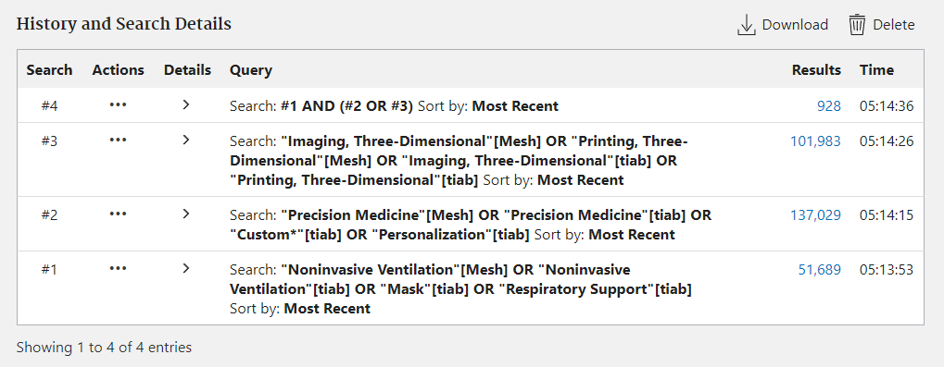

**EMBASE:** [Embase](https://www.embase.com/#advancedSearch/default) (n = 1664)

|  |  |
| --- | --- |
| **EMTREE database** | |
| Aspect 1: | ‘Noninvasive Ventilation’/syn |
| Aspect 2: | ‘Personalized Medicine’/syn |
| Aspect 3: | ‘Three-Dimensional imaging’/syn OR ‘Three-Dimensional printing’/syn |

|  |  |
| --- | --- |
| **Tiab** |  |
| Aspect 1: | 'noninvasive ventilation':ti,ab OR mask:ti,ab OR 'respiratory support':ti,ab |
| Aspect 2: | 'precision medicine:ti,ab' OR custom*:ti,ab OR personalization:ti,ab |
| Aspect 3: | 'imaging, three dimensional':ti,ab OR 'printing, three dimensional':ti,ab |

|  |  |
| --- | --- |
| **Combined** | |
| #1 | 'noninvasive ventilation'/syn OR 'noninvasive ventilation':ti,ab OR mask:ti,ab OR 'respiratory support':ti,ab |
| #2 | 'personalized medicine'/syn OR 'precision medicine:ti,ab' OR custom*:ti,ab OR personalization:ti,ab |
| #3 | 'three-dimensional imaging'/syn OR 'three-dimensional printing'/syn OR 'imaging, three dimensional':ti,ab OR 'printing, three dimensional':ti,ab |
| #4 | #2 OR #3 |
| #5 | #1 AND (#2 OR #3) |

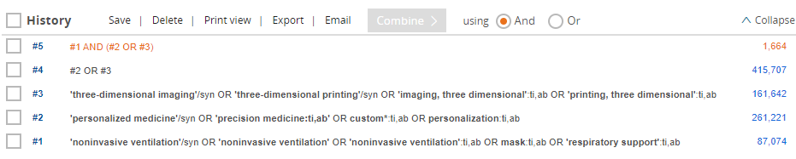

### **Appendix II: Data extraction instrument**

Available upon reasonable request.