Home non-invasive oxygenation strategies in COPD patients with chronic hypercapnic respiratory failure: a systematic review and network meta-analysis
Supplement
Contents
eTable 1. Search strategy 3
eTable 2. Risk of bias assessments 7
eTable 3. Heterogeneity statistics for each network 9
eTable 4. Mortality network estimates and GRADE assessments 10
eTable 5. Acute exacerbation network estimates and GRADE assessments 11
eTable 6. Hospitalization network estimates and GRADE assessments 12
eTable 7. SGRQ network estimates and GRADE assessments 13
eFigure 1. Mortality/Pairwise analysis 14
eFigure 2. Mortality/Node split analysis 15
eFigure 3. Mortality/Network estimates 16
eFigure 4. Mortality plot/Network funnel plot 17
eFigure 5. Acute exacerbation/Pairwise analysis 18
eFigure 6. Acute exacerbation/Node split analysis 19
eFigure 7. Acute exacerbation/Network estimates 20
eFigure 8. Acute exacerbation plot/Network funnel plot 21
eFigure 9. Hospitalization/Pairwise analysis 22
eFigure 10. Hospitalization/Network estimates 23
eFigure 11. Hospitalization plot/Network funnel plot 24
eFigure 12. SGRQ/Pairwise analysis 25
eFigure 13. SGRQ/Node split analysis 26
eFigure 14. SGRQ/Network estimates 27
eFigure 14. SGRQ plot/Network funnel plot 28
eFigure 15. NPPV - Mortality/stability 29
eFigure 16. NPPV - Mortality/PaCO2 30
eFigure 17. NPPV - Mortality/FEV1 31
eFigure 18. NPPV- Mortality/Study year 32
eFigure 19. NPPV - Mortality/Risk of bias 33
eFigure 20. HFNC – Mortality/FEV1 34
eFigure 21. HFNC – Mortality/PaCO2 35
eFigure 22. HFNC – Mortality/FEV1 36
eFigure 23. HFNC – Mortality/ROB 37

eTable 1. Search strategy

Database: Embase <1974 to 2023 July 14>
Search Strategy:
1 noninvasive ventilation/ or positive pressure ventilation/ (21275)
2 (BiPAP or BPAP or CPAP or APAP or HMV or IPPB or IPPV or NIAV or NIV or NPPV or PAP or PAV).ti,ab,kf. (74050)
3 (((facial or face or nasal) adj2 mask*) or ((respiration* or respiratory or breathing) adj2 (assist* or controlled or mechanical)) or "artificial respiration*").ti,ab,kf. (17583)
4 ("noninvasive positive pressure ventilat*" or "non-invasive positive pressure ventilat*" or "noninvasive ventilation" or "non-invasive ventilation" or (Positive adj2 pressure*)).ti,ab,kf. (52060)
5 high flow nasal cannula therapy/ (5250)
6 (HFNC or HFNP or Vapotherm or Optiflow or "Oxygen Regulator*").ti,ab,kf. (2678)
7 ((high flow or highflow or high frequency) adj3 (can?ul* or nasal* or oxygen* or therapy)).ti,ab,kf. (8608)
8 (transnasal adj3 insufflation).ti,ab,kf. (160)
9 1 or 2 or 3 or 4 or 5 or 6 or 7 or 8 (133088)
10 Obstructive Airway Disease/ or Chronic Bronchitis/ or Lung Emphysema/ (29861)
11 exp Chronic Obstructive Lung Disease/ (174289)
12 emphysema$.mp. (55358)
13 (chronic$ adj3 bronchiti$).mp. (20073)
14 (obstruct$ adj3 (pulmonary or lung$ or airway$ or airflow$ or bronch$ or respirat$)).mp. (260171)
15 (COPD or COAD or COBD or AECB).mp. (113879)
16 10 or 11 or 12 or 13 or 14 or 15 (325636)
17 Randomized Controlled Trials as Topic/ or randomized controlled trial/ or randomization/ or Double Blind Procedure/ or Single Blind Procedure/ or exp Clinical Trial/ or exp controlled clinical trial/ (2138095)
18 ((singl* or doubl* or tripl* or trebl*) adj3 (blind* or mask* or method* or procedure*)).ti,ab,kf. (398745)
19 (((clinical or control*) adj2 trial*) or random*).tw,kf. (2513826)
20 17 or 18 or 19 (3648801)
21 9 and 16 and 20 (2782)
22 limit 21 to (adult <18 to 64 years> or aged <65+ years>) (1533)
23 limit 21 to (embryo or infant or child or preschool child <1 to 6 years> or school child <7 to12 years> or adolescent <13 to 17 years>) (164)
24 23 not 22 (107)
25 21 not 24 (2675)
Database: Ovid MEDLINE(R) ALL <1946 to July 14, 2023>
Search Strategy:
1 noninvasive ventilation/ or exp *positive-pressure respiration/ (20441)
2 (BiPAP or BPAP or CPAP or APAP or HMV or IPPB or IPPV or NIAV or NIV or NPPV or PAP or PAV).ti,ab,kf. (44133)
3 (((facial or face or nasal) adj2 mask*) or ((respiration* or respiratory or breathing) adj2 (assist* or controlled or mechanical)) or "artificial respiration*").ti,ab,kf. (14241)
4 ("noninvasive positive pressure ventilat*" or "non-invasive positive pressure ventilat*" or "noninvasive ventilation" or "non-invasive ventilation" or (Positive adj2 pressure*)).ti,ab,kf. (33150)
5 Oxygen Inhalation Therapy/ (15980)
6 (HFNC or HFNP or Vapotherm or Optiflow or "Oxygen Regulator*").ti,ab,kf. (1354)
7 ((high flow or highflow or high frequency) adj3 (can?ul* or nasal* or oxygen* or therapy)).ti,ab,kf. (4667)
8 (transnasal adj3 insufflation).ti,ab,kf. (102)
9 1 or 2 or 3 or 4 or 5 or 6 or 7 or 8 (99219)
10 Lung Diseases, Obstructive/ (18283)
11 exp Pulmonary Disease, Chronic Obstructive/ (66857)
12 emphysema$.mp. (39593)
13 (chronic$ adj3 bronchiti$).mp. (12045)
14 (obstruct$ adj3 (pulmonary or lung$ or airway$ or airflow$ or bronch$ or respirat$)).mp. (138090)
15 (COPD or COAD or COBD or AECB).mp. (59914)
16 10 or 11 or 12 or 13 or 14 or 15 (182961)
17 Randomized Controlled Trials as Topic/ or randomized controlled trial/ or Random Allocation/ or Double Blind Method/ or Single Blind Method/ or exp Clinical Trial/ (1230181)
18 ((singl* or doubl* or tripl* or trebl*) adj3 (blind* or mask* or method* or procedure*)).ti,ab,kf. (271919)
19 (((clinical or control*) adj2 trial*) or random*).tw,kf. (1779335)
20 17 or 18 or 19 (2407363)
21 9 and 16 and 20 (1785)
22 limit 21 to ("all adult (19 plus years)" or "young adult (19 to 24 years)" or "adult (19 to 44 years)" or "young adult and adult (19-24 and 19-44)" or "middle age (45 to 64 years)" or "middle aged (45 plus years)" or "all aged (65 and over)" or "aged (80 and over)") (1047)
23 limit 21 to ("all infant (birth to 23 months)" or "all child (0 to 18 years)" or "newborn infant (birth to 1 month)" or "infant (1 to 23 months)" or "preschool child (2 to 5 years)" or "child (6 to 12 years)" or "adolescent (13 to 18 years)") (146)
24 23 not 22 (94)
25 21 not 24 (1691)

Scopus ALL <1946 to July 14, 2023>
( ( TITLE-ABS-KEY ( "chronic airflow disease*" OR "chronic airflow disorder*" OR "chronic airflow limitation*" OR "chronic airflow obstruction*" OR "chronic airway disease*" OR "chronic airway disorder*" OR "chronic airway limitation*" OR "chronic airway obstruction*" OR "chronic bronchitis" OR "chronic obstructive airflow disease*" OR "chronic obstructive airflow disorder*" OR "chronic obstructive airway disease*" OR "chronic obstructive airway disorder*" OR "chronic obstructive bronchitis" OR "chronic obstructive bronchopulmonary disease*" OR "chronic obstructive broncho-pulmonary disease*" OR "chronic obstructive bronchopulmonary disorder*" OR "chronic obstructive broncho-pulmonary disorder*" OR "chronic obstructive lung disease*" OR "chronic obstructive lung disorder*" OR "chronic obstructive pulmonary disease*" OR "chronic obstructive pulmonary disorder*" OR "chronic obstructive respiratory disease*" OR "chronic obstructive respiratory disorder*" OR coad OR copd OR emphysema OR "obstructive lung disease" OR "obstructive lung disorder*" OR "obstructive pulmonary disease*" OR "obstructive pulmonary disorder*" OR "obstructive pulmonary tract disease*" OR "obstructive pulmonary tract disorder*" OR "obstructive respiratory disease*" OR "obstructive respiratory disorder*" OR "obstructive respiratory tract disease*" OR "obstructive respiratory tract disorder*" ) ) AND ( ( INDEXTERMS ( "clinical trials" OR "clinical trials as a topic" OR "randomized controlled trial" OR "Randomized Controlled Trials as Topic" OR "controlled clinical trial" OR "Controlled Clinical Trials" OR "random allocation" OR "Double-Blind Method" OR "Single-Blind Method" OR "Cross-Over Studies" OR "Placebos" OR "multicenter study" OR "double blind procedure" OR "single blind procedure" OR "crossover procedure" OR "clinical trial" OR "controlled study" OR "randomization" OR "placebo" ) ) OR ( TITLE-ABS-KEY ( ( "clinical trials" OR "clinical trials as a topic" OR "randomized controlled trial" OR "Randomized Controlled Trials as Topic" OR "controlled clinical trial" OR "Controlled Clinical Trials as Topic" OR "random allocation" OR "randomly allocated" OR "allocated randomly" OR "Double-Blind Method" OR "Single-Blind Method" OR "Cross-Over Studies" OR "Placebos" OR "cross-over trial" OR "single blind" OR "double blind" OR "factorial design" OR "factorial trial" ) ) ) OR ( TITLE-ABS ( clinical AND trial* OR trial* OR rct* OR random* OR blind* ) ) ) AND ( ( TITLE-ABS-KEY ( "noninvasive ventilation" OR "non-invasive ventilation" OR "positive-pressure respiration" OR "positive end-expiratory pressure*" OR bipap OR bpap OR cpap OR apap OR hmv OR ippb OR ippv OR niav OR niv OR nppv OR pap OR pav OR "noninvasive positive pressure ventilation" OR "non-invasive positive pressure ventilation" OR "Positive Airway Pressure*" ) ) OR ( TITLE-ABS-KEY ( "Oxygen Inhalation Therapy" OR hfnc OR hfnp OR vapotherm OR optiflow OR "Oxygen Regulator*" OR "high flow nasal" OR "highflow nasal" OR "high frequency nasal" OR "high flow cannul*" OR "highflow cannul*" OR "high frequency cannul*" OR "high flow oxygen" OR "highflow oxygen" OR "high frequency oxygen" OR "high flow therapy" OR "highflow therapy" OR "high frequency therapy" OR "transnasal insufflation" ) ) ) ) AND NOT ( TITLE-ABS-KEY ( newborn* OR neonat* OR infant* OR toddler* OR child* OR adolescent* OR paediatric* OR pediatric* OR girl OR girls OR boy OR boys OR teen OR teens OR teenager* OR preschooler* OR "pre-schooler*" OR preteen OR preteens OR "pre-teen" OR "pre-teens" OR youth OR youths ) AND NOT TITLE-ABS-KEY ( adult OR adults OR "middle age" OR "middle aged" OR elderly OR geriatric* OR "old people" OR "old person*" OR "older people" OR "older person*" OR "very old" ) )
Cochrane CENTRAL
Search Name:
Date Run: 14/07/2023 23:56:28
Comment:

ID Search Hits
#1 MeSH descriptor: [Noninvasive Ventilation] this term only 634
#2 MeSH descriptor: [Positive-Pressure Respiration] this term only 1840
#3 MeSH descriptor: [Oxygen Inhalation Therapy] this term only 1514
#4 (transnasal NEAR/3 insufflation):ti,ab,kw 94
#5 (BiPAP or BPAP or CPAP or APAP or HMV or IPPB or IPPV or NIAV or NIV or NPPV or PAP or PAV):ti,ab,kw 10404
#6 (((facial or face or nasal) NEAR/2 mask*) or ((respiration* or respiratory or breathing) NEAR/2 (assist* or controlled or mechanical)) or artificial NEXT respiration*):ti,ab,kw 12201
#7 ("noninvasive positive pressure ventilat*" or "non-invasive positive pressure ventilat*" or "noninvasive ventilation" or "non-invasive ventilation" or (Positive adj2 pressure*)):ti,ab,kw 3009
#8 HFNC or HFNP or Vapotherm or Optiflow or Oxygen NEXT Regulator*:ti,ab,kw 937
#9 ((high flow or highflow or high frequency) NEAR/3 (can?ul* or nasal* or oxygen* or therapy)):ti,ab,kw 14091
#10 #1 or #2 or #3 or #4 or #5 or #6 or #7 or #8 or #9 36893
#11 MeSH descriptor: [Lung Diseases, Obstructive] this term only 3317
#12 MeSH descriptor: [Pulmonary Disease, Chronic Obstructive] explode all trees 7248
#13 emphysema*:ti,ab,kw 1743
#14 (chronic* NEAR/3 bronchiti*):ti,ab,kw 2122
#15 (obstruct* NEAR/3 (pulmonary or lung* or airway* or airflow* or bronch* or respirat*)):ti,ab,kw 23351
#16 (COPD or COAD or COBD or AECB):ti,ab,kw 18937
#17 #11 or #12 or #13 or #14 or #15 or #16 30693
#18 #10 AND #17 3179
#19 (child* or adolescen* or pediatric* or paediatric* or newborn or neonatal):ti,ab,kw 329565
#20 #18 NOT #19 2911

Limit to trials 2888

We based the search strategy from Cochrane Airways (https://airways.cochrane.org/about-us)
The search strategy aimed to locate both published and unpublished studies. A three-step search strategy was utilized in this review. First an initial limited search of MEDLINE (Ovid) and Clinicaltrials.gov was undertaken to identify studies on this topic. The text words contained in the titles and abstracts of relevant articles, and the index terms used to describe the trials were used to develop a full search strategy for Medline (Ovid), Embase (Ovid), CENTRAL (via Cochrane Register of Studies), Scopus and Clinicaltrials.gov (see Appendix #). The search strategy was developed by adapting strategies from previous reviews, including all identified keywords and index terms, and was adapted for each included database. All databases and trials registries were searched from their inception to the present, and there was no restriction on language or type of publication. The reference list of all included sources of evidence was screened for additional studies. Following the search, all identified citations was collated and uploaded into EndNote and duplicates removed.

eTable 2. Risk of bias assessments
Study |  | Outcome | Bias arising from the randomization process | Bias due to deviations from the intended intervention | Bias due to missing outcome data | Bias in measurement of the outcome | Bias in selection of the reported results | Risk of bias arising from period and carryover effects | Overall
Casanova et al. 2000 |  | Mortality | Low | Probably high | High | Probably low | Probably low | NA | High
Clini et al. 2002 |  | Mortality | Low | Probably high | High | Probably low | Probably low | NA | High
Duiverman et al. 2011 |  | Mortality | Low | Probably high | High | Probably low | Probably high | NA | High
McEvoy et al. 2009 |  | Mortality | Low | Probably high | High | Probably low | Probably low | NA | High
Murphy et al. 2017 |  | Mortality | Low | Probably low | High | Probably low | Probably low | NA | High
Storgaard et al. 2018 |  | Mortality | Low | Probably high | High | Probably low | Low | NA | High
Struik et al. 2014 |  | Mortality | Low | Probably high | High | Probably low | Probably low | NA | High
Braunlich et al. 2019 |  | Mortality | Low | Probably high | High | Probably low | Low | Low | High
Nagata et al. 2022 |  | Mortality | Low | Probably high | High | Probably low | Probably low | NA | High
Koehnlein et al. 2014 |  | Mortality | Low | Probably low | Low | Probably low | Low | NA | Low
Rea et al. 2010 |  | Mortality | Low | Probably low | Probably low | Probably low | Probably low | NA | Low
Zhou et al. 2017 |  | Mortality | Low | Probably low | Low | Probably low | Probably high | NA | Some concerns
Xiang et al. 2007 |  | Mortality | Low | Probably high | High | Probably low | Probably high | NA | High
Kaminski et al. 1999 |  | Mortality | Low | Probably high | High | Probably low | Probably high | NA | High
Bhatt et al. 2013 |  | Exacerbations | Low | Probably high | Probably low | High | Probably low | NA | High
Casanova et al. 2000 |  | Exacerbations | Low | Probably high | High | Probably low | Probably low | NA | High
Cheung et al. 2010 |  | Exacerbations | Low | Probably high | High | Probably low | Low | NA | High
Garrod et al. 2000 |  | Exacerbations | Low | Probably high | High | Probably low | Probably low | NA | High
Murphy et al. 2017 |  | Exacerbations | Low | Probably low | High | Probably low | Probably low | NA | High
Storgaard et al. 2018 |  | Exacerbations | Low | Probably high | High | Probably low | Low | NA | High
Braunlich et al. 2019 |  | Exacerbations | Low | Probably high | High | Probably low | Low | Low | High
Nagata et al. 2018 |  | Exacerbations | Low | Probably high | Low | Probably low | Probably low | Low | High
Nagata et al. 2022 |  | Exacerbations | Low | Probably high | High | Probably low | Probably low | NA | High
Rea et al. 2010 |  | Exacerbations | Low | Probably low | Probably low | Probably low | Probably low | NA | Low
Kohnlein et al. 2014 |  | QOL | Low | Probably high | Low | Probably high | Probably high | NA | High
Murphy et al. 2017 |  | QOL | Low | Probably high | High | Probably high | Probably low | NA | High
Rea et al. 2010 |  | QOL | Low | Probably high | Probably low | Probably high | Probably low | NA | High
Storgaard et al. 2018 |  | QOL | Low | Probably high | High | Probably high | Low | NA | High
Braunlich et al. 2019 |  | QOL | Low | Probably high | High | Probably high | Low | Low | High
Nagata et al. 2018 |  | QOL | Low | Probably high | Low | Probably high | Probably low | Low | High
Nagata et al. 2022 |  | QOL | Low | Probably high | High | Probably high | Probably low | NA | high
Casanova et al. 2000 |  | Hospitalizations | Low | Probably high | High | Probably low | Probably low | NA | High
Clini et al. 2002 |  | Hospitalizations | Low | Probably high | High | Probably low | Probably low | NA | High
McEvoy et al. 2009 |  | Hospitalizations | Low | Probably high | High | Probably low | Probably low | NA | High
Storgaard et al. 2018 |  | Hospitalizations | Low | Probably high | High | Probably low | Low | NA | High
Struik et al. 2014 |  | Hospitalizations | Low | Probably high | High | Probably high | Probably low | NA | High
Rea et al. 2010 |  | Hospitalizations | Low | Probably low | Probably low | Probably low | Probably low | NA | Low
Kohnlein et al. 2014 |  | Hospitalizations | Low | Probably low | Low | Probably low | Probably high | NA | Some concerns

eTable 3. Heterogeneity statistics for each network
Mortality
Heterogeneity | tau^2 = 0.0088; tau = 0.0936; I^2 = 6.5% [0.0%; 61.0%]
Acute exacerbations
Heterogeneity | tau^2 < 0.0001; tau < 0.0001; I^2 = 0% [0.0%; 64.8%]
Hospitalizations
Heterogeneity | tau^2 < 0.0001; tau < 0.0001; I^2 = 0% [0.0%; 79.2%]
SGRQ
Heterogeneity | tau^2 = 25.0607; tau = 5.0061; I^2 = 74.5% [42.1%; 88.8%]

eTable 4. Mortality network estimates and GRADE assessments
Mortality | Comparison | Network estimate |  |  | Absolute estimate |  |  | GRADE
 |  | Relative estimate |  |  | Risk difference
Treatment 1 | Treatment 2 | Point estimate | CI Lower limit | CI upper limit | Point estimate | CI lower limit | CI upper limit | Starting evidence | Incoherence | Intransitivity | Starting rating | Imprecision | Final rating
Non-invasive ventilation | Control | 0.82 | 0.66 | 1 | -30.6 | -57.8 | 0 | Moderate | None | None | Moderate | Serious | Low
Non-invasive ventilation | HFNC | 0.69 | 0.35 | 1.34 | -63.24 | -132.6 | 69.36 | Moderate | None | None | Moderate | Very serious | Very low
HFNC | Control | 1.2 | 0.63 | 2.27 | 34 | -62.9 | 215.9 | Moderate | None | None | Moderate | Very serious | Very low

eTable 5. Acute exacerbation network estimates and GRADE assessments
Acute exacerbations | Comparison | Network estimate |  |  | Absolute estimate |  |  | GRADE
 |  | Relative estimate |  |  | Risk difference
Treatment 1 | Treatment 2 | Point estimate | CI Lower limit | CI upper limit | Point estimate | CI lower limit | CI upper limit | Starting evidence | Incoherence | Intransitivity | Starting rating | Imprecision | Final rating
Noninvasive ventilation | Control | 0.71 | 0.58 | 0.87 | -145 | -210 | -65 | Moderate | No concerns | No concerns | Moderate | No concerns | Moderate
Noninvasive ventilation | HFNC | 0.92 | 0.72 | 1.16 | -28.4 | -99.4 | 56.8 | Moderate | No concerns | No concerns | Moderate | Serious | Low
HFNC | Control | 0.77 | 0.68 | 0.88 | -115 | -160 | -60 | Moderate | No concerns | No concerns | Moderate | No concerns | Moderate

eTable 6. Hospitalization network estimates and GRADE assessments
Hospitalizations | Comparison | Network estimate |  |  | Absolute estimate |  |  | GRADE
 |  | Relative estimate |  |  | Risk difference
Treatment 1 | Treatment 2 | Point estimate | CI Lower limit | CI upper limit | Point estimate | CI lower limit | CI upper limit | Starting evidence | Incoherence | Intransitivity | Starting rating | Imprecision | Final rating
Non-invasive ventilation | Control | 1.03 | 0.97 | 1.09 | 4.5 | -4.5 | 13.5 | Direct | No concerns | No concerns | Moderate | Serious | Low
Non-invasive ventilation | HFNC | 1.18 | 0.94 | 1.5 | 27 | -9 | 75 | Direct | No concerns | No concerns | Moderate | Serious | Low
HFNC | Control | 0.87 | 0.69 | 1.09 | -19.5 | -46.5 | 13.5 | Direct | No concerns | No concerns | Moderate | Serious | Low

eTable 7. SGRQ network estimates and GRADE assessments
SGRQ | Comparison | Network estimate |  |  | GRADE
 |  | Relative estimate
Treatment 1 | Treatment 2 | Point estimate | CI Lower limit | CI upper limit | Starting evidence | Incoherence | Intransitivity | Starting rating | Imprecision | Final rating
Noninvasive ventilation | Control | -3.81 | -10.84 | 3.23 | Low | No concerns | No concerns | Low | Serious | Very low
Noninvasive ventilation | HFNC | 3.22 | -4.18 | 10.61 | Moderate | No concerns | No concerns | Moderate | Very serious | Very low
HFNC | Control | -7.02 | -12.27 | -1.77 | Moderate | No concerns | No concerns | Moderate | Serious | Low

eFigure 1. Mortality/Pairwise analysis
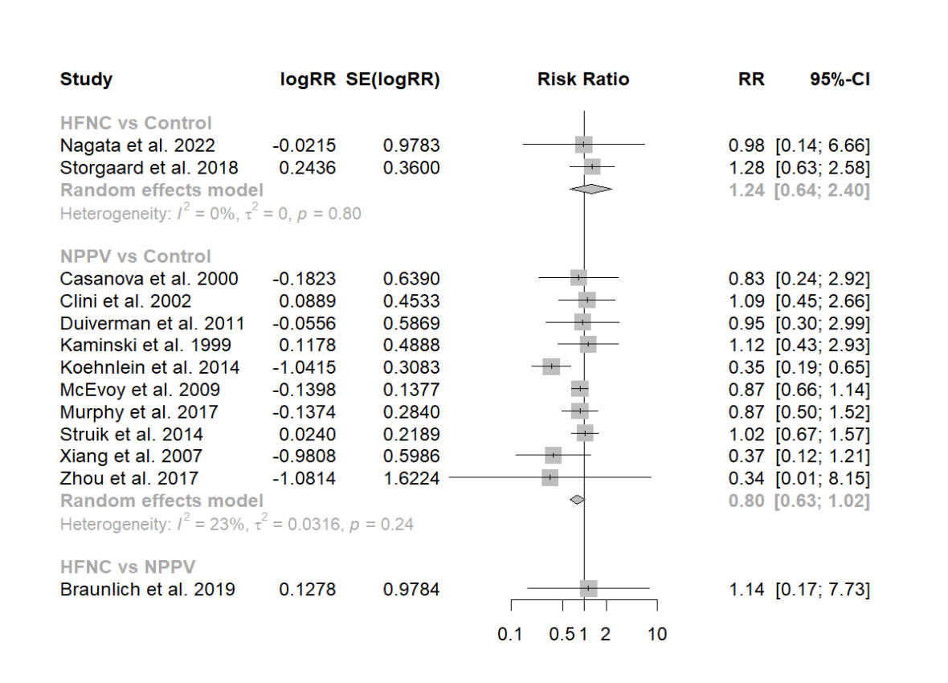

eFigure 2. Mortality/Node split analysis
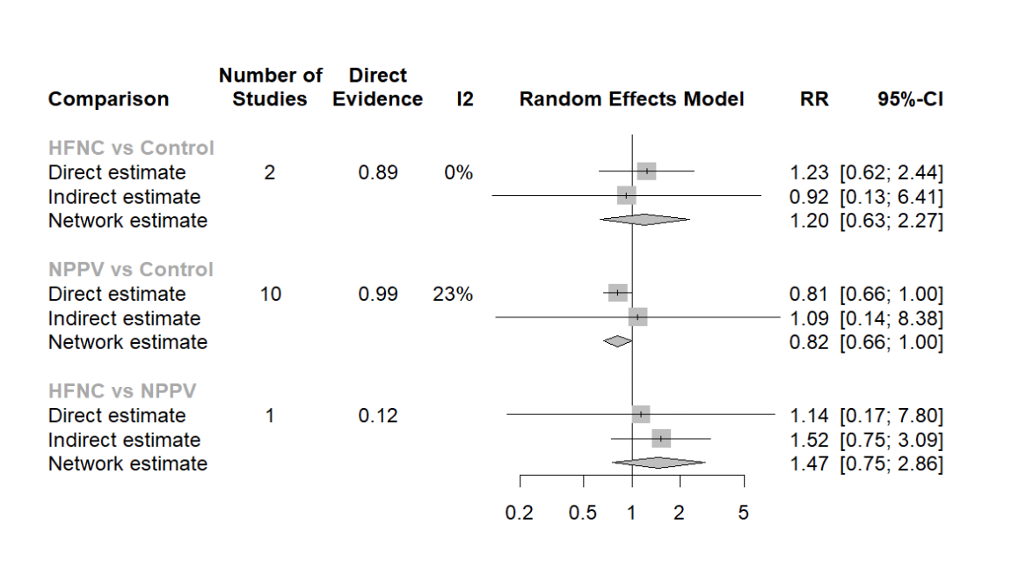

eFigure 3. Mortality/Network estimates
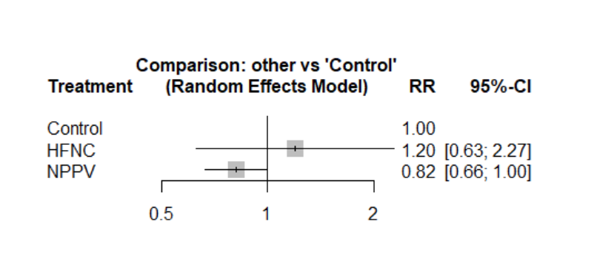

eFigure 4. Mortality plot/Network funnel plot
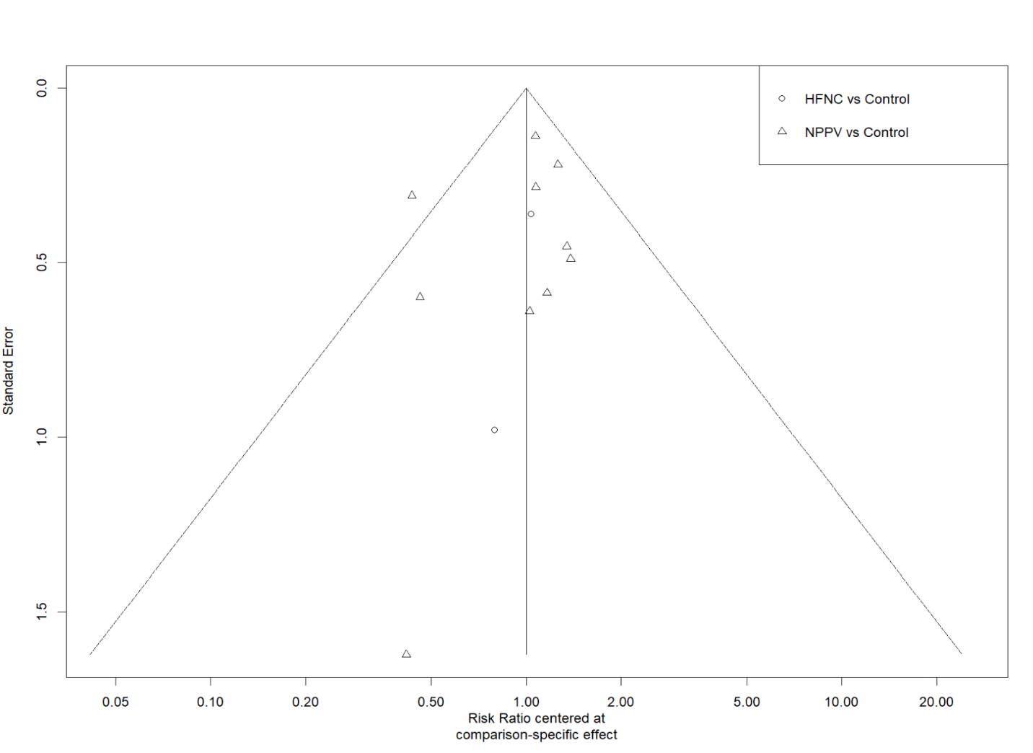

eFigure 5. Acute exacerbation/Pairwise analysis
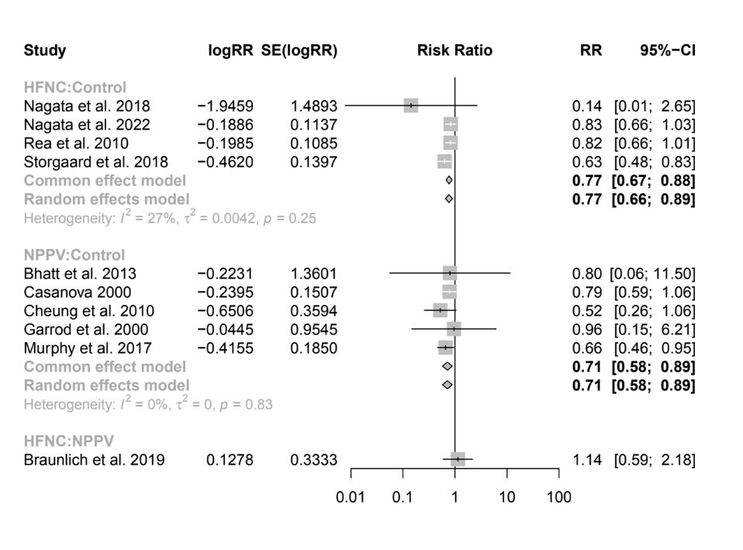

eFigure 6. Acute exacerbation/Node split analysis
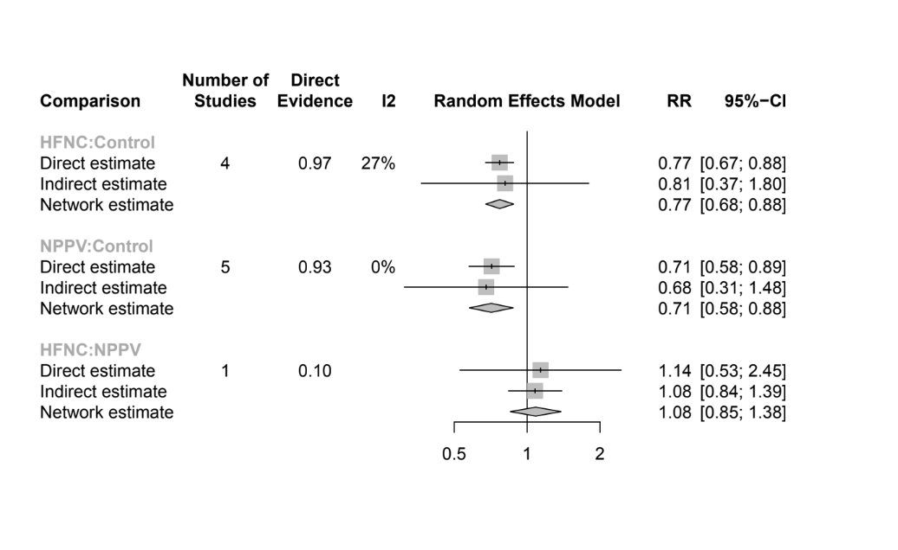

eFigure 7. Acute exacerbation/Network estimates
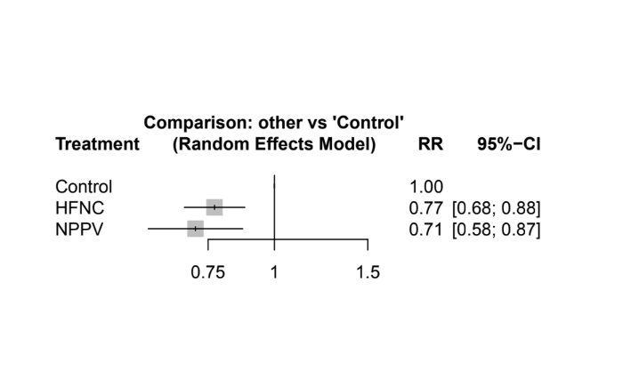

eFigure 8. Acute exacerbation plot/Network funnel plot
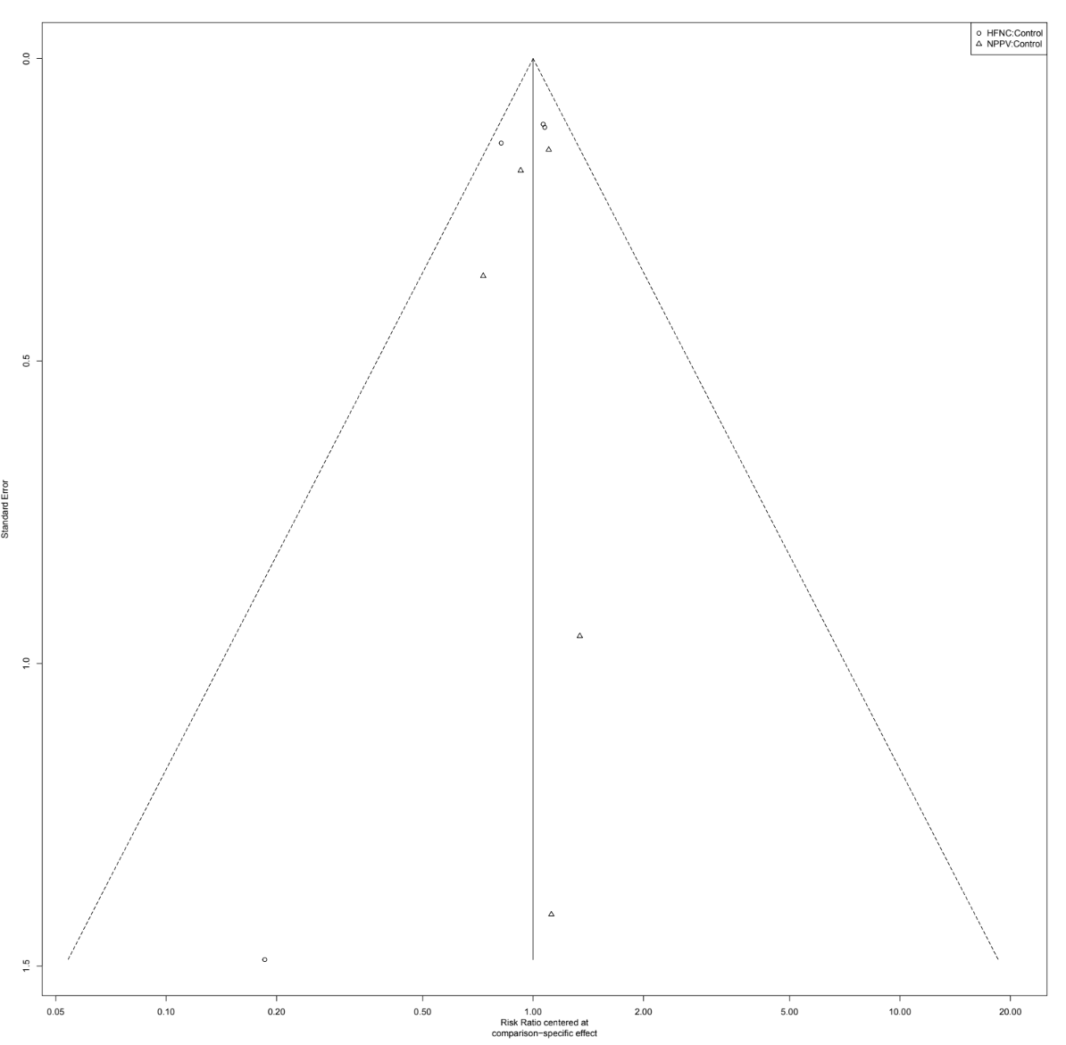

eFigure 9. Hospitalization/Pairwise analysis
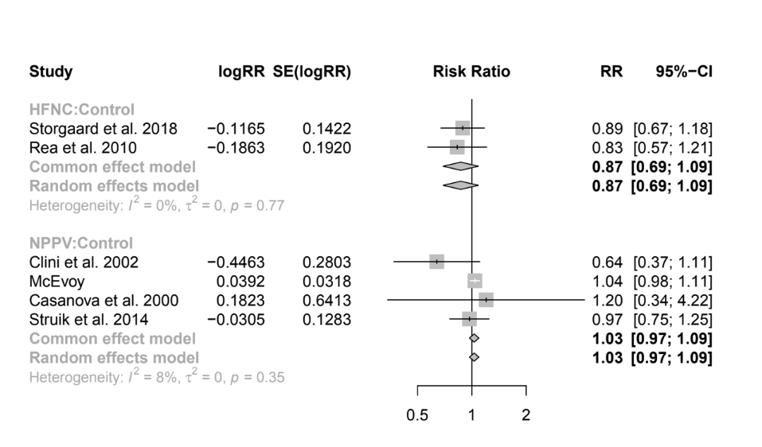

eFigure 10. Hospitalization/Network estimates
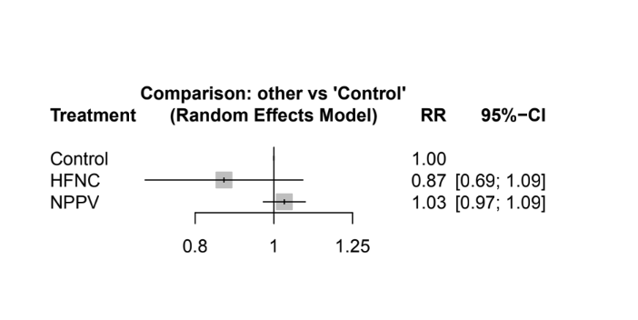

eFigure 11. Hospitalization plot/Network funnel plot

eFigure 12. SGRQ/Pairwise analysis
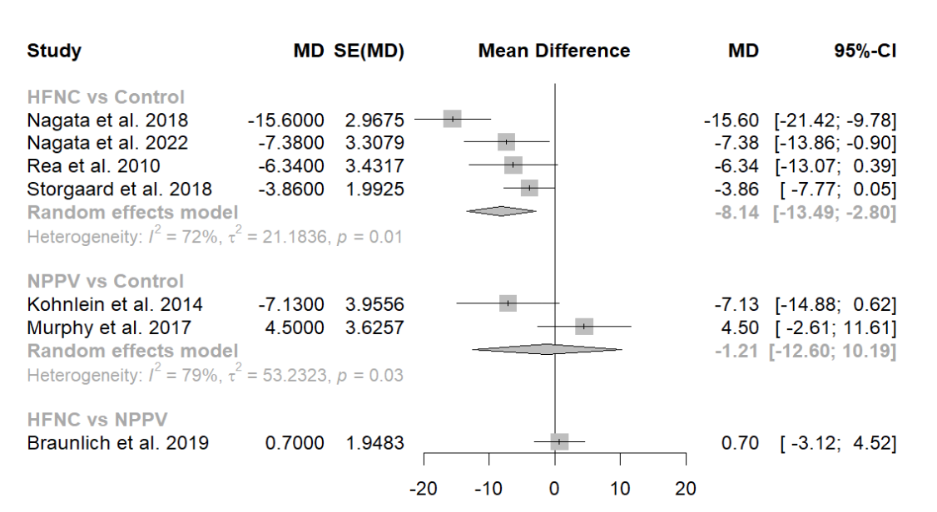

eFigure 13. SGRQ/Node split analysis
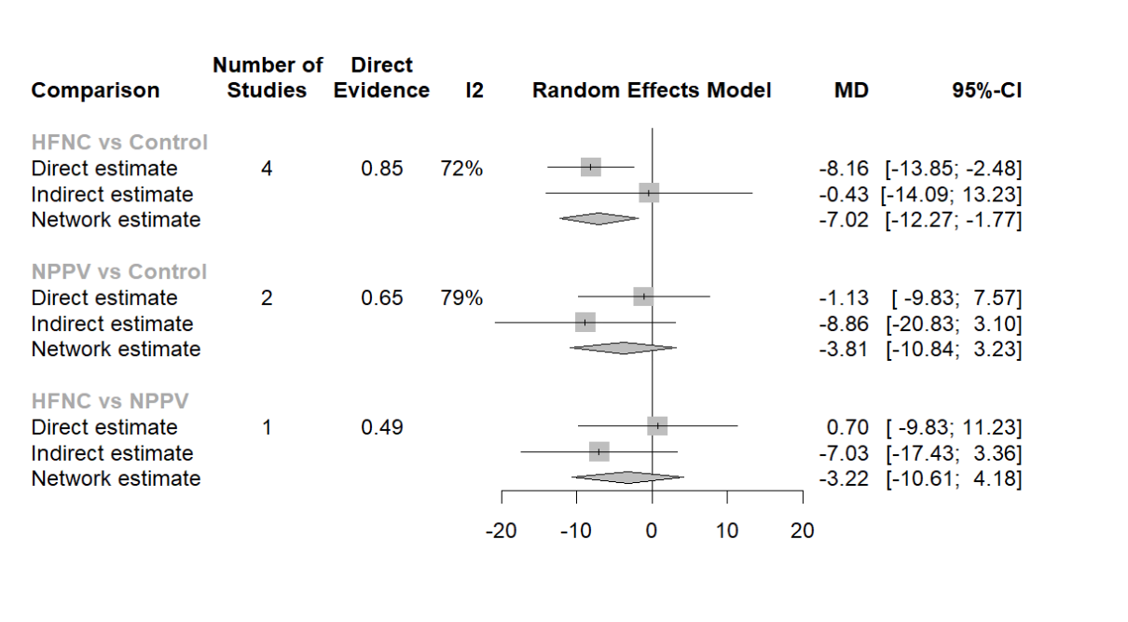

eFigure 14. SGRQ/Network estimates
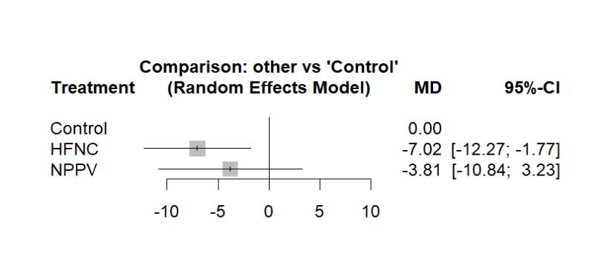

eFigure 14. SGRQ plot/Network funnel plot
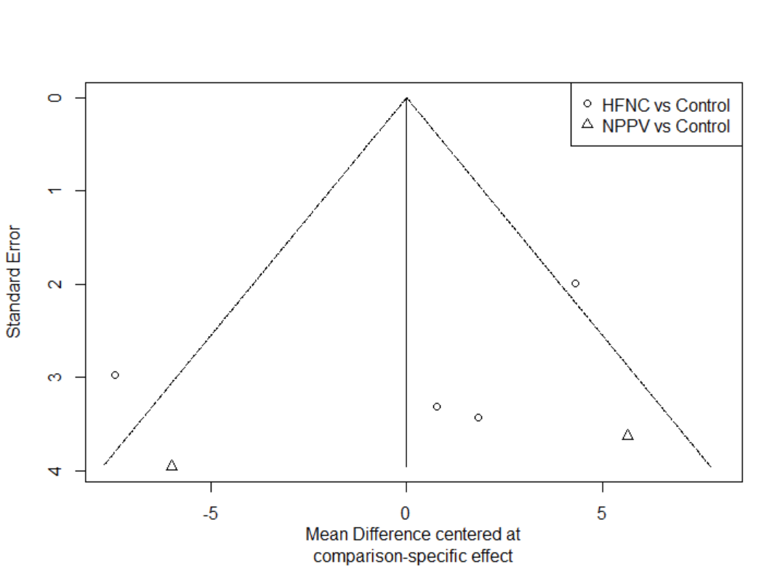

eFigure 15. NPPV - Mortality/stability
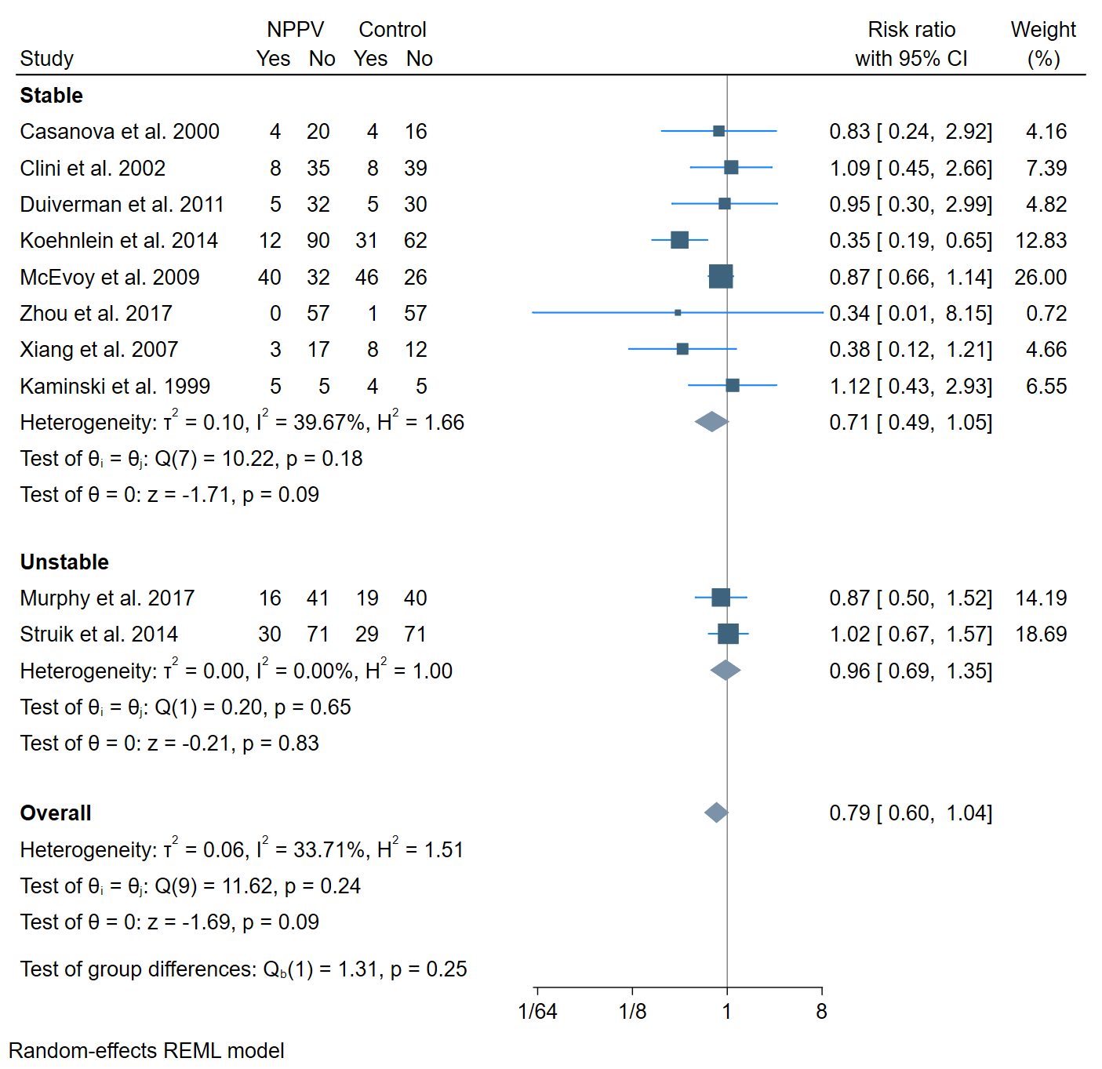

eFigure 16. NPPV - Mortality/PaCO2
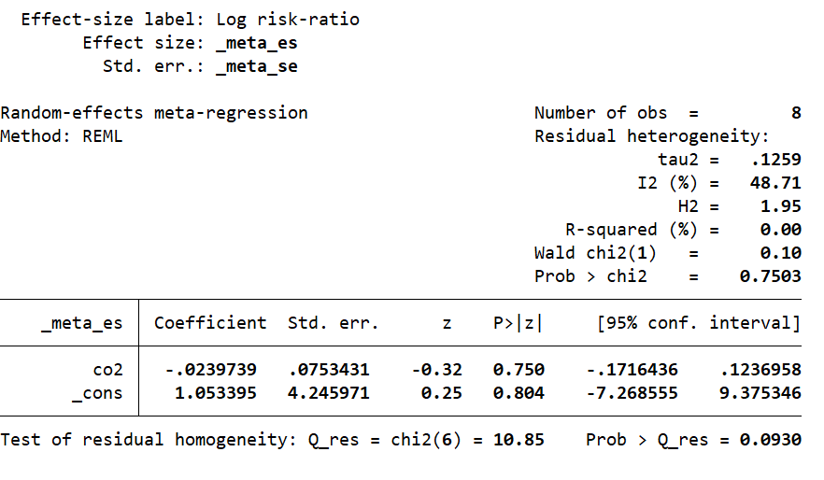
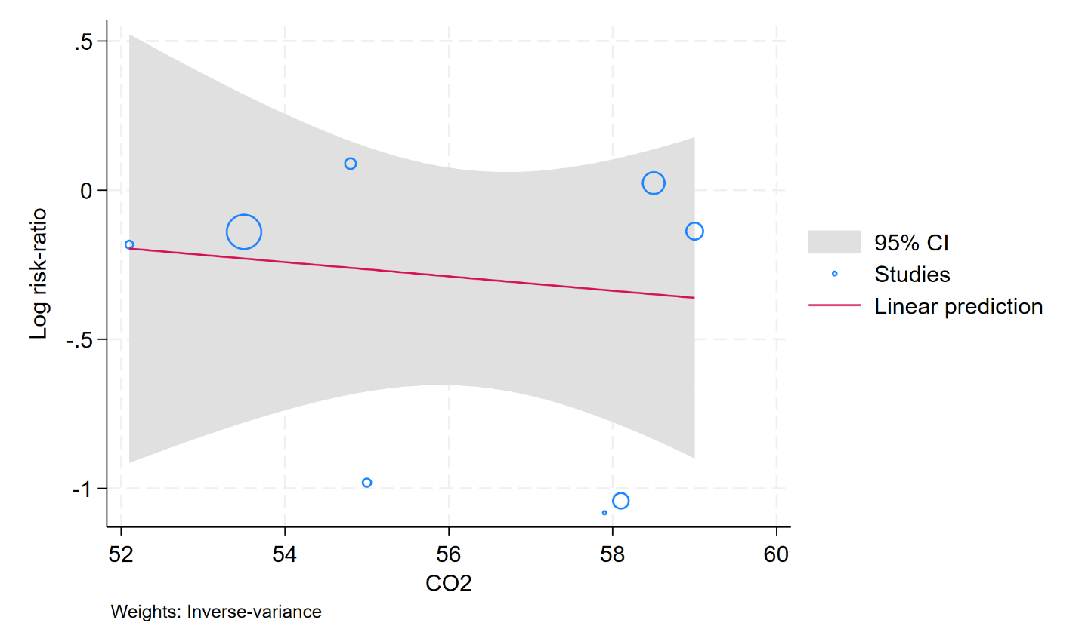

eFigure 17. NPPV - Mortality/FEV1
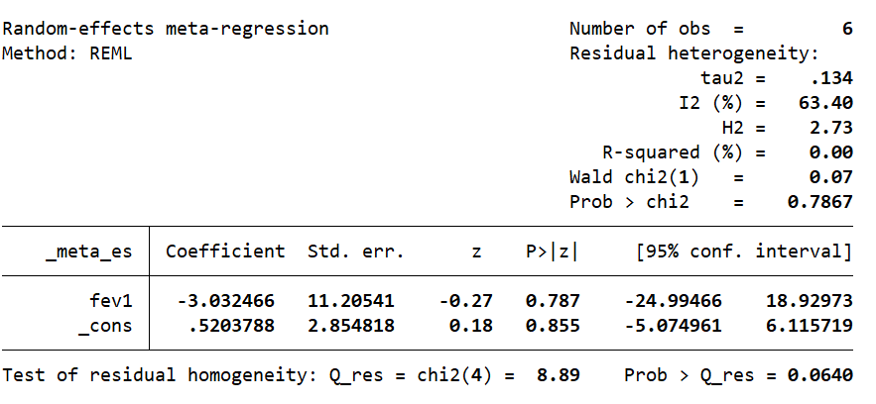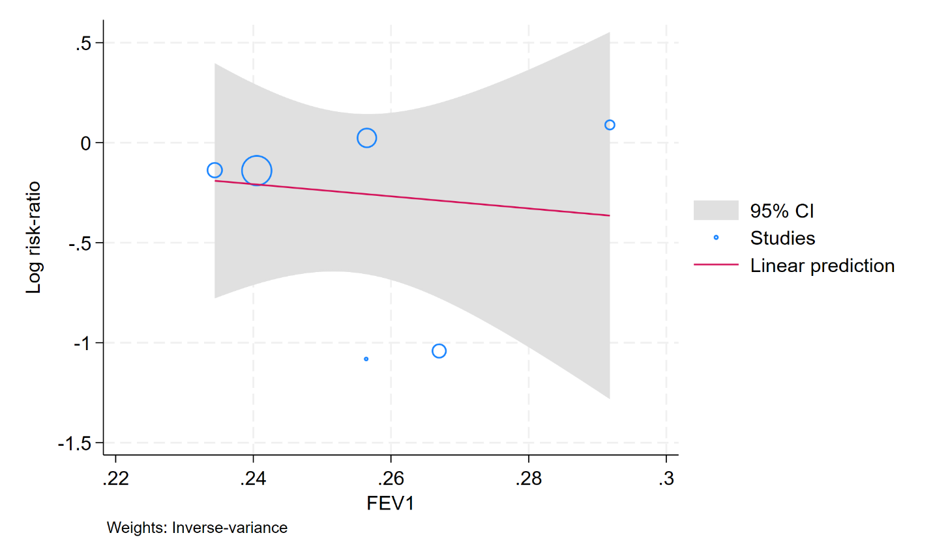

eFigure 18. NPPV- Mortality/Study year
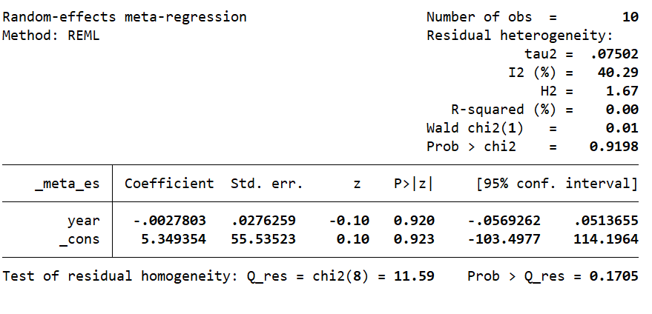
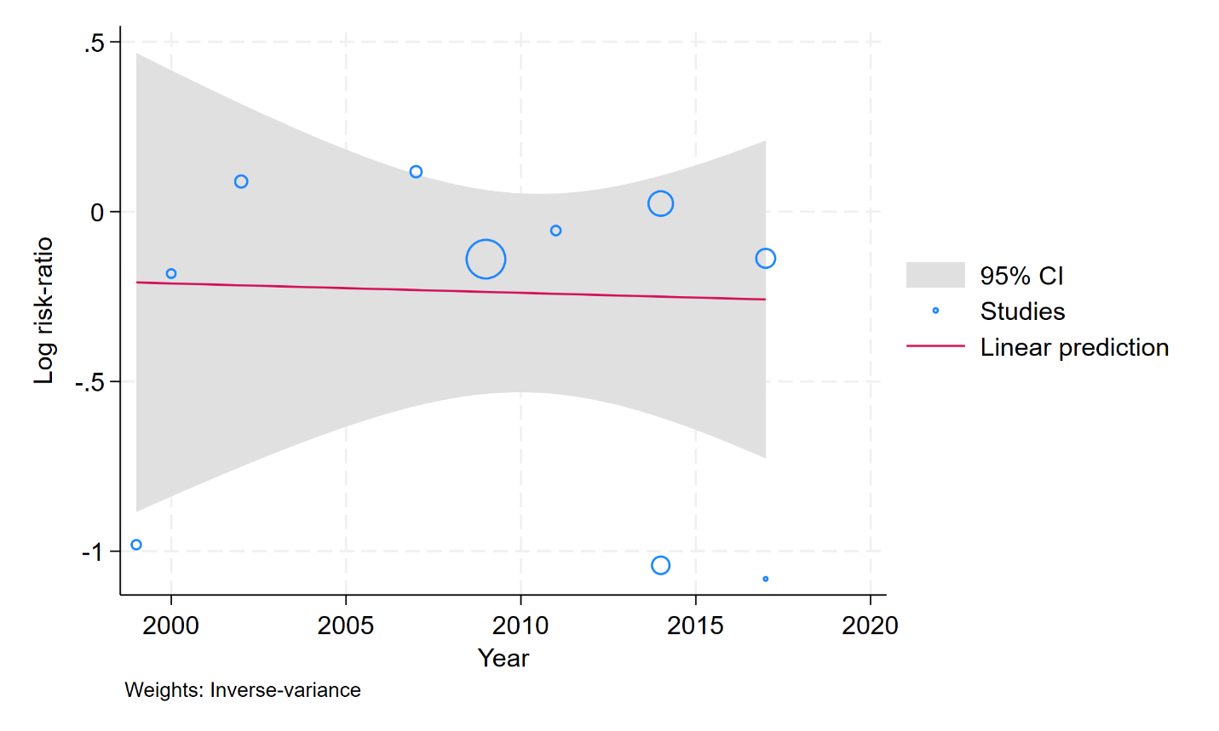

eFigure 19. NPPV - Mortality/Risk of bias
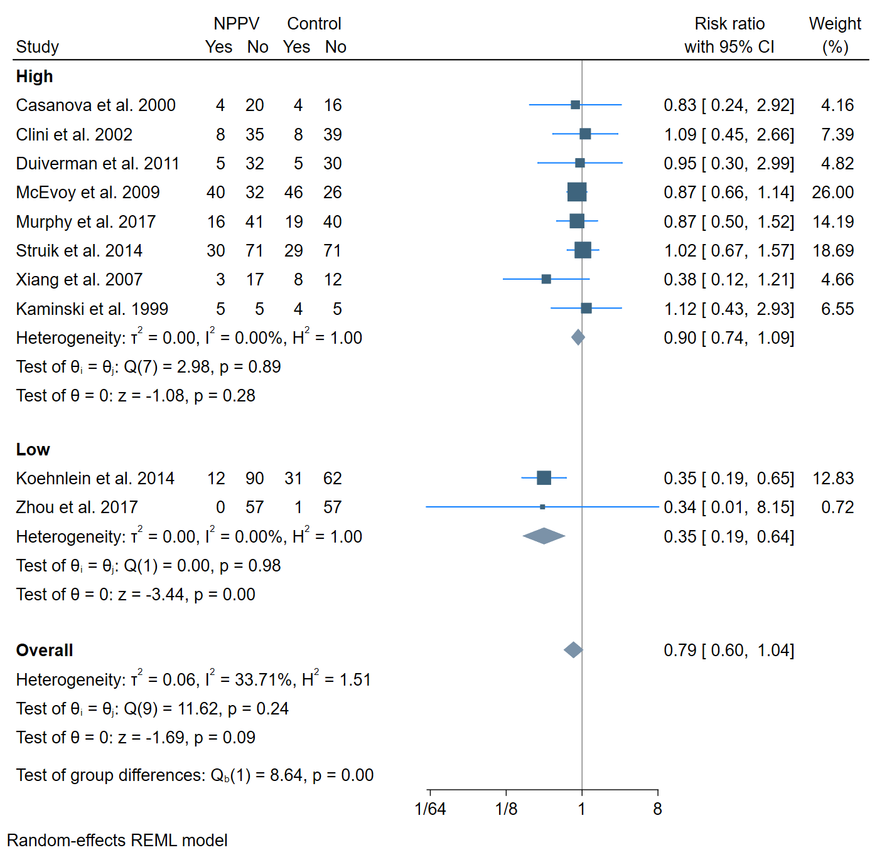

eFigure 20. HFNC – Mortality/FEV1
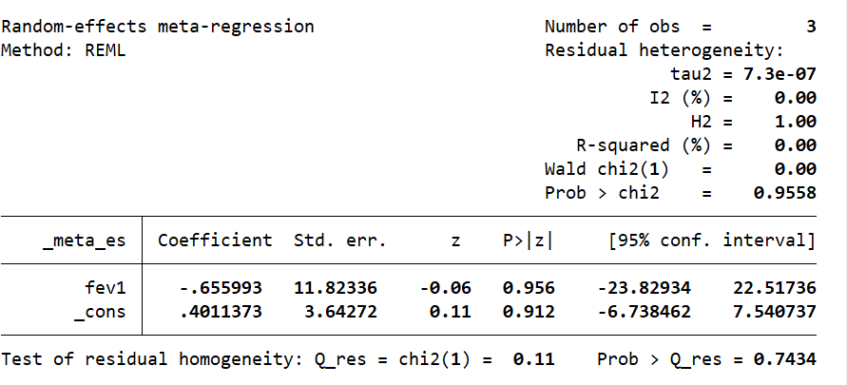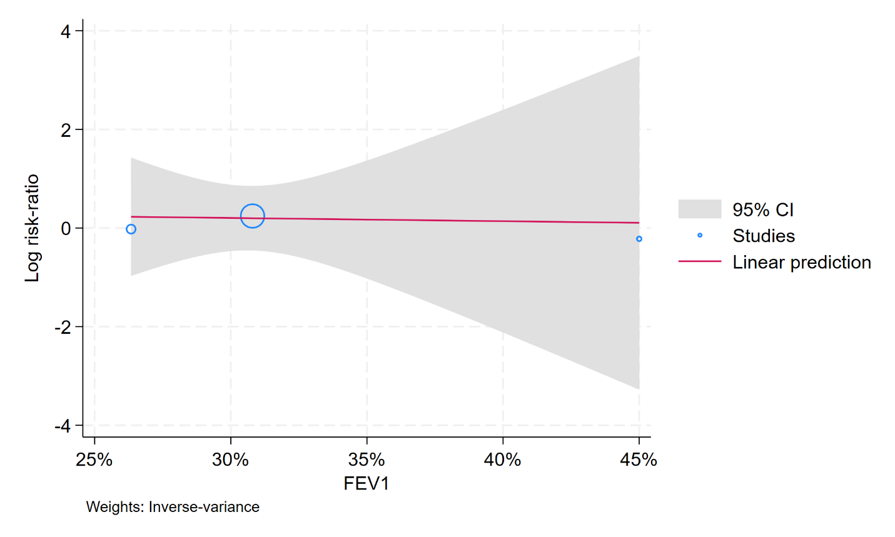

eFigure 21. HFNC – Mortality/PaCO2
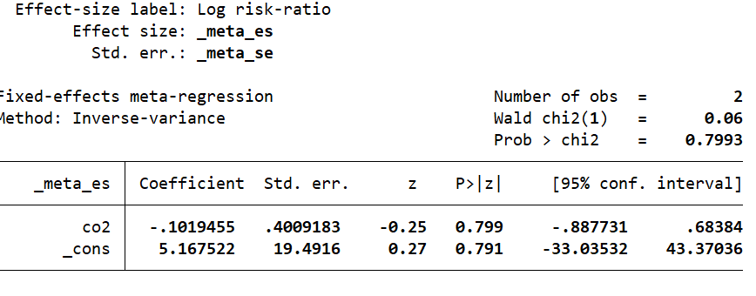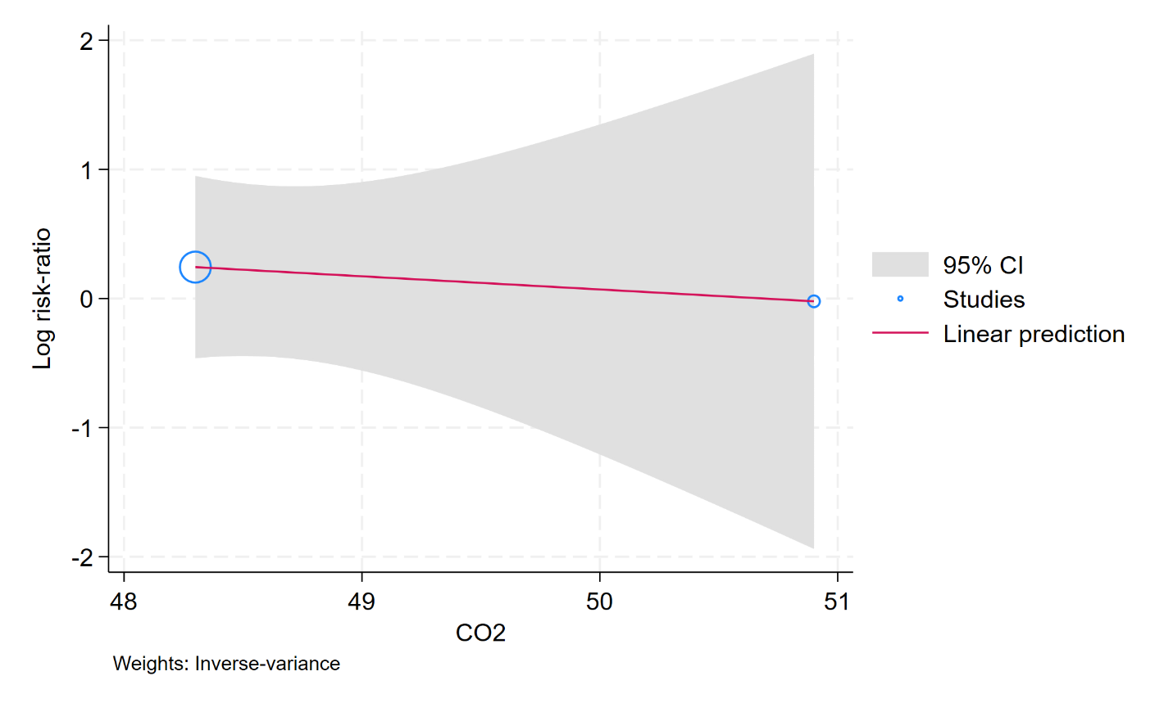

eFigure 22. HFNC – Mortality/FEV1

eFigure 23. HFNC – Mortality/ROB
