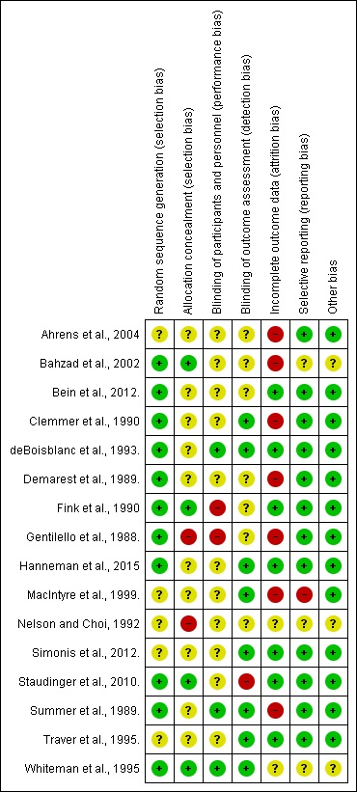

**Supplement 3.** Summary of risk of bias of randomized controlled trials (RCT)