Impact of the airway humidification strategy in mechanically ventilated COVID-19 patient. Retrospective analysis and literature review.

Carole-Anne Lavoie-Bérard¹, M.D., Jean-Claude Lefebvre², M.D., Pierre-Alexandre Bouchard³ Inh., Mathieu Simon³, M.D., and François Lellouche ^{2, 3}, M.D., Ph.D.

¹ Université Laval, département de médecine
² Département d’anesthésiologie et de soins intensifs, division de soins intensifs, Université Laval
³ Centre de recherche de l’Institut universitaire de cardiologie et de pneumologie de Québec, Université Laval

Supplementary material

Detailed Method

We conducted a retrospective observational study including all intubated patients in the two designated COVID-19 centers for adults in Quebec City between March 23rd and June 6th. We obtained a waiver of consent from both institutions (Institut Universitaire de Cardiologie et de Pneumologie de Québec and Centre Hospitalier Universitaire de Québec) given the retrospective analysis of the data, the absence of intervention and the usual utilization of the evaluated devices.
In one center, HH (MR 850, Fisher&Paykel, Auckland, New Zealand) were used to reduce instrumental dead space. In the other center, HME (Hygrobac S, Medtronic, Minneapolis, MN, USA) was the first line humidification strategy for its filtering characteristics.
In both centres, an electrostatic filter was placed at the expiratory port of the ventilator. In the “HH” center, we used a heated wire circuit RT380 (Evaqua2) that allows a prolonged utilization of HEPA filters placed at the expiratory port of the ventilator. As previously shown in Tonnelier et al study, with these “porous” circuits, the humidity decreases along the expiratory circuit, which may reduce the expiratory resistances¹. In our experience with COVID-19 patients, with this setting, the expiratory filters were let in place during 4-5 days.
We collected informations about demographics data, set and measured respiratory parameters, total dead space, and arterial blood gases after intubation and after initial modifications of the ventilator settings. We also collected needs for humidification system changes and clinical outcomes, including endotracheal tube occlusions and sub-occlusions. Total dead space was calculated by the addition of endotracheal tube volume (related to the diameter), HME volume (45ml, when present), connectors (CO₂ sensor: 5 ml; closed suction system: 9 ml), and estimated physiologic dead space (~1.1ml/kg PBW)².

Bench study:
We conducted a bench study with the objective to determine the relation between the heater plate temperature and the absolute humidity delivered by the heated wire HH used in our institution. Different ambient temperatures were studied, as well as different minute ventilations. We varied the inlet temperature of the gas at the humidification chamber to modify the heater plate temperature (the objective of the HH being to reach 37°C at the outlet chamber). After steady state, we concomitantly recorded the heater plate temperature of the HH (as described below) and measured the inspiratory absolute humidity with the psychrometric method as previously described ³. We conducted this bench study before the pandemic and used these results to implement the monitoring of the HH.
Based on these data, we implemented several measures to prevent under-humidification related to HH dysfunction:
- activation of the compensation algorithm by the respiratory therapists on HH devices ³ or increase of the humidification chamber temperature when under-humidification was suspected or when heater plate temperature was below 62°C (Video E1, supplementary material, Figure E1 electronic supplement),
- monitoring of the heater plate temperature by the respiratory therapists. This monitoring became part of the regular checks of the respiratory therapists of the ICU. The recommendation was to adjust humidifiers settings when heater plate temperature was below 62°C (Video E2, supplementary material) and
- installation of a new air conditioning system compatible with the negative pressure rooms.

Video E1: This video shows how to activate the humidity compensation algorithm on heated wire heated humidifier devices used in the study https://www.youtube.com/watch?v=kK0ikf8PjlE&feature=youtu.be

Video E2: This video shows the monitoring of the heater plate temperature. This temperature is closely related to the humidity delivered by this heated wire heated humidifiers
https://www.youtube.com/watch?v=z2xQuv69N1s&t=10s

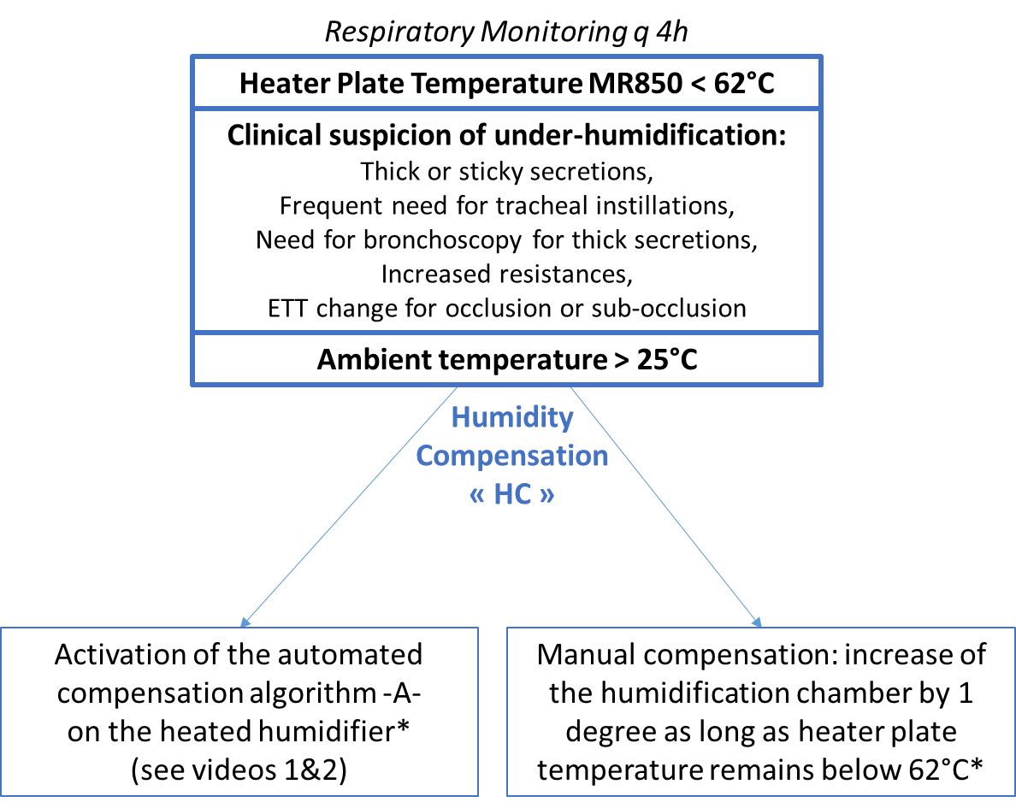

Figure E1: algorithm to prevent under-humidification in invasively mechanical patients when heated humidification is used.
When heated wire humidifiers are used, in situations with high ambient temperature (>25°C), the risk of under-humidification exists. In the case of low heater plate temperature (below 62°C), or in the case of clinical suspicion of under-humidification, humidification compensation should be activated. Automated HC algorithm or manual compensation (by increasing the humidification chamber temperature) may be used.
*Excessive condensate may form in the breathing circuit if the automated or manual humidity compensation functions are enabled, especially in the case of reduced ambient temperature or sudden change in minute ventilation. It is recommended to disable the compensation settings (set HC = ‘0.0’) in these situations if the condensate becomes excessive.

Abbreviations: ETT: endotracheal tube, HC: humidity compensation

REFERENCES

1. Tonnelier A, Lellouche F, Bouchard PA, L'Her E. Impact of humidification and nebulization during expiratory limb protection: an experimental bench study. Respiratory care 2013;58(8):1315-1322.
2. Lellouche F, Delorme M, Brochard L. Impact of Respiratory Rate and Dead Space in the Current Era of Lung Protective Mechanical Ventilation. Chest 2020;158(1):45-47.
3. Lellouche L, Taillé S, Maggiore SM, Qader S, L'Her E, Deye N, et al. Influence of ambient air and ventilator output temperature on performances of heated-wire humidifiers. Am J Respir Crit Care Med 2004;170:1073-1079.

