SUPPLEMENTARY APPENDIX

Effect of Prone Positioning on Clinical Outcomes of Non-Intubated Subjects with COVID-19: A Comparative Systematic Review and Meta-Analysis

Azizullah Beran; MD, Mohammed Mhanna; MD, Omar Srour; MD, Hazem, Ayesh; MD, Omar Sajdeya; MD, Sami Ghazaleh; MD, Asmaa S. Mhanna; MD, Dana Ghazaleh; MD, Waleed Khokher; MD, Aadil Maqsood; MD, Ragheb Assaly; MD

Supplementary tables

Title | Page
Supplementary table 1: Search strategy used in each database searched. | 2
Supplementary table 2: Quality assessment of the included studies. | 3-4

Supplementary figures

Title | Page
Supplementary figure 1: Sensitivity analysis for the need for endotracheal intubation. | 5
Supplementary figure 2: Sensitivity analysis for the mortality. | 6

Supplementary table 1: Search strategy used in each database searched.

Database | Search Strategy | Articles retrieved
MEDLINE/PUBMED | ("prone position"[MeSH Terms] OR ("prone"[All Fields] AND "position"[All Fields]) OR "prone position"[All Fields]) AND ("covid 19"[All Fields] OR "covid 19"[MeSH Terms] OR "covid 19 vaccines"[All Fields] OR "covid 19 vaccines"[MeSH Terms] OR "covid 19 serotherapy"[All Fields] OR "covid 19 serotherapy"[Supplementary Concept] OR "covid 19 nucleic acid testing"[All Fields] OR "covid 19 nucleic acid testing"[MeSH Terms] OR "covid 19 serological testing"[All Fields] OR "covid 19 serological testing"[MeSH Terms] OR "covid 19 testing"[All Fields] OR "covid 19 testing"[MeSH Terms] OR "sars cov 2"[All Fields] OR "sars cov 2"[MeSH Terms] OR "severe acute respiratory syndrome coronavirus 2"[All Fields] OR "ncov"[All Fields] OR "2019 ncov"[All Fields] OR (("coronavirus"[MeSH Terms] OR "coronavirus"[All Fields] OR "cov"[All Fields]) AND 2019/11/01:3000/12/31[Date - Publication])) | 341
Embase | ('prone position'/exp OR 'prone position' OR (prone AND ('position'/exp OR position))) AND ('covid 19'/exp OR 'covid 19') | 636
Cochrane | (prone position):ti,ab,kw AND (covid-19):ti,ab,kw | 71

Supplementary table 2: Quality assessment of the included studies.

Cohort studies | Selection |  |  |  | Comparability | Outcome |  |  |  | Quality score
 | Representativeness of the exposed cohort | Selection of non-exposed cohort | Ascertainment of exposure | Demonstration that outcome of interest was not present at start of study | Comparability of the cohorts on the basis of design or analysis | Assessment of outcome | Was follow up long enough for outcomes to occur |  | Adequacy of follow up cohorts
Ferrando, 2020 | 1 | 1 | 1 | 1 | 1 | 1 | 1 |  | 1 | 8
Jagan, 2020 | 1 | 1 | 1 | 1 | 1 | 1 | 0 |  | 1 | 6
Jouffroy, 2021 | 1 | 1 | 1 | 1 | 0 | 1 | 1 |  | 1 | 7
Ni, 2020 | 1 | 1 | 1 | 1 | 1 | 1 | 0 |  | 1 | 7
Padrao, 2020 | 1 | 1 | 1 | 1 | 1 | 1 | 0 |  | 0 | 6
Perez-Nieto, 2021 | 1 | 1 | 1 | 1 | 1 | 1 | 0 |  | 0 | 6
Prud’homme, 2021 | 1 | 1 | 1 | 1 | 1 | 1 | 0 |  | 1 | 7
Tonelli, 2021 | 1 | 1 | 1 | 1 | 1 | 1 | 1 |  | 1 | 8
Zang, 2020 | 1 | 1 | 1 | 1 | 1 | 1 | 1 |  | 0 | 7
Randomized controlled studies | Randomization |  |  |  | Blinding |  |  | Withdrawals |  | Quality score
 | Was the study described as randomized? |  | Was the randomization appropriate? |  | Was the study described as double blind? | Was the double blinding appropriate? |  | Was there a description of withdrawals and dropouts?
Ehrmann, 2021 | 1 |  | 1 |  | 0 | 0 |  | 1 |  | 3
Jayakumar, 2021 | 1 |  | 1 |  | 0 | 0 |  | 1 |  | 3
Johnson, 2021 | 1 |  | 1 |  | 0 | 0 |  | 1 |  | 3
Rosen, 2021 | 1 |  | 1 |  | 0 | 0 |  | 1 |  | 3
Taylor, 2020 | 1 |  | 1 |  | 1 | 1 |  | 1 |  | 5

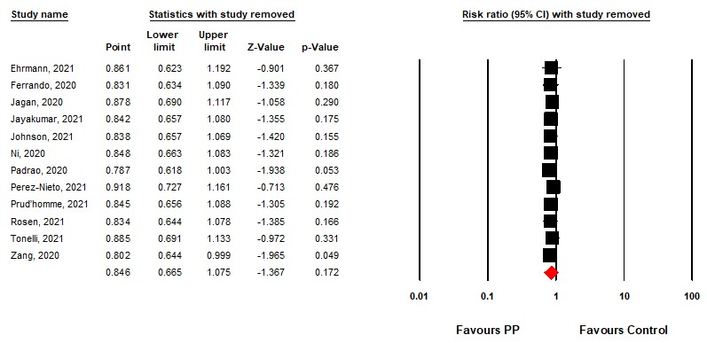
Supplementary figure 1: Sensitivity analysis for the need for endotracheal intubation.

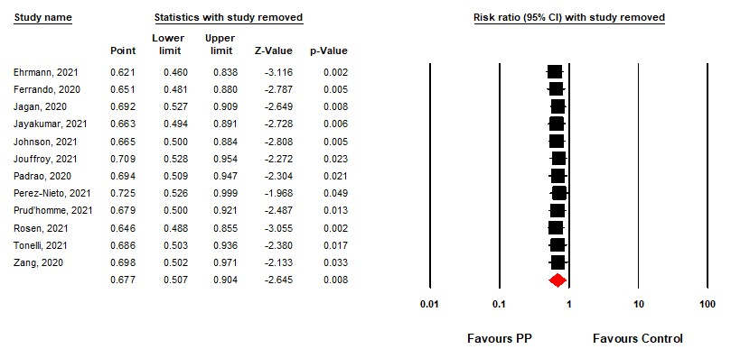
Supplementary figure 2: Sensitivity analysis for in-hospital mortality.

