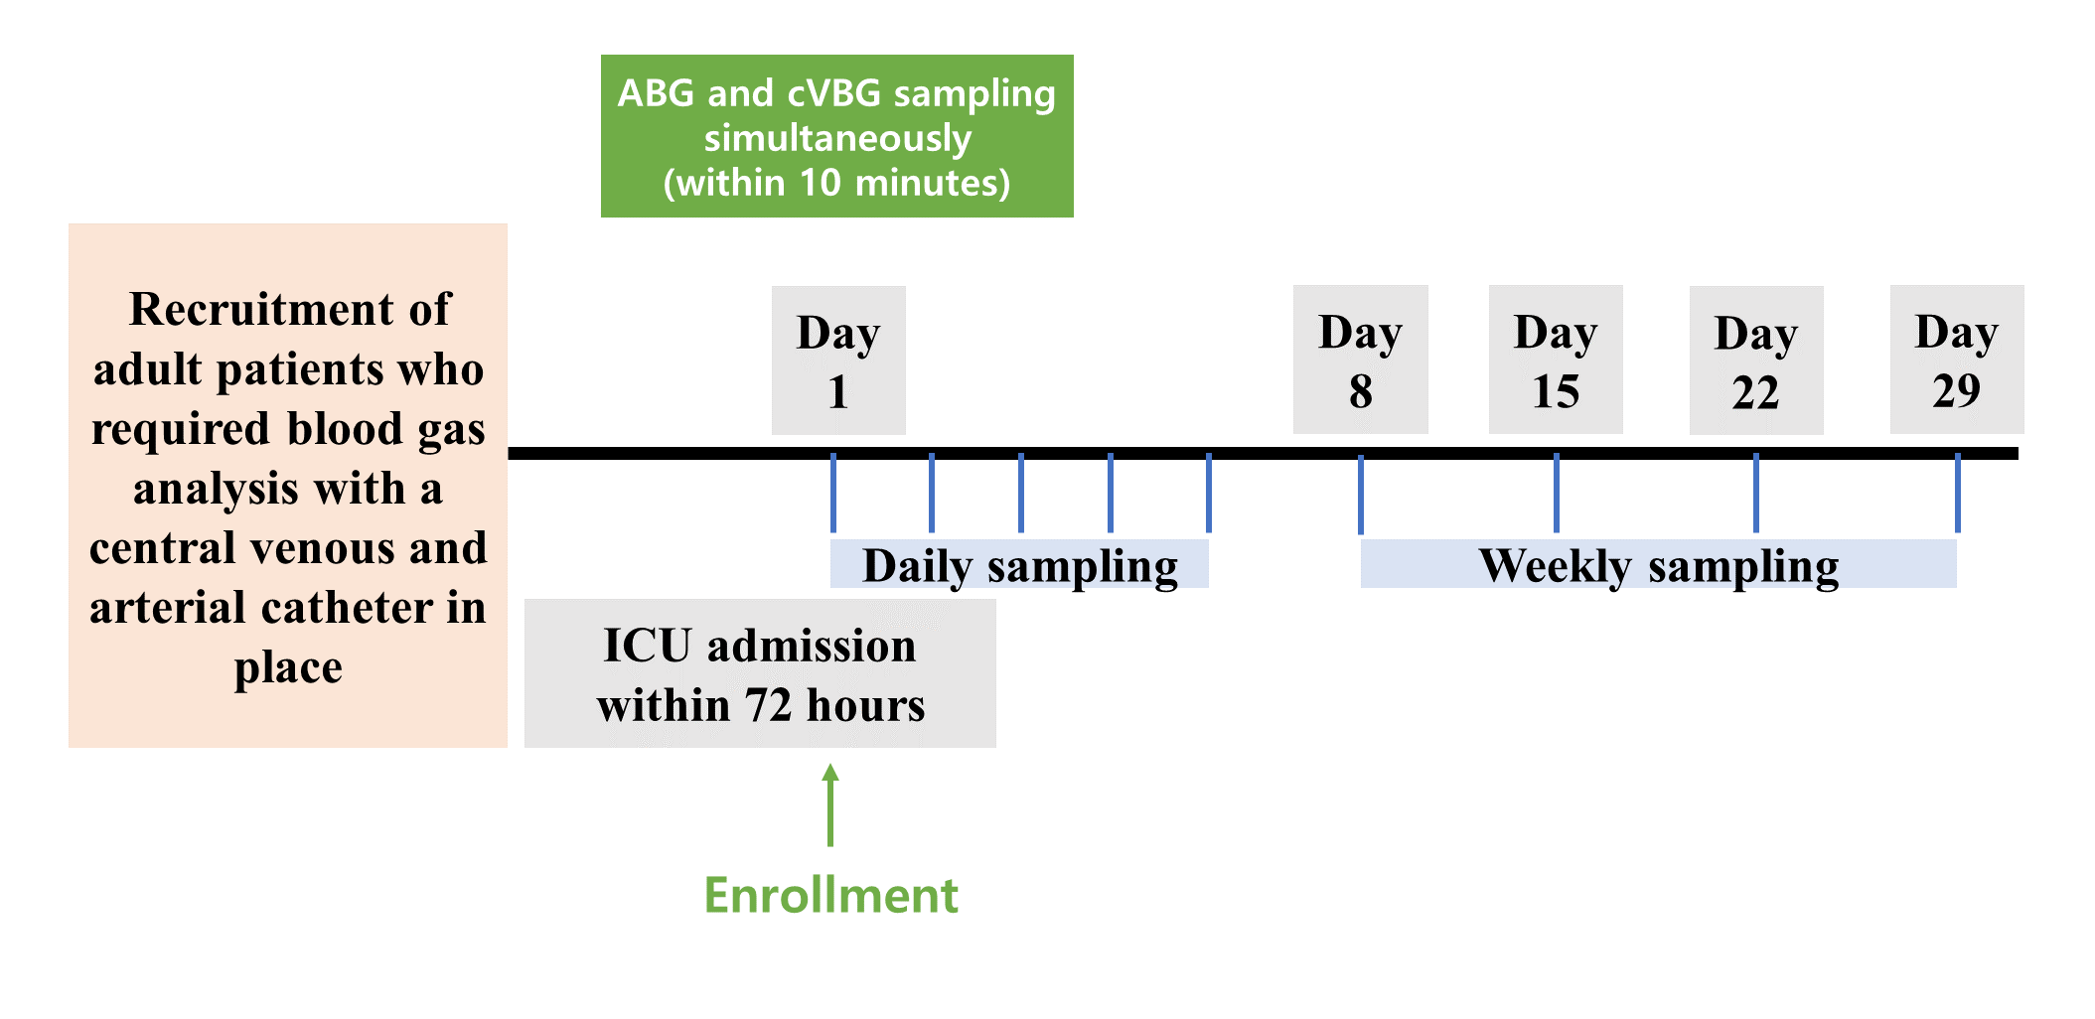 Fig. S1. Schematic of the study protocol. ICU, intensive care unit; ABG, arterial blood gas; cVBG, central venous blood gas.

Table S1. Arterial and central venous blood gas values.
Parameter | ABG  (Mean ± SD) | cVBG  (Mean ± SD) | A-V difference  (Mean ± SD) | 95% LOA
All samples (n = 292)
pH | 7.44 ± 0.07 | 7.40 ± 0.07 | 0.05 ± 0.05 | −0.05 to 0.15
pCO₂ (mmHg) | 37.03 ± 8.28 | 42.68 ± 8.79 | −5.56 ± 4.97 | −15.30 to 4.19
Base excess (mmEq/L) | 0.97 ± 4.53 | 0.60 ± 4.99 | 0.37 ± 2.41 | −4.36 to 5.10
HCO₃ (mmEq/L) | 25.46 ± 3.93 | 24.56 ± 4.23 | 0.91 ± 1.94 | −2.90 to 4.71
Lactic acid (mmol/L)* | 2.35 ± 2.34 | 2.07 ± 1.92 | −0.02 ± 0.34 | −0.69 to 0.66
*The numbers of lactic acid samples in ABG, VBG, and A-V difference were 165, 215, and 139, respectively.
ABG, arterial blood gas; A-V = arterial blood gas to venous blood gas; LOA, limits of agreements; cVBG, central venous blood gas; SD, standard deviation

Table S2. Baseline characteristics between subjects with ΔpCO₂ > 6 and ΔpCO₂ ≤ 6.
Characteristics | ΔpCO₂ > 6 (n = 133) | ΔpCO₂ ≤ 6 (n = 159)
Age, median (IQR) | 68.0 (60.0–78.0) | 65.0 (59.0–70.0)
Sex, n (%)
Male | 96 (72.2) | 132 (83.0)
Female | 37 (27.8) | 27 (17.0)
Primary diagnosis, n (%)
Infection | 93 (69.9) | 125 (78.6)
Hemorrhagic hypovolemia | 2 (1.5) | 1 (0.6)
Cardiac abnormality | 9 (6.8) | 6 (3.8)
Respiratory abnormality | 17 (12.8) | 15 (9.4)
Other* | 12 (9.0) | 12 (7.5)
Preexisting condition, n (%)
Heart failure | 12 (9.0) | 15 (9.4)
Liver cirrhosis | 11 (8.3) | 18 (11.3)
Chronic renal failure | 15 (11.3) | 14 (8.8)
Time interval between ABG and VBG, minutes (IQR) | 3.0 (1.0–5.0) | 3.0 (1.0–5.0)
Shock (mean arterial pressure < 65 mmHg), n (%) | 10 (7.5) | 8 (5.0)
Organ support at the time of blood sampling, n (%)
Mechanical ventilation** | 90 (67.7) | 124 (78.0)
Renal replacement therapy | 32 (24.1) | 43 (27.0)
Vasopressor requirement | 52 (39.1) | 55 (34.6)
*Others included pancreatitis, hepatic failure, acute kidney injury, thrombotic thrombocytopenic purpura, and hyperosmolar hyperglycemic state
**P = 0.047
ΔpCO₂, difference of arterial pCO₂ and venous pCO₂; ABG, arterial blood gas; IQR, interquartile range; VBG, venous blood gas

Table S3. Intraclass correlations for pCO₂ in the arterial and central venous blood samples of subjects who contributed more than two samples.
Patient | No. of samples | ICC | 95% CI |  | P-value
1 | 4 | 0.451 | −1.327 to 0.957 | 0.263
4 | 3 | 0.673 | −2.077 to 0.991 | 0.210
5 | 4 | 0.349 | −0.079 to 0.909 | 0.065
6 | 4 | 0.639 | −0.089 to 0.969 | 0.019
8 | 4 | 0.511 | −0.125 to 0.950 | 0.056
10 | 5 | 0.535 | −0.095 to 0.932 | 0.017
11 | 5 | 0.594 | −0.047 to 0.946 | 0.003
12 | 8 | 0.073 | −0.133 to 0.514 | 0.314
13 | 7 | 0.610 | −0.052 to 0.916 | 0.028
15 | 2 | −0.211 | −0.236 to -0.232 | 0.818
16 | 3 | 0.198 | −0.166 to 0.941 | 0.286
17 | 4 | 0.566 | −0.146 to 0.959 | 0.056
18 | 5 | −0.120 | −0.377 to 0.612 | 0.676
20 | 3 | 0.360 | −0.128 to 0.964 | 0.159
21 | 5 | 0.319 | −0.043 to 0.853 | 0.018
22 | 5 | 0.236 | −0.133 to 0.815 | 0.152
25 | 3 | −0.460 | Not measurable | 0.984
26 | 3 | 0.115 | −0.348 to 0.940 | 0.406
27 | 2 | 0.307 | 0.000 to 0.997 | 0.020
28 | 3 | 0.424 | −0.129 to 0.971 | 0.133
29 | 7 | 0.663 | −0.104 to 0.938 | 0.003
30 | 4 | 0.499 | −0.079 to 0.947 | 0.032
32 | 4 | 0.604 | −0.123 to 0.964 | 0.037
33 | 6 | 0.791 | 0.190 to 0.967 | 0.016
34 | 3 | 0.124 | −0.159 to 0.920 | 0.343
35 | 2 | 0.102 | −0.005 to 0.988 | 0.135
36 | 5 | 0.504 | −0.137 to 0.924 | 0.041
37 | 4 | 0.308 | −0.050 to 0.891 | 0.048
38 | 3 | 0.672 | −0.125 to 0.988 | 0.061
39 | 5 | 0.072 | −0.207 to 0.714 | 0.384
40 | 2 | 0.347 | −0.094 to 0.998 | 0.235
42 | 6 | 0.442 | −0.184 to 0.883 | 0.089
43 | 4 | 0.068 | −0.157 to 0.769 | 0.382
44 | 6 | 0.669 | −0.110 to 0.947 | 0.008
45 | 7 | 0.417 | −0.089 to 0.856 | 0.010
46 | 3 | 0.663 | −0.072 to 0.988 | 0.037
47 | 5 | 0.133 | −0.562 to 0.836 | 0.388
48 | 5 | 0.660 | −0.014 to 0.959 | < 0.001
49 | 8 | 0.865 | −0.038 to 0.979 | < 0.001
50 | 7 | 0.549 | −0.127 to 0.903 | 0.015
51 | 4 | 0.670 | −0.108 to 0.972 | 0.022
52 | 6 | 0.482 | −0.283 to 0.902 | 0.122
53 | 2 | 0.696 | −0.244 to 0.999 | 0.191
55 | 2 | 0.855 | −0.049 to 1.000 | 0.068
56 | 3 | 0.211 | −0.088 to 0.933 | 0.203
57 | 5 | 0.265 | −0.112 to 0.829 | 0.106
58 | 3 | 0.148 | −0.243 to 0.938 | 0.359
59 | 2 | −0.043 | −0.046 to -0.046 | 0.825
60 | 2 | 0.483 | −0.064 to 0.999 | 0.160
63 | 4 | 0.488 | −0.188 to 0.948 | 0.104
64 | 2 | 0.006 | −0.109 to 0.986 | 0.491
65 | 3 | 0.189 | −0.064 to 0.921 | 0.182
66 | 2 | 0.397 | 0.000 to 0.998 | 0.029
67 | 2 | 0.196 | −0.049 to 0.995 | 0.248
68 | 3 | 0.573 | −0.073 to 0.982 | 0.052
69 | 7 | 0.082 | −0.053 to 0.481 | 0.149
70 | 2 | 0.713 | −0.004 to 0.999 | 0.036
71 | 2 | 0.000 | −0.618 to 0.996 | 0.500
72 | 4 | 0.668 | −0.234 to 0.973 | 0.094
73 | 5 | 0.872 | 0.326 to 0.985 | 0.012
74 | 5 | 0.084 | −0.078 to 0.625 | 0.256
75 | 6 | 0.337 | −0.097 to 0.834 | 0.038
76 | 5 | 0.686 | −0.076 to 0.960 | 0.043
77 | 5 | 0.130 | −0.052 to 0.677 | 0.117
79 | 3 | −0.023 | −0.243 to 0.869 | 0.530
80 | 3 | 0.621 | −0.184 to 0.986 | 0.102
81 | 6 | 0.632 | −0.057 to 0.943 | 0.001
82 | 4 | 0.624 | −0.192 to 0.968 | 0.082
ICC, intraclass coefficient; CI, confidence interval

Table S4. Comparison of intraclass correlations for pH, pCO₂, base excess, HCO₃, and lactic acid in arterial and central venous blood samples across other subgroups.
Parameters | Coefficient* | 95% CI | Coefficient* | 95% CI | P-value
Shock | (−) (n = 274) |  | (+) (n = 18)
pH | 0.625 | 0.081 to 0.823 | 0.627 | 0.030 to 0.866 | 0.495
pCO₂ (mmHg) | 0.701 | 0.021 to 0.883 | 0.649 | −0.023 to 0.884 | 0.359
Base excess (mmEq/L) | 0.866 | 0.832 to 0.893 | 0.904 | 0.764 to 0.963 | 0.253
HCO₃ (mmEq/L) | 0.861 | 0.769 to 0.910 | 0.912 | 0.757 to 0.968 | 0.181
Lactic acid (mmol/L)† | 0.989 | 0.985 to 0.992 | 0.982 | 0.791 to 0.999 | 0.402
Vasopressor or shock | (−) (n = 181) |  | (+) (n = 111)
pH | 0.502 | 0.075 to 0.721 | 0.748 | 0.003 to 0.912 | <0.0001
pCO₂ (mmHg) | 0.742 | 0.040 to 0.904 | 0.610 | −0.014 to 0.834 | 0.022
Base excess (mmEq/L) | 0.787 | 0.723 to 0.837 | 0.948 | 0.925 to 0.964 | <0.0001
HCO₃ (mmEq/L) | 0.797 | 0.670 to 0.868 | 0.936 | 0.870 to 0.964 | <0.0001
Lactic acid (mmol/L)† | 0.972 | 0.957 to 0.982 | 0.990 | 0.983 to 0.994 | 0.002
Vasopressor in ventilated subjects | (−) (n = 123) |  | (+) (n = 91)
pH | 0.656 | −0.022 to 0.865 | 0.771 | −0.018 to 0.926 | 0.046
pCO₂ (mmHg) | 0.788 | 0.152 to 0.921 | 0.650 | −0.014 to 0.861 | 0.019
Base excess (mmEq/L) | 0.869 | 0.817 to 0.906 | 0.949 | 0.924 to 0.966 | <0.0001
HCO₃ (mmEq/L) | 0.846 | 0.712 to 0.909 | 0.938 | 0.863 to 0.967 | <0.0001
Lactic acid (mmol/L)† | 0.965 | 0.940 to 0.979 | 0.991 | 0.983 to 0.995 | 0.001
Controlled ventilation | (−) (n = 56) |  | (+) (n = 158)
pH | 0.453 | −0.097 to 0.757 | 0.787 | 0.041 to 0.927 | <0.001
pCO₂ (mmHg) | 0.726 | 0.122 to 0.893 | 0.739 | 0.053 to 0.902 | 0.430
Base excess (mmEq/L) | 0.851 | 0.757 to 0.911 | 0.937 | 0.914 to 0.953 | 0.002
HCO₃ (mmEq/L) | 0.822 | 0.611 to 0.910 | 0.923 | 0.852 to 0.955 | 0.003
Lactic acid (mmol/L)† | 0.965 | 0.909 to 0.987 | 0.990 | 0.984 to 0.993 | 0.012
*The P-values of all parameters were lower than 0.05.
CI, confidence interval
†The samples included in the analysis of lactic acid were as follows: 135 and 4 for shock, 84 and 55 for vasopressor or shock, 54 and 45 for vasopressor in ventilated subjects, and 18 and 81 for controlled ventilation.

Table S5. Intraclass coefficients for pH, pCO₂, base excess, HCO₃, and lactic acid in the arterial and central venous blood samples of the adjusted models.
Parameters | Agreement coefficient | 95% CI | P-value
Adjusted model (all samples, n = 292)
pH | 0.744 | 0.642 to 0.813 | <0.0001
pCO₂ (mmHg) | 0.833 | 0.767 to 0.877 | <0.0001
Adjusted model 1 (mechanically ventilated subjects with ScvO₂ ≥ 70%, n = 133)
pH | 0.871 | 0.822 to 0.907 | <0.0001
pCO₂ (mmHg) | 0.918 | 0.886 to 0.941 | <0.0001
Adjusted model 2 (mechanically ventilated subjects with ScvO₂ ≥ 70% without RRT, n = 104)
pH | 0.892 | 0.844 to 0.925 | <0.0001
pCO₂ (mmHg) | 0.925 | 0.892 to 0.949 | <0.0001
Adjusted model 3 (mechanically ventilated subjects with ScvO₂ ≥ 70% without vasopressors, n = 84)
pH | 0.850 | 0.778 to 0.900 | <0.0001
pCO₂ (mmHg) | 0.924 | 0.885 to 0.950 | <0.0001
CI, confidence interval; ScvO₂, central venous O₂ saturation; RRT, renal replacement therapy

