WAVEFORMS ANALYSIS IN ALS PATIENTS FOR ENHANCED EFFICACY OF MECHANICALLY ASSISTED COUGHING
Online Supplementary Material

Jesus Sancho,^{1,2} Santos Ferrer,^{1,2} Enric Bures^{1,2} Lucía Fernandez-Presa,^{1,2} Pilar Bañuls,^{1,2} M Cruz Gonzalez,^{1,2} Jaime Signes-Costa^{1,2}
1 Respiratory medicine Department. Hospital Clínico Universitario. Valencia, Spain
2 INCLIVA Institute of Health Research. Valencia, Spain

Corresponding author:
Jesus Sancho
Respiratory Care Unit
Respiratory Medicine Department.
Hospital Clínico Universitario.
Avd Blasco Ibañez 17, 46010 Valencia, Spain
jesus.sancho@uv.es

REFERENCE PATTERN
At the start of insufflation the air flow rises rapidly until reaching a peak, accompanied by an increase in pressure until the predetermined value is reached, and a slower increase in volume. Once the peak flow in insufflation is reached, flow decreases progressively to reach zero at the end of insufflation. Pressure remains constant throughout insufflation and the volume reaches a maximum before returning to zero at the end of this phase. Once the insufflation time has elapsed to where flow is zero, exsufflation quickly begins, during which pressure lowers rapidly to the predetermined value and stays constant throughout exsufflation. The airflow produced during exsufflation quickly reaches maximum value (mechanically assisted peak cough flow –PCF_{MIE}-) after which it progressively decreases to zero at the end of exsufflation. During exsufflation air volume is generated until reaching a maximum value. Once exsufflation has ended, prior to the start of the pause period, the flow curve is modified by elastic recoil when the lung returns to functional residual capacity.¹

SELECTION OF OPTIMAL PARAMETERS

After graphics were recorded with different set pressures, curves were evaluated for possible alterations, using the previously described references for comparison.^{2,3,4} (E-Figure 1) Based on this analysis we selected optimal set pressures for both insufflation and exsufflation, and the duration of insufflation and exsufflation times were modified to be capable of generating effective PCF_{MIE} and a graph without alterations. Using these selected parameters, the graphs and measurement of the described variables were recorded in a new session. In the whole of ssessions MIE were applied in order to prevent airleaks around the mask. Analysis of waveforms and adjustments were made by three of the authors (JS, SF and EB). The optimal parameters were selected with the criteria set out below, and recorded as pathological when the alterations were present in at least three cycles of the session:

-Insufflation pressure was adjusted by examining the tested insufflation pressure in the recorded curves and selecting the one that generated (fundamentally in the flow-time curve) an insufflation branch similar to that described in previous studies (flow rapidly increasing to a peak then later decreasing progressively until reaching zero) and was able to reach the highest PCF_{MI-E}. A medium/high insufflation flow was also selected to avoid an obstructive pattern (E Figure 2).

-Exsufflation pressure was adjusted by examining the exsufflation pressures tested in the recorded curves and selecting the one that produced (mainly in the flow-time curve) an exsufflation branch similar to that described in previous studies (flow rapidly increasing to a peak, and later decreasing progressively until reaching zero, followed by a depression generated by thoracic pulmonary compliance) and was able to reach the highest PCF_{MI-E} (E Figure 2).
-If the flow at the end of insufflation reached zero and time elapsed before moving to exsufflation, this was considered a long insufflation time and it was shortened (E Figure 3).
-If the flow at the end of insufflation did not reach zero before moving to exsufflation, this was considered a short insufflation time and it was increased (E Figure 3).
-If the exsufflation flow did not reach zero, and the notch generated by thoracic pulmonary compliance appeared after a long pause, this was considered a long exsufflation time and it was shortened (E Figure 3).
-If the exsufflation flow reached zero and time elapsed before the pause began and the notch generated by thoracic pulmonary compliance appeared, this was considered a short exsufflation time and it was increased (E Figure 3).

REFERENCES
1.-Gómez-Merino E, Sancho J, Marín J, Servera E, Blasco ML, Belda FJ, Castro C, et al. Mechanical insufflation-exsufflation: pressure, volume, and flow relationships and the adequacy of the manufacturer's guidelines. Am J Phys Med Rehabil. 2002;81(8):579-83.
2.-Chatwin M, Toussaint M, Gonçalves MR, Sheers N, Mellies U, Gonzales-Bermejo J, et al. Airway clearance techniques in neuromuscular disorders: A state of the art review. Respir Med. 2018;136:98-110.
3.-Lacombe M, Boré A, Amo Castrillo LD, Boussaïd G, Falaize L, Vlachos E, et al. Peak Cough Flow Fails to Detect Upper Airway Collapse During Negative Pressure Titration for Cough-Assist. Arch Phys Med Rehabil. 2019;100(12):2346-2353.
4.-Nilsestuen JO, Holland VA. Graphics analysis during mechanical insufflation-exsufflation and implications for improving cough effectiveness. Respiratory Therapy 202015(3):29-37

SUPPLEMENTARY FIGURES

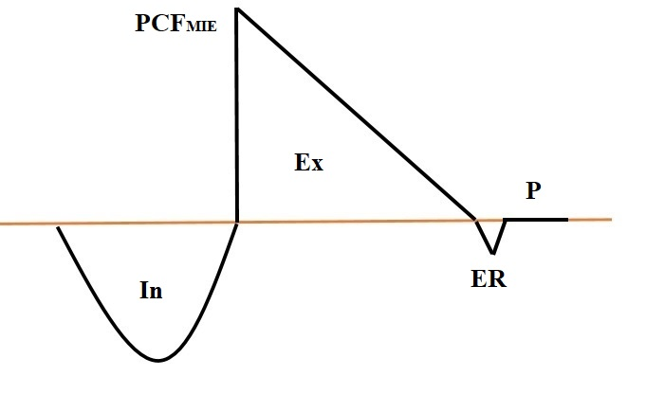
E Figure 1: Diagram representing the optimal flow-time graph generated by MI-E. (Ex: Exsufflation, ER: Elastic recoil, In: Insufflation, P: Pause, PCF_{MIE}: Mechanically peak cough flow)

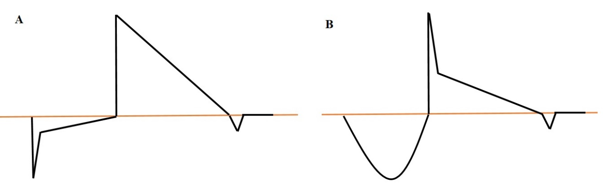
E Figure 2: Diagram representing obstruction in flow-time graph generated by MI-E. A) Upper airway obstruction during insufflation, B) Upper airway collapse during exsufflation

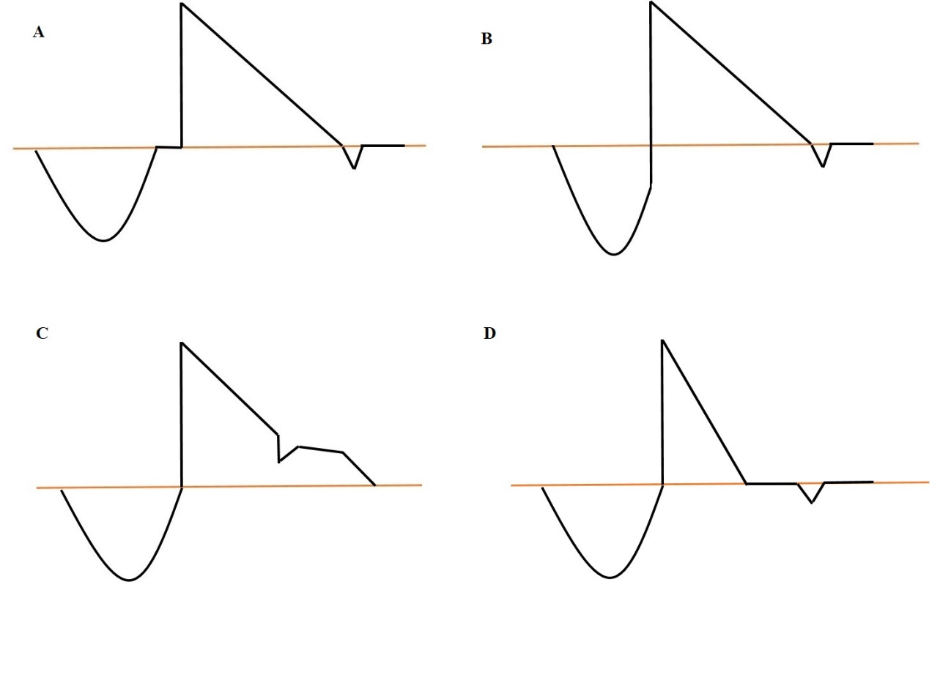
E Figure 3: Diagram representing alterations in exsufflation and insufflation times in flow-time graph generated by MI-E. A) Long Insufflation, B) Short Insufflation, C) Long Exsufflation, D) Short Exsufflation

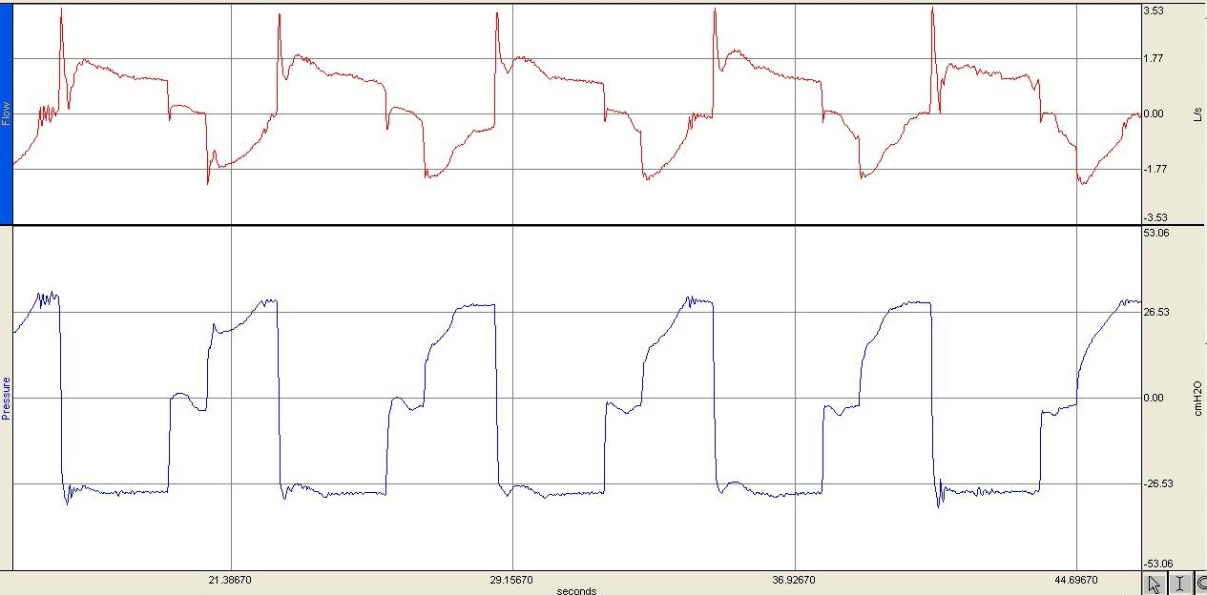

E Figure 4: Flow-time (top) and pressure-time (bottom) graphs generated by MI-E showing long insufflation (Insufflation Pressure +20 cmH₂O, Exsufflation Pressure -20 cmH₂O, Insufflation Time 2 s, Exsufflation Time 3 s, Insufflation Flow High, Pause 1 s)

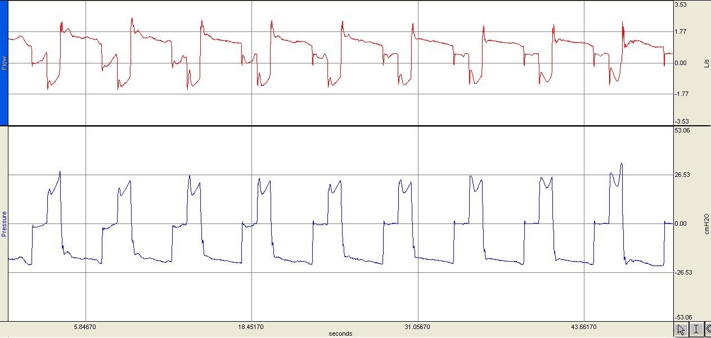

E Figure 5: Flow-time (top) and pressure-time (bottom) graphs generated by MI-E showing short insufflation (Insufflation Pressure +30 cmH₂O, Exsufflation Pressure -40 cmH₂O, Insufflation Time 1 s, Exsufflation Time 2 s, Insufflation Flow High, Pause 1 s)

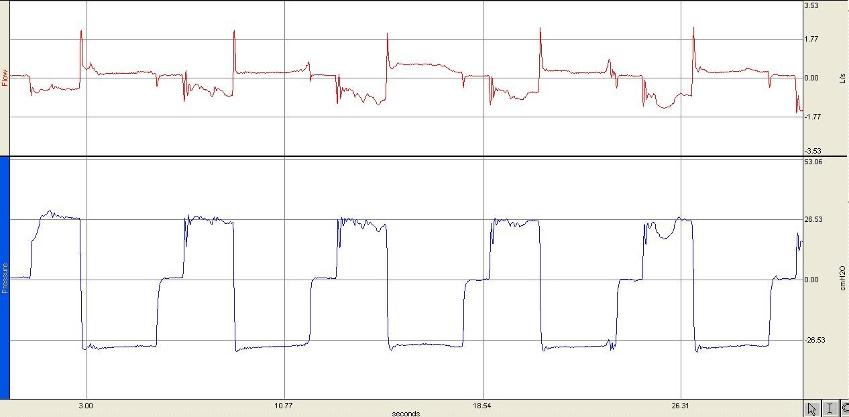

E Figure 6: Flow-time (top) and pressure-time (bottom) graphs generated by MI-E showing long exsufflation (Insufflation Pressure +20 cmH₂O, Exsufflation Pressure -20 cmH₂O, Insufflation Time 2 s, Exsufflation Time 3 s, Insufflation Flow High, Pause 1 s)

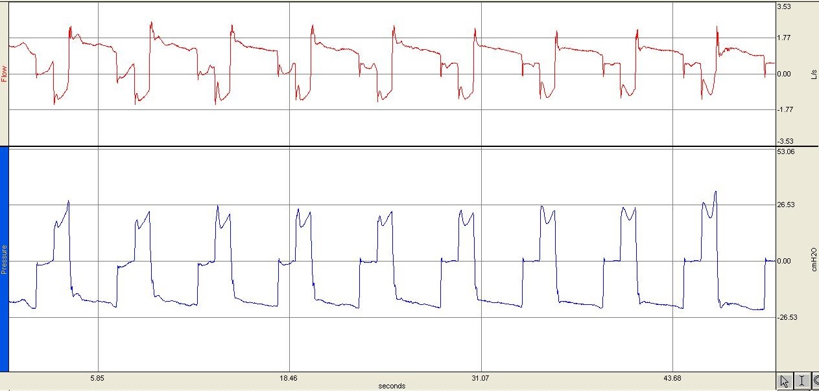

E Figure 7: Flow-time (top) and pressure-time (bottom) graphs generated by MI-E showing short exsufflation (Insufflation Pressure +30 cmH₂O, Exsufflation Pressure -40 cmH₂O, Insufflation Time 1 s, Exsufflation Time 2 s, Insufflation Flow High, Pause 1 s)

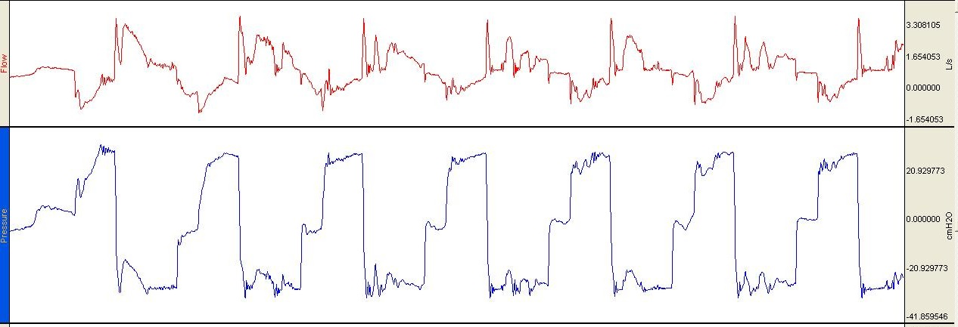

E Figure 8: Flow-time (top) and pressure-time (bottom) graphs generated by MI-E showing cough efforts superimposed during exsufflation.

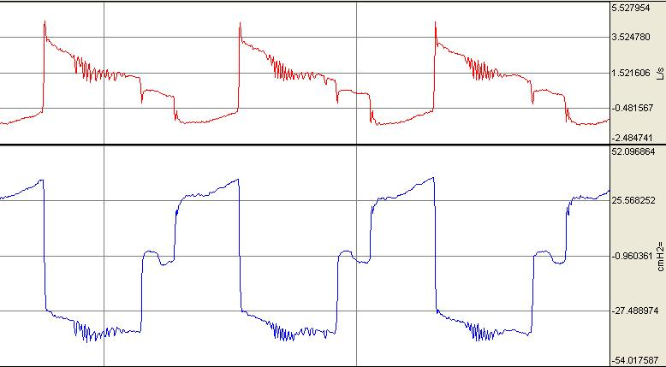

E Figure 9: Flow-time (top) and pressure-time (bottom) graphs generated by MI-E showing Oscillations during exsufflation (Insufflation Pressure +30 cmH₂O, Exsufflation Pressure -30 cmH₂O, Insufflation Time 2 s, Exsufflation Time 3 s, Insufflation Flow High, Pause 1 s)

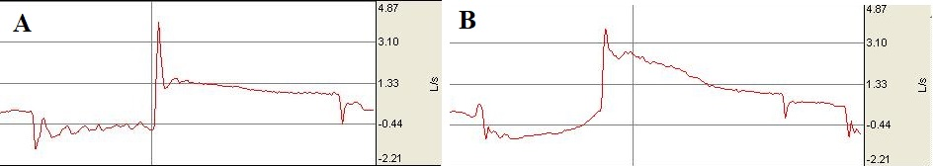

E Figure 10: Flow-time graph generated by MI-E showing upper airway obstruction during Insufflation (A) solved after changing the set parameters (B). A: Insufflation pressure +40 cmH₂O, exsufflation pressure -40 cmH₂O, maximal insufflation flow, insufflation time 2s, exsufflation time 3s. B: Insufflation pressure +30 cmH₂O, exsufflation pressure -40 cmH₂O, maximal insufflation flow, insufflation time 2s, exsufflation time 3s.

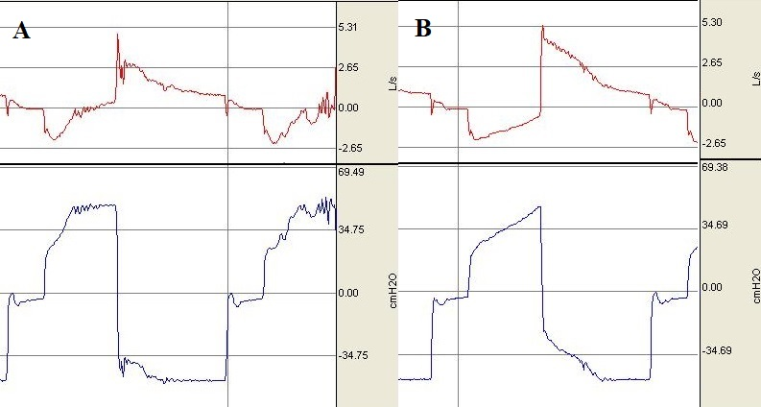
E Figure 11: Flow-time (top) and pressure-time (bottom) graphs generated by MI-E showing upper airway collapse during exsufflation (A) resolved after changing the set parameters (B). A: Insufflation pressure +50 cmH₂O, exsufflation pressure -50 cmH₂O, maximal insufflation flow, insufflation time 2s, exsufflation time 3s. B: Insufflation pressure +40 cmH₂O, exsufflation pressure -40 cmH₂O, maximal insufflation flow, insufflation time 2s, exsufflation time 3s.

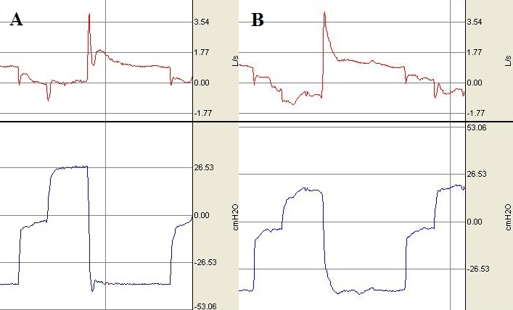

E Figure 12: Flow-time (top) and pressure-time (bottom) graphs generated by MI-E showing upper airway obstruction during insufflation and collapse during exsufflation (A) resolved after changing the set parameters (B). A: Insufflation pressure +50 cmH₂O, exsufflation pressure -50 cmH₂O, maximal insufflation flow, insufflation time 2s, exsufflation time 3s. B: Insufflation pressure +25 cmH₂O, exsufflation pressure -40 cmH₂O, maximal insufflation flow, insufflation time 1s, exsufflation time 3s.

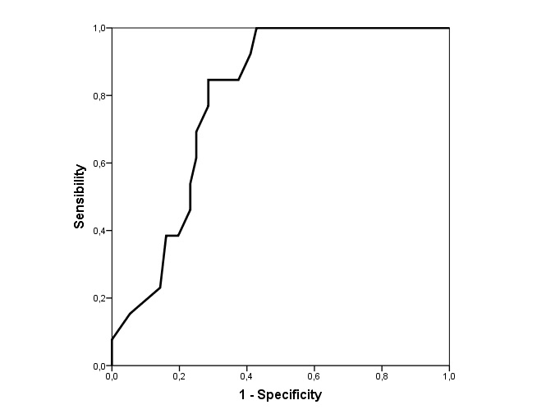
E Figure 13
Receiver Operating Curves. NBS as predictor of no alterations in the generated graphs by MI-E (AUC 0.790, 95%CI 0.68–0.89, p=0.001)

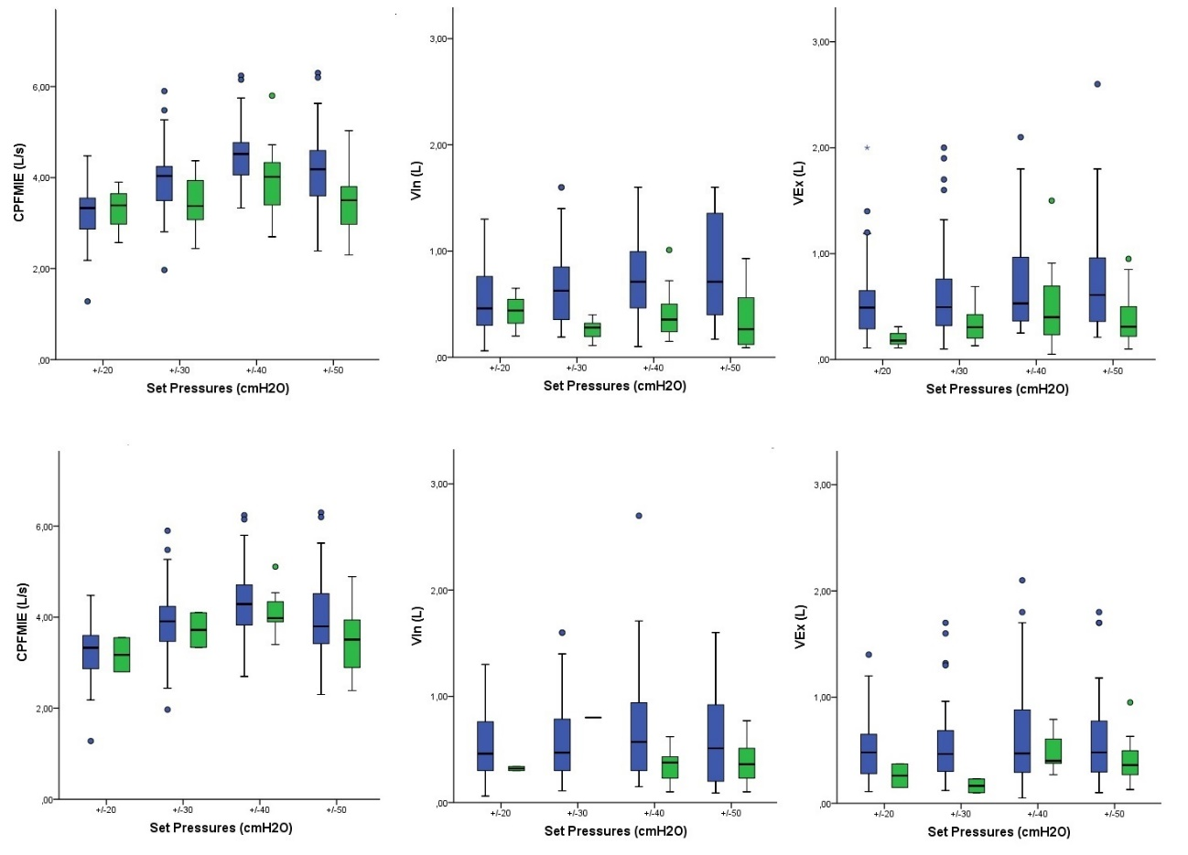

E Figure 14
Bloxpot of CPF_{MIE}, VIn and Vex measured with different set pressures. Dots represent outliers (1.5 times the interquartile range above the upper quartile and below the lower quartile). Top panel represents episodes of obstruction during insufflation and bottom panel during exsufflation. Green color reflect obstructive episodes

