SUPPLEMENTAL MATERIAL

Supplemental e-Table 1. Clinical pulmonary infection score (CPIS)ª
CPIS Points | 0 | 1 | 2
Tracheal secretions | Rare | Abundant | Abundant + purulent
Chest X-ray infiltrates | None | Diffuse | Localized
Temperature, °C | ≥ 36.5 and ≤ 38.4 | ≥ 38.5 and ≤ 38.9 | ≥ 39 or ≤ 36
Leukocyte count, per mm³ | ≥ 4,000 and ≤ 11,000 | < 4,000 or > 11,000 | > 4,000 or < 11,000 + band forms ≥500
PaO₂/FiO₂, mmHg | > 240 or ARDS |  | ≤240 and no evidence of ARDS
Microbiology | Negative |  | Positive
ARDS, acute respiratory distress syndrome; CPIS, Clinical Pulmonary Infection Score
ªFor our study, at baseline in each patient, we determined a modified CPIS (mCPIS) without the microbiological results, as these were not yet available. The full CPIS was subsequently obtained by adding two points to the mCPIS if the culture and/or Gram stain were positive.⁸

Supplemental e-appendix-1
Summary of statistical techniques used to derive Spiegelhalter-Knill-Jones weights
Step 1: Computing the likelihood ratio (LR) of each variable
The patients were divided into two groups based on whether they had confirmed nosocomial pneumonia (NOSOP). A standard 2x2 contingency table was created to determine the sensitivity, specificity, and LR of the presence or absence of each variable:
- LR for presence of the variable = sensitivity / (1-specificity)
- LR for absence of the variable = (1-sensitivity) / specificity
Step 2: Applying Bayes’ theorem to compute the posterior odds of NOSOP
The independence Bayes’ equation states that the posterior odds equal the prior odds x LR of variable 1 x LR of variable 2... x LR of variable N, where the posterior odds are the predicted odds of NOSOP in the individual patient and the prior odds are the odds of NOSOP in the study population.
Step 3: Converting LRs into scores and weights
To obtain a simple summed score from the LR values, we converted the LR to its natural logarithm (Ln). To allow the expression of crude weights as whole numbers, we multiplied the natural logarithm by 100 and rounded off the result. The independence Bayes’ equation was thus 100 Ln posterior odds = 100 Ln prior odds + 100 Ln LR of variable 1 +100 Ln LR of variable 2... + 100 Ln LR of variable N. In Spiegelhalter-Knill-Jones scores-and-weights terminology, this equation becomes Total score (T) = starting score + crude weights of variable 1 + crude weights of variable 2 ...+ crude weights of variable N. The starting score reflects the probability of NOSOP before the development of criteria used to suspect NOSOP and may therefore vary according to the case-mix in each ICU.
Step 4: Adjusting crude weights
The variables used to suspect NOSOP are rarely independent in clinical practice. Consequently, Bayes’ independence equation may substantially overestimate the probability of NOSOP. The Spiegelhalter-Knill-Jones method avoids such overestimation, since adjusted weights of evidence are computed by entering the crude weights as independent variables into a logistic regression equation. We assessed goodness-of-fit by applying the Hosmer-Lemeshow chi-square test. We show the regression coefficients a_{0,} a₁, a₂, a_{n} with their standard errors (SEs). The adjusted weights are computed by multiplying each crude weight by its regression coefficient. The equation then becomes Total score (T) = a₀ + adjusted weight of variable 1 + adjusted weight of variable 2 ...+ adjusted weight of variable N.
Step 5: Converting scores back to probability of NOSOP
Because T=100 (Ln posterior odds) and because odds = (probability of NOSOP) / (1-probability of NOSOP), the probability of NOSOP as a percentage is (e^{T/100}/1+e^{T/100})x100=1/ (e^{-T/100}+1)x100. This conversion can be performed more rapidly using a simple graph (Figure 1)

Supplemental e-Table 2. Bacteria identified from pulmonary specimens in 165 and 84 episodes of confirmed hospital-acquired pneumonia (HAP) in the derivation and validation cohorts, respectively. For some episodes, more than one microorganism was identified. The data are n (%).
Bacteria | Derivation cohort  (n=165) | Validation cohort  (n=84) | P value
Staphylococcus aureus  - MRSA  - MSSA | 20 (12.1)  4 (2.4%)  16 (9.7%) | 5 (5.9)  0  5 (5.9%) | 0.12
Enterococcus sp. | 9 (5.4) | 4 (4.8) | 0.81
Streptococcus pneumoniae | 7 (4.2) | 4 (4.8) | 0.45
Oropharyngeal flora* | 16 (9.7) | 2 (2.4) | 0.03
Enterobacteriaceae | 92 (55.7) | 60 (71.4) | 0.02
Pseudomonas aeruginosa | 38 (23.0) | 18 (21.4) | 0.77
Non-fermenting Gram-negative bacteria | 7 (4.2) | (4.8) | 0.81
Haemophilus influenzae | 16 (9.7) | 4 (4.8) | 0.17
Branhamella catarrhalis | 3 (1.8) | 2 (2.4) | 0.76
Anaerobic bacteria | 1 (0.60) | 0 | 0.76
Miscellaneous | 1 (0.60) | 1 (1.2) | 0.62
Total | 210 | 104
MRSA: Methicillin-resistant Staphylococcus aureus
MSSA: Methicillin-sensible Staphylococcus aureus
* Oropharyngeal flora was considered as nosocomial pathogens only when more than 4% of bronchoalveolar lavage cells contained intracellular bacteria.
Supplemental e Figure
e-Figure 1: Impact of antibiotic treatment
* Antibiotherapy was escalated 20 times, de escalated 72 times, and unchanged 48 times.
† Antibiotherapy was adappted
‡ Empirical or adapted antibiotherapy was initiated
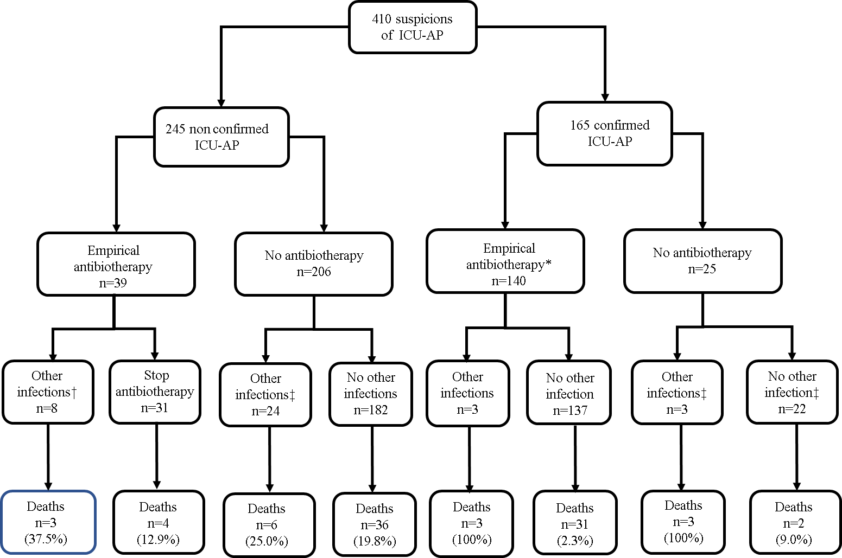
e-Figure 1

Supplemental e-appendix 2: Example of NOSOP prediction
To predict the risk of ICU-acquired pneumonia in an individual patient the starting score is added to the adjusted weights of evidence for that patient to obtain the total score (Table 4). Figure 1 then converts the total score into the probability of ICU-acquired pneumonia . For instance, in a patient with complications after mitral surgery requiring invasive mechanical ventilation but no antibiotic therapy, the occurrence on the fourth postoperative day of a fever and leukocytosis with purulent tracheal secretions and a SOFA score increase ≥2 suggests ICU-acquired pneumonia . The adjusted weights of evidence for an unchanged SOFA score (+72), purulent tracheal secretions (+11), leukocytosis (-4), mechanical ventilation (+3), and no antibiotic therapy (+2) are added to the starting score (-41) (Table 4) to obtain the total score of +43, which yields a total score of +43 and a predicted probability of ICU-acquired pneumonia of 60% (Figure 1).

Supplemental e-Table 3. Event Net Reclassification Index (NRI; patients with ICU-acquired pneumonia) (A) and nonevent NRI (patients without ICU-acquired pneumonia ) (B)
(A) Event NRI (validation -cohort patients with ICU-acquired pneumonia)
N=78 | Probability given by the modelª ≤35% | Probability given by the model >35%
CPIS ≤6^{b} | 17 | 31
CPIS >6 | 8 | 22
Event NRI: (31-8)/78=0.295
(B) Nonevent NRI (validation-cohort patients without ICU-acquired pneumonia)
N=130 | Probability given by the model ≤35% | Probability given by the model >35%
CPIS ≤6 | 55 | 39
CPIS >6 | 20 | 16
Nonevent NRI: (20-39)/130 = -0.146
a: The CPIS was available for 213 episodes of suspected ICU-acquired pneumonia
b: the SOFA Spiegelhalter-Knill-Jones model was available in 210 episodes of suspected ICU-acquired pneumonia
CPIS, Clinical Pulmonary Infection Score

