Appendices
Appendix 1: Covariates
For each patient in our cohort, we extracted baseline variables including: age, sex, weight, first care unit, admission type, select Elixhauser comorbidities, and a baseline frailty score. We also extracted time-stamped, time-varying variables over the course of follow-up, including: vital signs (heart rate, respiratory rate, arterial pressure, temperature, spO2), lab values (PH, PO2, PCO2, AADO2), RASS score, fluid volume, vasopressor dose, and both set and observed ventilator readings (PEEP, standardized tidal volume, peak inspiratory pressure, mean airway pressure, PaO2-FiO2 ratio, inspiratory time, driving pressure, compliance). Driving pressure measurements were computed as plateau pressure – PEEP throughout follow-up.

Appendix 2: Driving Pressure PEEP Model
We might express this regression model formulaically as
$$dΔP_{t}∼{\left(ΔP_{t-1}+δ_{PEEP,t}+PEEP_{t-1}+{\overline{ΔP}}_{t-1}+ {\overline{PEEP}}_{t-1}+VT_{t-1}+t\right)}^{×2}+PEEP_{t}^{2}+ΔP_{t-1}^{2}+s\left(t\right)+Vitals_{t-1}+Labs_{t-1}+Vent_{t-1}+X_{baseline}$$
where $dΔP_{t}$ denotes change in driving pressure at time t since previous measurement; ${\overline{ΔP}}_{t-1}$ and ${\overline{PEEP}}_{t-1}$ denote running mean past driving pressure and PEEP, respectively; ${\left( \right)}^{×2}$ denotes two way interactions of terms enclosed in the parentheses; $δ_{PEEP,t}$ denotes change in PEEP at time t from previous driving pressure measurement; s(t) denotes a spline basis for hour after baseline; and $Vitals_{t-1}$, $Labs_{t-1}$, $Vent_{t-1}$, and $X_{baseline}$ denote most recent readings of, respectively, all vitals, lab, ventilator, and baseline variables listed in the cohort construction section prior to PEEP setting at time t. Note that we are careful not to adjust for post-treatment (i.e. post PEEP setting) variables.

Under the assumptions that the model is approximately correctly specified and we have included as predictors all variables which might both influence PEEP setting decisions and be associated with driving pressure recordings at any given time, we can interpret the output of the model causally. That is, the difference between predicted driving pressure given the same patient history but different PEEP settings can be interpreted as the expected effect of the PEEP settings. For example, let $L_{t-1}$ denote all patient data through time t-1 and ${\hat{ΔP}}_{t}\left(δ_{PEEP},L_{t-1}\right)$ denote model predicted driving pressure at time t given patient history $L_{t-1}$ and peep change $δ_{PEEP,t}$=$δ_{PEEP}$ (with PEEP_{t} set correspondingly to PEEP_{t-1}+$δ_{PEEP,t}$). ${\hat{ΔP}}_{t}\left(δ_{PEEP}=2,L_{t-1}\right)-{\hat{ΔP}}_{t}\left(δ_{PEEP}=0,L_{t-1}\right)$ can then be interpreted as the expected effect on driving pressure of increasing PEEP by 2cmH₂0 compared to keeping PEEP constant conditional on patient history $L_{t-1}$.

Appendix 3: Driving Pressure Vt Model
To estimate effects of tidal volume, we fit a very similar model to the one we used to estimate effects of PEEP. The only differences were that we included tidal volume at the same hour as driving pressure as a predictor in the model, added a change in tidal volume variable, and added an interaction term between change in tidal volume and compliance. The regression model could be expressed formulaically as:$$dΔP_{t}∼{\left(ΔP_{t-1}+δ_{VT,t}+PEEP_{t}+{\overline{ΔP}}_{t-1}+VT_{t-1}+t\right)}^{×2}+{VT}_{t}^{2}+δ_{VT,t}×compliance_{t-1}+s\left(t\right)+Vitals_{t-1}+Labs_{t-1}+Vent_{t-1}+X_{baseline}$$
All notation has the same interpretation as in the model we used to estimate effects of PEEP. We included PEEP at the same hour as driving pressure measurement in the model to adjust for PEEP settings as a confounder of tidal volume because PEEP is set independently and can be thought of as causally preceding tidal volume settings (i.e. not a post-treatment variable). We again used the default independent weakly informative prior distributions for all model coefficients in the bayesglm() function from the arm R package and bootstrap for computation of standard errors.

Under the assumptions that the above model is approximately correctly specified and we have included as predictors all variables which might both influence tidal volume setting decisions and be associated with driving pressure recordings at time t, we can interpret the output of the model causally. For example, let $L_{t-1}$ denote all patient data through time t-1 and ${\hat{ΔP}}_{t}(δ_{VT},L_{t-1})$ denote model predicted driving pressure at time t given patient history $L_{t-1}$ and tidal volume change $δ_{VT,t}$=$δ_{VT}$ (with VT_{t} set correspondingly to VT_{t-1}+$δ_{VT,t}$). ${\hat{ΔP}}_{t}\left(δ_{VT}=-30,L_{t-1}\right)-{\hat{ΔP}}_{t}(δ_{VT}=0,L_{t-1})$ can then be interpreted as the expected effect of decreasing tidal volume by 30cc compared to keeping tidal volume constant conditional on patient history $L_{t-1}$.

Appendix 4: Mechanical Power Vt and Respiratory Rate Model
We specify the linear model for
$E[MP_{t}|TV_{t},RR_{t},PEEP_{t},Vitals_{t},Labs_{t},BloodGas_{t},Baseline,PiP_{t-1},DP_{t-1},MP_{t-1},Vent_{t-1}]$ formulaically as $MP_{t} ∼(TV_{t}+RR_{t}+PEEP_{t}+ΔTV_{t}+ΔRR_{t}+MP_{t-1}+\bar{MP_{t-1}}+PiP_{t-1}+DP_{t-1}+compliance_{t-1})^{×2}$
$$+TV^{2}+M{P_{t-1}}^{2}+s(t) +Vitals_{t-1}+Labs_{t-1}+Vent_{t-1}+X_{baseline}$$
where $MP_{t}$ denotes mechanical power at time t, $ΔTV_{t}$denotes change in tidal volume since previous MP measurement, ${\bar{MP}}_{t-1}$denotes running mean past MP; $( )^{×2}$denotes two way interactions of terms enclosed in the parentheses; s(t) denotes a spline basis for hour after baseline; and$Vitals_{t-1}$,$Labs_{t-1}$, $Vent_{t-1}$, and $X_{baseline}$ denote most recent readings of, respectively, all vitals, lab, ventilator, and baseline variables listed in the cohort construction section prior to tidal volume setting at time t.

Under the assumptions that the model is approximately correctly specified and we have included as predictors all confounding variables which might both influence tidal volume and respiratory rate setting decisions and be associated with mechanical power recordings at time t, we can interpret the output of the model causally. For example, let $L_{t}$denote all variables needed by the model to predict $MP_{t}$other than the two treatment variables tidal volume and respiratory rate. Let $\hat{MP_{t}}(tv,{rr(tv,TV_{t-1},RR_{t-1}),L}_{t})$denote model predicted mechanical power at time t given patient covariates $L_{t}$, tidal volume setting $TV_{t}=tv$, and respiratory rate $RR_{t}=rr(tv,TV_{t-1},RR_{t-1})$set so that $RR_{t}=RR_{t-1}×TV_{t-1}/tv$ to maintain minute volume at its value from the previous mechanical power measurement. $\hat{MP_{t}}(tv=TV_{t-1}-30,{rr(tv,TV_{t-1},RR_{t-1}),L}_{t}) -\hat{MP_{t}}(tv=TV_{t-1},{rr(TV_{t},TV_{t-1},RR_{t-1}),L}_{t})$can then be interpreted as the expected effect of decreasing tidal volume by 30cc compared to keeping tidal volume constant conditional on patient covariates $L_{t}$. The average value of $\hat{MP_{t}}(tv=TV_{t-1}-30,{rr(tv,TV_{t-1},RR_{t-1}),L}_{t}) -\hat{MP_{t}}(tv=TV_{t-1},{rr(TV_{t},TV_{t-1},RR_{t-1}),L}_{t})$
over all patient-times is the average immediate effect (over person-times) of a 30cc decrease in TV on mechanical power.

There is reason to believe that the effect of tidal volume (and corresponding respiratory rate) modifications might vary with compliance. The average values of $\hat{MP_{t}}(tv=TV_{t-1}-30,{rr(tv,TV_{t-1},RR_{t-1}),L}_{t}) -\hat{MP_{t}}(tv=TV_{t-1},{rr(TV_{t},TV_{t-1},RR_{t-1}),L}_{t})$
over all patient-times with low (<25) or high (>50) compliance are the average immediate effects (over person-times) of a 30cc decrease in TV on mechanical power at low or high compliance.

Appendix 5: Average effects of PEEP increases by prior driving pressure and prior PEEP. Each point in the plots above represents the estimated average effect of a two point PEEP increase on driving pressure (ΔP) in the subpopulation with prior ΔP level stated in the plot title and prior PEEP setting given by the point’s X-coordinate. Each subpopulation effect is estimated as the average over all patients in the subpopulation of patient level effects predicted by our confounding adjusted ΔP model fit to 2,622 patients with ARDS. Bootstrap confidence intervals reflect uncertainty in the estimation of model parameters. Figure 4 delivers a similar message to Figure 3, that effects of PEEP increases approach and sometimes cross zero as prior PEEP levels increase. While Figure 3 provides a visual sense of patient level variation given a fixed estimate of model parameters (all estimated response curves in Figure 3 are based on the point estimates of model parameters), Figure 4 averages over patients and quantifies uncertainty due to sampling variability in model parameter estimates with bootstrap confidence intervals.

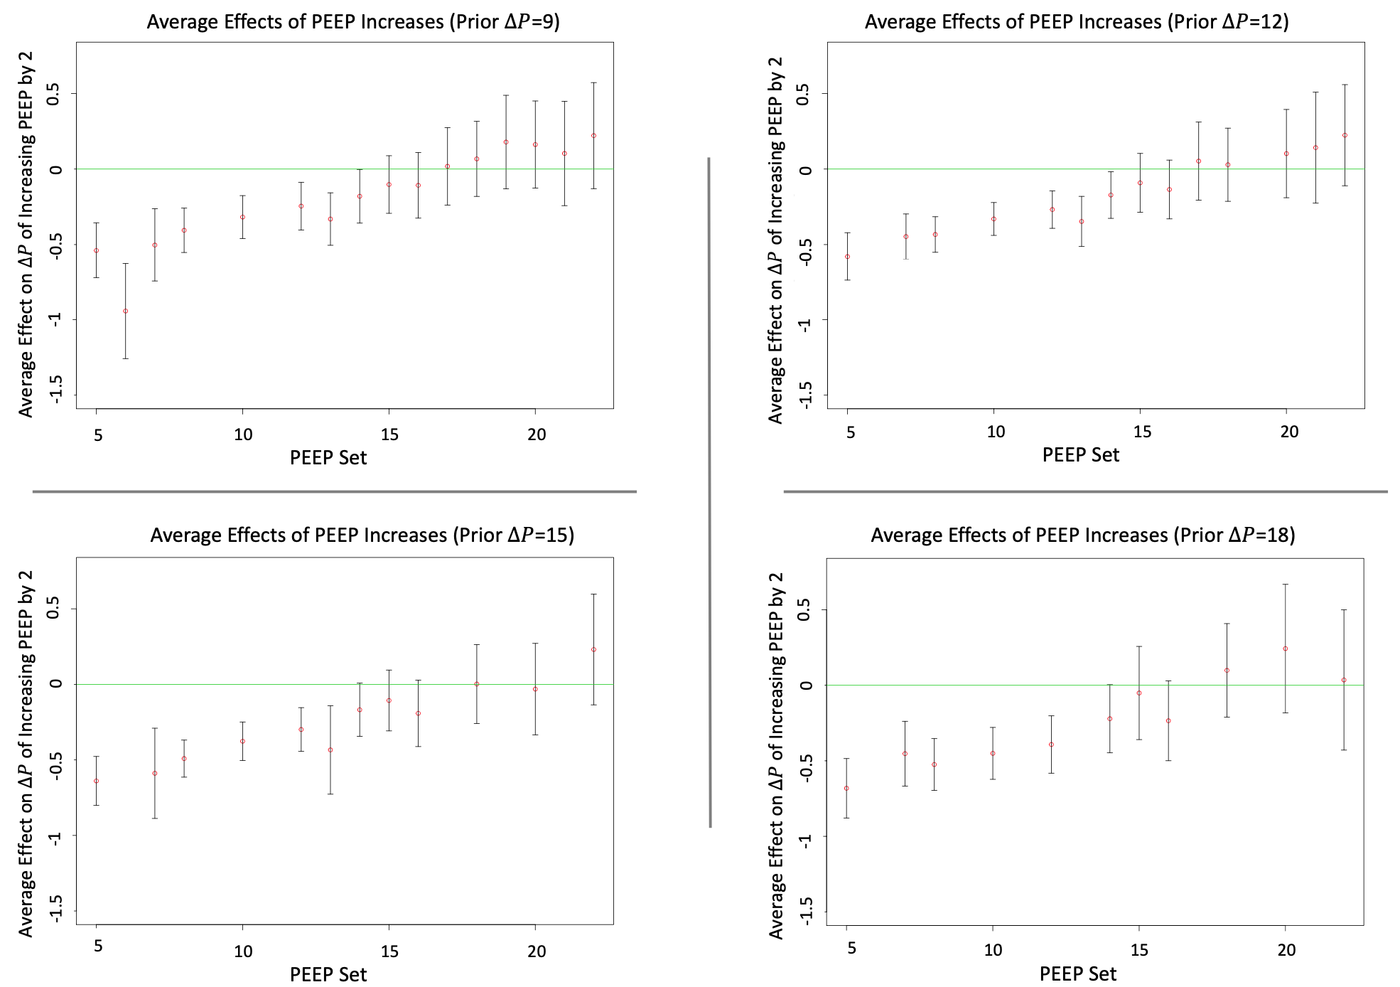

Appendix 6. Average Effects of PEEP increases by prior driving pressure and PEEP in late stage patients intubated for more than 10 days.Each point in the plots above represents the estimated average effect of a two point PEEP increase on driving pressure in the subpopulation ventilated for at least 10 days and with prior driving pressure level stated in the plot title and prior PEEP setting given by the point’s X-coordinate. Each subpopulation effect is estimated as the average over all patients in the subpopulation of patient level effects predicted by our confounding adjusted driving pressure model fit to 543 patients with ARDS at times when they were in a control mode at least 10 days after they first entered a control mode. Bootstrap confidence intervals reflect uncertainty in the estimation of model parameters. Compared to Figure 4, Appendix 5 shows that in ARDS patients who have been ventilated for extended periods, PEEP increases more quickly become ineffective at lowering driving pressure.

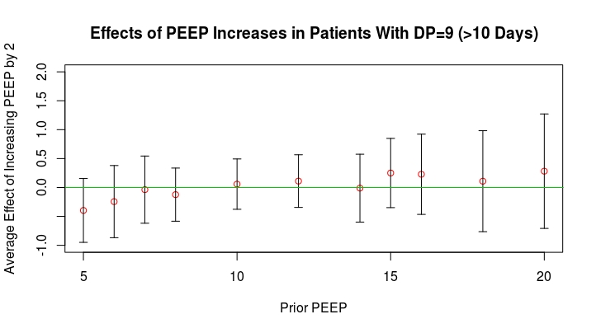

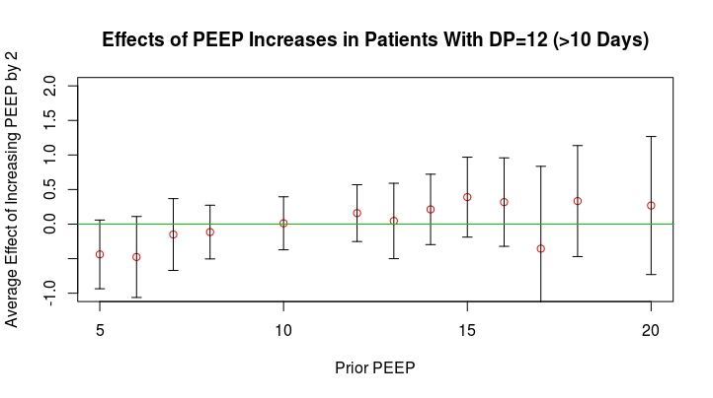
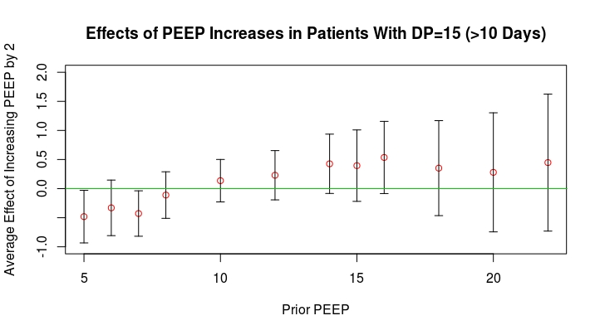
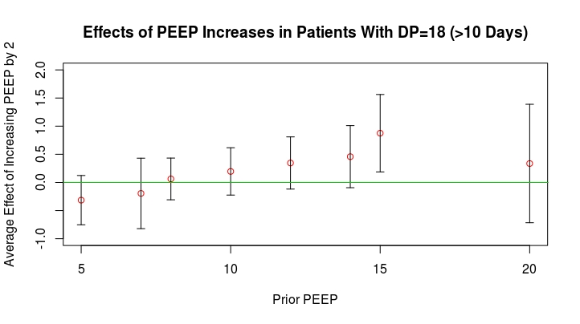

Appendix 7. Schematic for proposed sigmoidal pressure-volume characteristics of the respiratory system and the resulting U-shaped curve created from this relationship when comparing driving pressure (∆P), and positive end expiratory pressure (PEEP) in patients with early Acute Respiratory Distress Syndrome (ARDS). (A) The pressure-volume relationship during inflation is defined by the sigmoidal shape. At low airway pressures the lungs and airways are partially collapsed from a combination of chest wall compression and loss of alveolar surfactant. At these low airway pressures, a large amount of pressure is needed to open airways and collapsed alveoli for a given set volume. This can be visualized by the low cord compliance (dotted red line) at low pressures (compliance = Vt/ ∆P) for a given delivered tidal volume (Vt), with a correspondingly high ∆P (Vt/compliance) for each delivered breath. As airway pressure increases, the airways and alveoli open and the cord compliance increases while the ∆P decreases. This region of highest compliance represents the “optimal” range for this specific patient where recruitment is maximized with less overdistension of the lungs. Eventually the lungs become overdistended and compliance decreases once again as can be seen by the more horizontal slope of the dotted lines at higher pressures. (B) This diagram represents the corresponding ∆P from the prior graph with the starting pressure of the compliance curve representing the level of PEEP. As visualized, the sigmoidal shape of the pressure-volume curve determines the U-shaped curve of the ∆P, with lowest (optimized) ∆P in the mid-PEEP range.

