Supplemental Digital Content

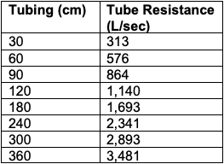

Table E1. Leak tubing and resistance, measured with 0.5 liter of flow

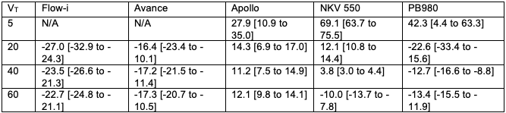

Table E2. Median and interquartile range of VT % error per ventilator at different set VT

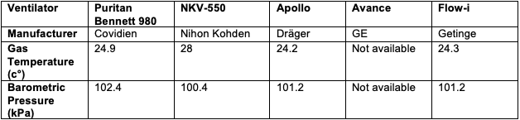

Table E3. Ventilator Characteristics

