**Characterization of SARS-CoV-2 Aerosols Produced During Noninvasive Respiratory Support of COVID-19 Patients**

Meghan E. Ramsey Ph.D.,Anthony J. Faugno MD, Wendy B. Puryear Ph.D., Brian C. Lee Ph.D., Alexa D. Foss, Lester H. Lambert M.D., Frances E. Nargi Ph.D., Gregory P. Bopp Ph.D., Lauren P. Lee Ph.D., Christina M. Rudzinski Ph.D., Benjamin L. Ervin Ph.D., Jonathan A. Runstadler Ph.D., Nicholas S. Hill M.D.

**Online Supplement**

© 2022 Massachusetts Institute of Technology

**Methods**

**Semiquantitative real time RT-PCR**

Filter cassettes were disassembled and the filter was removed using sterile forceps. The entire filter membrane was cut into thin strips and placed into an o-ringed screw top cryovial. PTFE filters were submerged in 2 ml of lysis buffer, vortexed on high speed for 1 minute at room temperature, and incubated at 37 oC for 10 minutes. A 180-l volume was processed for viral RNA extraction. Gelatin filters were dissolved in 1 ml of nuclease free water, vortexed on high for 20 seconds, incubated at 37 oC for 10 minutes, vortexed on high for an additional 1 minute, then 50 l was added to 130 l of lysis buffer (derived from the viral RNA extraction kit, see below) and processed for viral RNA extraction.

For saliva samples, 1 ml of sputum or saliva was added to lysis buffer at a 1:1 ratio in an o-ringed screw top cryovial. A 50-l volume of Proteinase K (Omega Bio-Tek, Norcross, GA, USA) was added to the solution and vortexed on high for 1 minute at room temperature. For samples that remained viscous, this step was repeated up to 4 times for a maximum input of 200 l proteinase K. The sample was incubated at 37 oC for 10 minutes, and 180 l was processed for viral RNA extraction.

Viral RNA was extracted using Omega MagMax viral RNA/DNA kit (Omega Bio-Tek, Norcross, GA, USA) and a KingFisher Magnetic Particle Processor (Thermo Scientific, Waltham, MA, USA) according to manufacturer instructions with the following exception: lysis buffer was directly used to recover the sample for PTFE and sputum/saliva samples and therefore 180 l of sample was added for the starting input with no additional dilution. All samples were eluted in 50 l of RNAse-free water.

Extracted RNA was screened by semiquantitative real time RT-PCR using qScript XLT One-Step RT-qPCR ToughMix (Quanta Biosciences, Gaithersburg, MD, UA) and analyzed for fluorescence on a StepOnePlus Real-Time PCR System from Applied Biosystems (ABI, Foster City, CA, USA).

Primer sets for semiquantitative real time RT-PCR targeted a conserved region of SARS-CoV-2 ORF1 gene using HKU-ORF1, Forward: TGGGGYTTTACRGGTAACCT, Reverse: AACRCGCTTAACAAAGCACTC, Probe: FAM-TAGTTGTGATGCWATCATGACTAG-TAM and an internal control for β-actin using CoVERS-ACTB, Forward: GATGCAGAAGGAGATCAC, Reverse: CTAGAAGCATTTGCGGTG, Probe: HEX-CTCCTGCTTGCTGATCCACA-TAM. All plates were run with negative viral transport medium (VTM) controls and positive control (NR-52285, Genomic RNA from SARS-Related Coronavirus 2, Isolate USA-WA1/2020, BEI Resources).

**Chamber Measurement Study Procedures**

This section provides some additional detail on the chamber and sensor setup used. The chamber measured approximately 16’ x 7’ x 8’ in size with >10 air changes per hour of HEPA-filtered air in order to reduce background aerosol concentrations. However, the air within the plastic box in which the subject sat was largely shielded from the room airflow to help concentrate any generated aerosols near the sensor inlets. This made the environment directly near the participants head and sensor inlets unrepresentative of airflow in a hospital room in the interest of improved detection sensitivity. The back side of the plastic shielding box was left open, and a plastic sheet was draped over the box and subject’s head, as shown in Figure E1. Each participant was asked to sit with their face approximately 6 inches from the sensor inlets. Two sensors were used: the Optical Particle Sizer (OPS) 3330 and the Droplet Measurement Technologies Wideband Integrated Bioaerosol Sensor (WIBS-5/NEO). Of note, the OPS 3330 is able to detect particles in smaller size bins compared to the WIBS-5/NEO, which may account for some differences in measured aerosol concentrations between the two devices. Asphericity is a measure of how close the particle is to a sphere (asphericity = 0%) or a rod (asphericity = 100%) and can help distinguish between types of particles (e.g. water vs. dust).

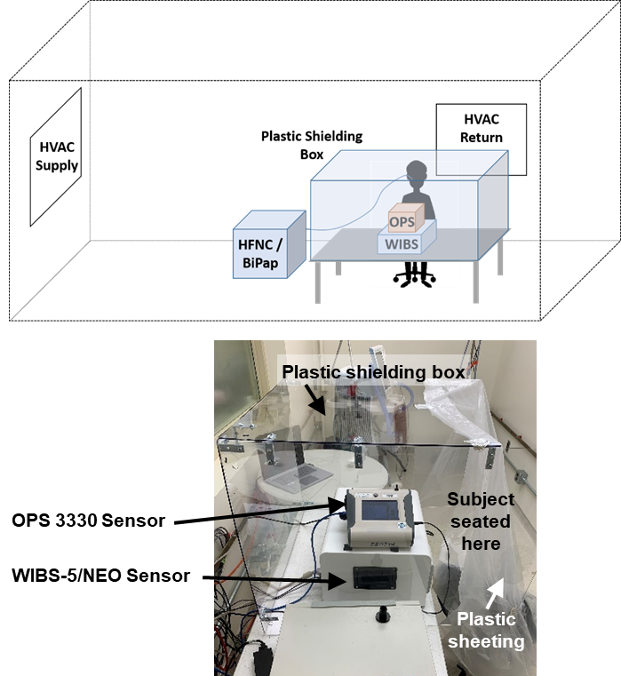

***Figure E1:*** *(Top) Illustration of the experimental chamber setup. (Bottom) Photograph of the plastic shielding box containing the real-time aerosol measurement devices (an OPS 3330 and a WIBS-5/NEO).*

**Results**

**Chamber measurements**

Figure E2 shows representative total aerosol measurements from two different aerosol sensors for one of the participants. Several increases in aerosol concentration were observed, but only one was attributed to the respiratory equipment, which occurred at approximately 11:20 when the HFNC was turned on for the first time by this participant. The remaining peaks were due to the water mist (11:03), the participant coughing / singing (12:40), or the five instances of the participant moving/lifting up the plastic drape covering the open side of the plastic shielding box to press a button on the HFNC or NIV device (as indicated by the arrows). Moving the plastic sheet stirred up dust in the chamber, which results in increases in the aerosol concentrations detected by the real-time sensors.

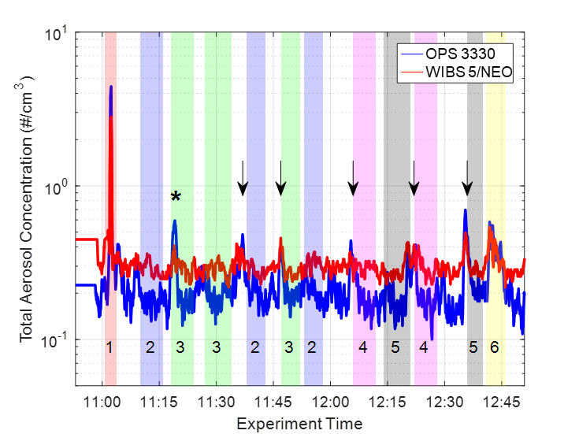

**Figure E2:** Time series plot of 20-second averaged total aerosol concentration measurements from a representative test (size range of 0.37 – 10 µm for the OPS 3330 and 0.5 – 30 µm for the WIBS). The shaded regions indicate the type of test being performed (1 – positive control water mist, 2 - HFNC background, 3 – HFNC On, 4 – NIV background, 5 – NIV On, 6 – participant coughing, singing, talking loudly). The asterisk indicates an aerosol peak attributed to turning the HFNC on for the first time, and the vertical arrows indicate aerosol peaks attributed to the participant moving or lifting the plastic drape.

An increase in aerosol concentration was consistently observed when the HFNC was first turned on and appears to be associated with the humidification chamber and tubing not yet being warmed up. Figure E3 shows measured total aerosol concentrations for three tests in which the participant was wearing the HFNC when the equipment was turned on. The largest increase in aerosol production was observed when the equipment was turned on after having been at room temperature (e.g. having been off for several days, Figure E3C), and no increase was observed when the equipment was nearly at temperature before being turned on (e.g. having been off for only 5 minutes, Figure E3A). Figure E4 shows the particle-size distribution measured during the HFNC warm up period as compared to just before the equipment was turned on. The distributions show an increase mostly in sub-micron particles with a slightly larger increase seen from the OPS 3330 due to its smaller particle-size cutoff than the WIBS (0.37 vs. 0.5 µm). Figure E5 shows the asphericity and fluorescence measured by the WIBS during the HFNC warm-up period as compared to the water mist control spray, the participant coughing, and the background (e.g. subject wearing the cannula with the flow off). Both the asphericity and fluorescence of the particles generated by the HFNC during the warm up period were consistent with deionized water particles (i.e. measured as spherical and non-fluorescent), which suggests the HFNC was generating sub-micron water aerosols for a few minutes during warm up. The temperature and relative humidity in the test chamber varied between 21 – 24 oC, and 50 – 65%, respectively. These sub-micron particles appear to be generated by the HFNC device considering that the increased concentration during warm-up was observed both when the subject wore the nasal cannula, and when the cannula was held on its own near the sensor inlets.

In contrast to the observations made with the HFNC device, no increase in aerosol concentration was observed while operating the NIV device, including during its warm-up period.



**Figure E3:** Total aerosol concentrations measured when a participant wore the HFNC as it was turned on after having been off for (A) 5 minutes, (B) 4 hours, and (C) 3 days. Each time series was adjusted so that time=0 corresponds to when the equipment was turned on. The OPS 3330 and WIBS can measure particles as small as 0.37 and 0.5 µm, respectively, which may explain why more total aerosol was detected by the OPS 3330.



**Figure E4:** Particle-size distribution measured from the (A) OPS 3330 and (B) WIBS when the HFNC was initially turned on after having been off for 3 days (red) compared to just before the equipment was turned on (blue). Recall the OPS 3330 and WIBS sensors respond to 0.37 – 10 µm and 0.5 – 30 µm particle sizes, respectively.



***Figure E5:*** *Probability density function (PDF) histograms of (A) particle asphericity and (B) fluorescence measured by the WIBS during the HFNC warm-up period (blue triangles) as compared to the water mist (red crosses), participant coughing (black circles) and background (green squares). An asphericity value of zero corresponds to a sphere; an asphericity value of 100 corresponds to a rod.*

**Chamber Measurement Statistical Analysis**

This section provides additional detail on the linear mixed-effects model used to estimate the effect each device had on the aerosol concentration.

In each case, the total aerosol concentrations, sampled at a 1-second cadence, were modeled using a linear mixed-effects model. To account for subject-to-subject, and trial replicate variation, random intercepts were included for both subjects and trial replicates. The particle concentration measurements for a given trial exhibited small, but non-negligible, serial correlation that appeared to be sufficiently well described by an auto-regressive order-1 (AR(1)) model. Correspondingly, the nested error structure for a given trial replicate was modeled as an AR(1) process. Finally, the device status (on/off) was included as a main effect. We denote the total particle concentration for the $j^{th}$ trial, for the $i^{th}$ subject, at time index $t$ as $y_{ijt}$; the subject random intercept as ${ U}_{i}$, and the trial random intercept for the $i^{th}$ subject as $V_{ij}$. For each trial the experimental device (HFNC or BPAP may be on ${(X}_{ij}=1$), or off ($X_{ij}=0$). The linear mixed effects model can be written as

$$y_{ijt}=β_{0}+β_{1}X_{ij}+U_{i}+V_{ij}+ ϵ_{ijt}$$

$$U_{i}∼^{i.i.d.} N(0, σ_{U}^{2})$$

$$V_{ij}∼^{i.i.d.} N(0, σ_{V}^{2})$$

Where there are $i=1, …, 5$ ­ subjects, each of whom did $j=1, …, n_{i}$ trials, which may vary from subject to subject. The number of time steps may also vary for each subject-trial: $t=1,…, T_{ij}$. Within a given subject-trial, the errors are assumed to have an AR(1) structure, which we write generically (dropping the subject-trial subscripts, ij, on the errors for ease of notation) as:

$$ϵ_{t}=ϕϵ_{t-1}+ η_{t}, η_{t}∼^{i.i.d.} N(0, σ_{η}^{2})$$

Ultimately, we are interested in testing for the marginal effect of either the HFNC or BiPAP on the total aerosol concentration $H_{0}: β_{1}=0$ vs $H_{1}:β_{1}≠0$. Conditional level $α$ tests for the device fixed effect can be performed using the usual t-test for linear regression models using the restricted maximum likelihood (REML) conditional estimates of the variances. The corresponding $(1-α$)% confidence intervals obtained from inverting these t-tests are reported in Figure E6.

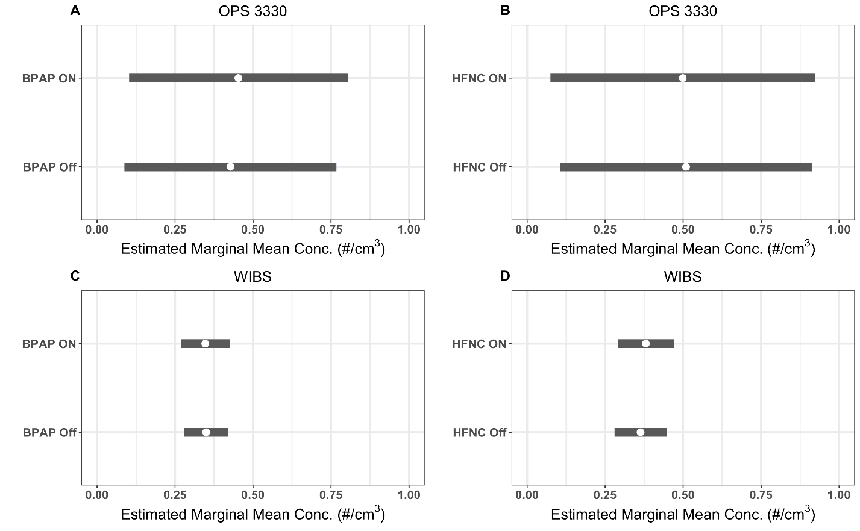

***Figure E6:*** *Estimated marginal means and associated 95% confidence intervals for the device on vs off states for four separate models: (A) OPS 3330 and BPAP, (B) OPS 3330 and HFNC, (C) WIBS and BPAP, and (D) WIBS and HFNC.*

**Chamber Measurement Model Uncertainty**

The uncertainty in the marginal effect of the respiratory devices on aerosol concentration gives rough guidance on the minimum detectable effect size. This can be described by the confidence interval estimate for the unknown parameter $β_{0}$, or the half-width of the 95% confidence interval – calculated as $F_{T_{df}}^{-1}\left(0.025\right)*standard error$, where $F_{T_{df}}$ is the CDF of a t-distribution with $df$ degrees of freedom. The largest of these half-widths across the four models is 0.24 $\#/cm^{3}$; concentrations below this value may not have resulted in a measurable effect in this experiment but may still be of concern for aerosol transmission. Table E1 lists the fitted model parameters.

**Table E1**: Summary of tests for device effect on mean aerosol concentration for the four models considered.

|  |  |  |  |  |  |  |
| --- | --- | --- | --- | --- | --- | --- |
| **Sensor** | **Device** | **Mean Estimate $$(\#/cm^{3})$$** | **Standard Error $(\#/cm^{3})$** | **Degrees of Freedom** | **t-value** | **p-value** |
| OPS 3330 333330 | BPAP | 0.025 | 0.043 | 3 | 0.57 | 0.60 |
| OPS 3330 | HFNC | -0.010 | 0.085 | 4 | -0.12 | 0.90 |
| WIBS-5/NEO | BPAP | -0.002 | 0.016 | 3 | -0.17 | 0.87 |
| WIBS-5/NEO | HFNC | 0.016 | 0.023 | 4 | 0.71 | 0.51 |

**Clinical measurements**

Additional clinical details and COVID-19 treatments for all subjects enrolled in the study are provided in Table E2. A photo of the scavenger mask used to concentrate samples is provided in Figure E7.

**Table E2:** Additional clinical details for all subjects in the study

|  |  |  |  |  |  |  |  |
| --- | --- | --- | --- | --- | --- | --- | --- |
| **Additional Subject Details** | | | | | **HFNC Parameters** | | |
| **Subject ID** | **COVID treatment (date initiated)** | **Respiratory Rate** | **Respiratory Effort** | **Number of ACH in room** | **Flow Rate (LPM)** | **FiO2** | **Temperature (°C)** |
| 1 | Remdesivir (4/14/2020) | 24-28 | no distress | 4 | 50 | 60 | 37 |
| 2 | Plaquenil (4/15/2020-4/20/2020) | 24-28 | no distress | 4 | 20 | 30 | nd |
| 3 | Remdesivir (4/26/2020) | 19-40 | no distress | 4 | 40 | 40 | 37 |
| 4 | Remdesivir (5/12/2020) Corticosteroids (5/11/2020) | 24 | mild accessory muscle use | 4 | 60 | 40 | 37 |
| 5 | Remdesivir (6/8/2020)  Convalescent plasma (6/6/2020) | 23 | agitated, delirious | 4 | 50 | 75 | 37 |
| 7 | None | nd | nd | 4 | na | na | na |
| 8 | Remdesivir (10/17/2020) Dexamethasone | 18-20 | no distress | 4 | na | na | na |
| 9 | Remdesivir (10/17/2020) Dexamethasone (10/17/2020) Convalescent Plasma (10/19/2020) | 18-20 | no distress | 4 | 50 | 55 | 30.9 |
| 10 | Remdesivir (10/19/2020) Dexamethasone (10/19/2020) | 18 | no distress | 4 | na | na | na |
| 11 | Remdesivir (10/19/2020) Dexamethasone (10/19/2020) | 18-28 | no distress | 6 | 40 | 50 | 31 |
| 12 | Remdesivir (10/7/2020) Dexamethasone (10/7/2020) | 18-23 | no distress | 4 | 40 | 50 | 31 |
| 13 | Dexamethasone (11/9/2020)  Remdesivir (11/9/2020) | 20-25 | mild accessory muscle use | 4 | 60 | 60 | na |
| 14 | Infliximab (11/19/2020)  Remdesivir (11/19/2020)  Ivermectin (11/18/2020-1/17/2021) | 27 | mild accessory muscle use | 4 | 35 | 40 | na |
| 15 | none | 21 | no distress | 4 | na | na | na |
| 16 | none | 20 | no distress | 4 | na | na | na |
| 17 | Remdesivir (11/27/2020) | 19 | mild accessory muscle use | 4 | 40 | 60 | 36.8 |
| 18 | Remdesivir (11/30/2020) | 36 | na | 6 | 50 | 60 | 31 |
| 19 | Remdesivir Decadron | 20 | na | 4 | na | na | na |
| 20 | Remdesivir  Decadron (12/7/2020) | 28 | mild distress | 4 | 30 | 50 | 31 |
| 21 | Remdesivir (12/7/2020)  Decadron (12/8/2020) | 18 | increase resp effort | 4 | 40 | 40 | 31 |
| 22 | Decadron (12/28/2020) | 15 | moderate distress | 4 | 55 | 75 | 30.9 |
| 23 | Remdesivir (12/27/2020)  Decadron (12/27/2020) | 24 | moderate distress | 4 | 50 | 50 | 31 |
| 24 | Remdesivir (1/3/2020 - 1/10/2020) stopped due to AKI  Decadron (1/3/21 - 1/12/2021) | 27 | moderate distress, hypoxia | 4 | 50 | 80 | 37 |
| 25 | Remdesivir (1/2/2021 - 1/6/2021)  Decadron (1/3/2021 - 1/12/2021) | 19 | moderate distress | 4 | 50 | 80 | 36.9 |
| 26 | Remdesivir (1/3/2021 - 1/8/2021)  Decadron (1/4/2021 - 1/13/2021) | 18 | increase resp effort | 4 | 40 | 60 | 30.8 |
| 27 | Remdesivir (1/4/2021 - 1/7/2021)  Decadron (1/4/2021 - 1/12/2021) | 24 | hypoxic resp failure, moderate distress | 4 | 50 | 60 | 31 |
| 28 | Remdesivir (1/10/2021 - 1/14/2021)  Decadron (1/10/2021 - 1/20/2021) | 20 | moderate distress | 4 | 40 | 60 | 31 |
| 29 | Remdesivir, Decadron (2/10/2021) | 18 | no distress | 4 | 1 | 24 | 25 |
| 30 | Remdesivir, Decadron, Tocilizumab (2/12/2021) | 20 | mild respiratory distress | 4 | 40 | 55 | 30 |
| 31 | Decadron, Remdesivir; Tocilizumab (2/15/2021) Convalescent plasma (2/13/2021) | 24 | mild respiratory distress | 4 | 50 | 50 | 31 |
| 32 | Remdesivir and Decadron  (2/26/2021) | 18 | no respiratory distress | 4 | 3 | 32 | 25 |
| 33 | Remdesivir and Decadron (3/11/2021) | 22 | moderate respiratory distress | 4 | na | na | na |
| 34 | Remdesivir and Decadron, Tocilizumab (3/8/2021) | 24 | moderate respiratory distress | 4 | 40 | 50 | 31 |
| 35 | Decadron (3/8/2021) | 18 | mild respiratory distress | 4 | 30 | 50 | 31 |
| 36 | Remdesivir, Decadron,  Tocilizumab (3/5/2021) | 20 | mild respiratory distress | 4 | 50 | 60 | 31 |
| 37 | Decadron and Remdesivir (3/9/2021) | 20 | mild respiratory distress | 4 | 40 | 80 | 31 |

nd: not determined; na: not applicable (i.e. subject did not receive HFNC therapy); ACH: Air Changes per Hour

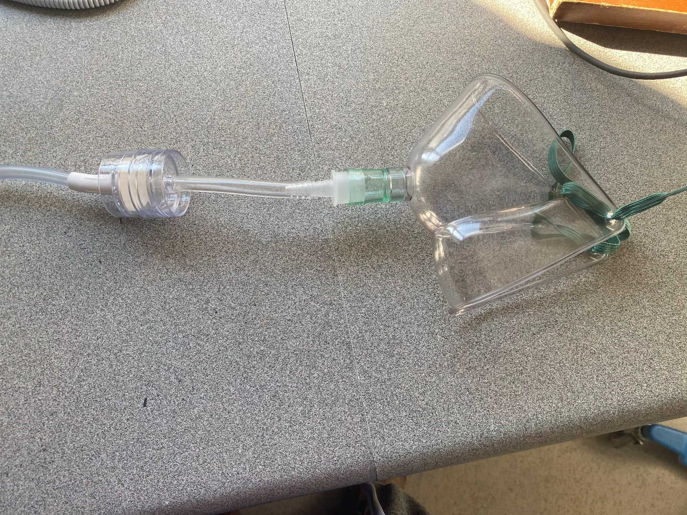

Tent/Scoop Mask

Concha ® Tubing Adaptor

PTFE Filter Cassette

***Figure E7:*** *A representative image of the scavenger mask used to concentrate samples for the final five collections. The Concha ® adaptor is attached to a small length of tygon tubing which is attached in line to a PTFE filter which attaches to low wall suction. The tent (or scoop) mask is placed on the subject’s face in the usual fashion allowing for more directed aerosol sampling.*