Online Supplement
Cough peak flow assessment without disconnection from the ICU ventilator in mechanically ventilated patients.

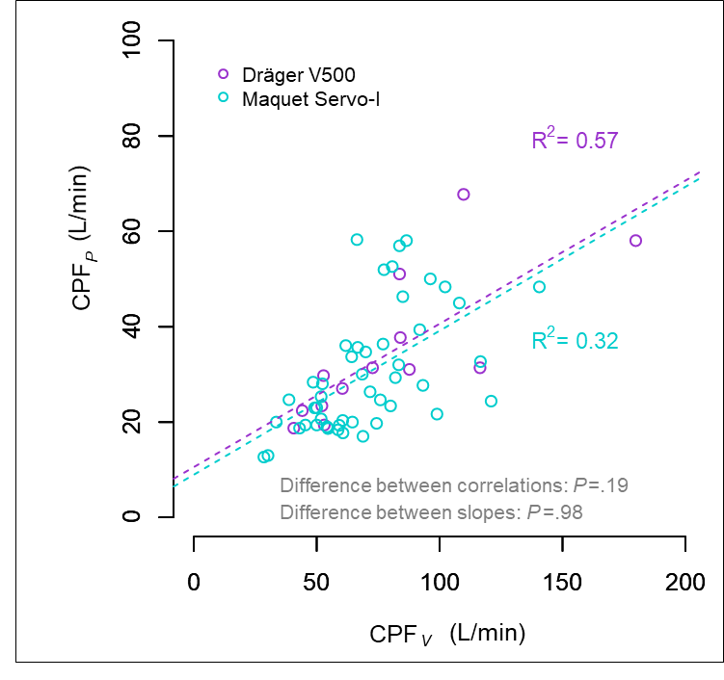
Figure S1: Cough peak expiratory flow correlation between ventilator and external spirometer, depending on the respirator used
Legend
CPF_{P}: cough peak flow measured by the electronic, external peak flow meter; CPF_{V}: Cough peak flow measured by the flow meter embedded into the ventilator; R: Pearson correlation coefficient; R²: Coefficient of determination.

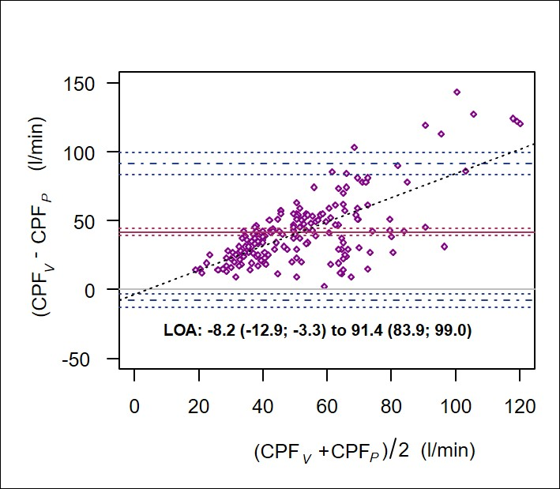
Figure S2: Bias and the limits of agreement between cough peak flow measured by the ventilator and by an external peak flow meter

Legend: CPF_{P}: cough peak flow measured by the electronic, external peak flow meter; CPF_{V}: Cough peak flow measured by the flow meter embedded into the ventilator; LOA: Limits of agreement.
The solid red line indicates the mean bias (surrounded by dotted red lines representing the 95% confidence interval). The horizontal dashed blue lines indicate the lower and upper limits of agreement (surrounded by dotted blue lines representing their 95% confidence interval).
The oblique dotted blue line represents the regression line between mean of measurements and the bias. The higher the mean of measurements, the higher the bias between measurements by the two methods (P<.0001).
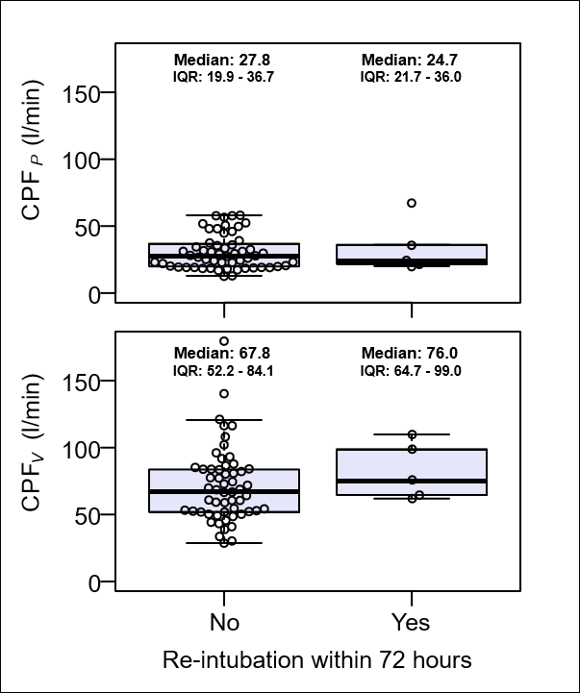
Figure S3: CPF_{V} and CPF_{P} between in reintubated and not reintubated patients

Legend: CPF_{P}: Cough peak flow measured by the electronic, external peak flow meter; CPEF_{V}: Cough peak flow measured by the flow meter embedded into the ventilator; IQR: Interquartile range.
This figure illustrates that reintubated patients were few in our population and that there was a great overlap of CPF_{V} and CPF_{P} values between reintubated and not reintubated patients, preventing the use of either measurement to predict reintubation in our population.

